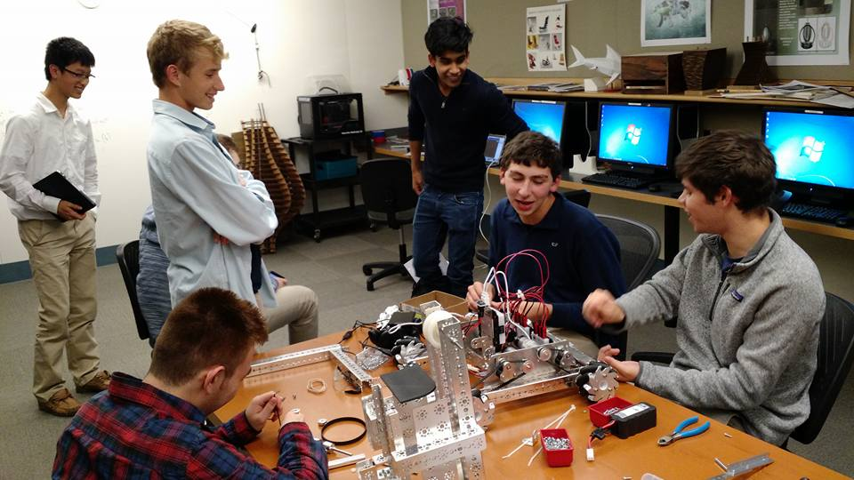

Individual Design Teams

Chassis/Drivetrain Design and Fabricaton – **Mike Letterio** 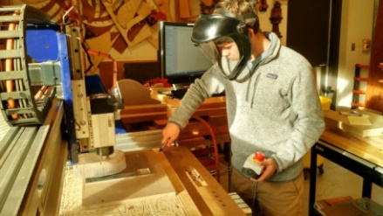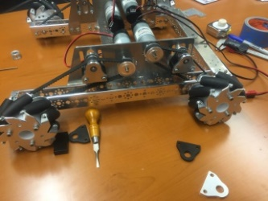

Particle Harvester Design and Fabricaton – **Troy Young** 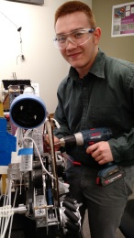 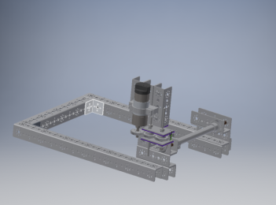 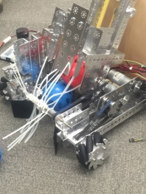

Particle Transfer Design and Fabrication **– Maheep Brar and Reed Chen**  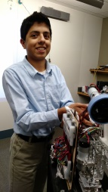 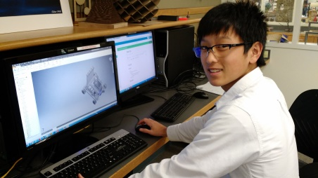

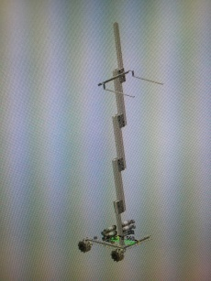 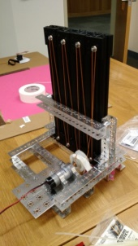 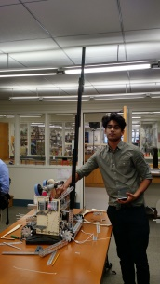 Lift Design and Fabrication – **Arjun Ramachandran**

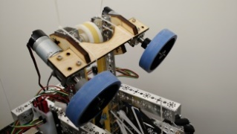 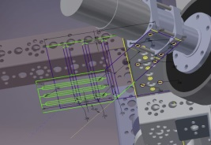 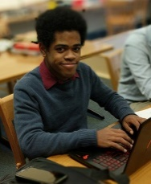 Shooter Mechanism – **Tiree Walker** 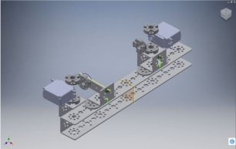 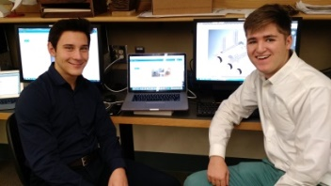 Button Pusher and Sparring Bots – **Max Adelstein and Victor Leweke**

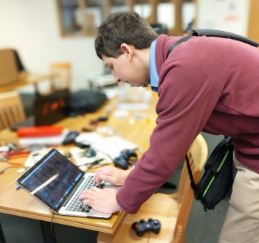 **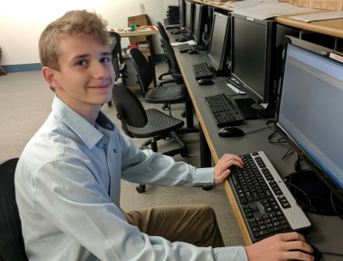**  Programming – **Dylan Siegler and Max Borsch**

Team Outreach and Research – Daniel Pichkar 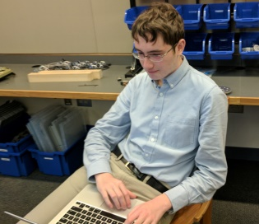

Support Team - Andrew Heater, Seamus Faulkner, Sharan Bhatia

University School started the US Robotics team last year. During our rookie season we made an excellent first showing and managed to impress the judges. We were one of two rookie teams who made it to states. Since then we have improved our engineering, building, and programming skills. The team put more hours in this year and worked hard to make a functional and beautiful robot. Everyone on the team is eager to excel in the First community or take what they have learned on to college. The team is excited and proud of the work we have accomplished this season.

**Tiree Walker** (Senior): Tiree co-founded robotics in 2014. He is a lead builder and a part of the drive team. During meetings, he likes to work with AutoCAD models and brainstorm, test, and build parts for the robot. He also provides helpful information to help troubleshoot mechanical problems on the robot. When he is not working in robotics, he likes building and flying R/C planes with friends, playing racing simulators on is custom PC, and designing and build personal projects in the school’s shop.

**Arjun Ramachandran** (Senior): Arjun cofounded the team in 2014 and is now a lead builder on the team. During meetings, Arjun enjoys proposing preposterous ideas, implementing them, watching them fail spectacularly, then claiming that he has disproved physics. On occasion, Arjun comes up with a truly breakthrough idea that surprise even him. After a long time, this idea usually comes to glorious fruition. When he is not in robotics, Arjun enjoys drifting, breaking speed limit, flying drones and other RC object dangerously close to humans and the ground, and skiing.

**Troy Young** (Senior): Troy joined in 2014 and is now a lead builder on the team. During meetings, he acts as a mentor and role model for the younger members. When he is not in robotics, Troy enjoys drawing, building models, archery, and volleyball. Troy wants to study Computer Science and Engineering in college.

**Sharan Bhatia** (Senior): Sharan joined in 2014 and is an important member of the U.S Robotics team. He assists with any ongoing construction of the robot and tries to help anyone on the team. When he is not at robotics, Sharan enjoys drawing, running, and playing the piano. In college he is looking to study Computer Science and Game Design.

**Max Adelstein** (Senior): Max joined the team this year. He helped with smaller components of the robot as he learned the programs used. His other interest is squash, which stole him away from the team early.

**Michael Letterio** (Junior): Micheal co-founded the robotics team in 2014. He is a lead builder and a part of the drive team. He played a crucial role in the design and build of the robot and will be a key member in the next generation of the team. When Michael is not in robotics, he enjoys building and flying R/C planes, skiing, and video editing.

**Max Borsch** (Sophomore): Max joined the team in 2014 as one of the programmers. During meetings, Max helps come up with ideas as well as working with the drivers to program controls. When he is not in robotics, Max enjoys programming personal projects as well as playing tennis and soccer.

**Andrew Heater** (Sophomore): Andrew joined the team this year. He helped with troubleshooting and ideating design elements on the robot. When he is not in robotics, Andrew enjoys playing videogames.

**Seamus Faulkner** (Sophomore): Seamus joined the team this year. He helped with troubleshooting issues with the robot while learning more about the building process.

**Victor Leweke** (Sophomore): Victor joined the team this year after coming to US as a foreign exchange student from France. He worked on smaller components of the robot as he learned the programs used.

**Reed Chen** (Sophomore): Reed joined the team in 2014. He played a crucial role in the design and construction of the robot this year. During meetings, Reed works on designing new parts to better the robot. When he is not in robotics, Reed likes to play videogames and tennis.

**Dylan Siegler** (Sophomore): Dylan joined 2015 and is now a lead programmer on the team. During meetings, he enjoys encouraging the builders to finish up, encouraging the builders to fix critical problems, and on rare occasion programming the robot. This usually consists of reading large amounts of red and scary sounding text and not knowing what to do. When he is not in robotics, Dylan enjoys programming, playing squash, looking devilishly handsome, and gangling.

**Daniel Pichkar** (Sophomore): Daniel joined the team in 2014. He works to inform the team on rules, research and gracious professionalism. He also is active on the community forums, asking and replying to questions. Daniel enjoys playing videogames and tennis. He will continue to be a valuable player on the robotics team in his remaining years.

**Maheep Brar**(Sophomore): Maheep joined the team in 2014. He assists with the ideating and building of the robot. His other interests include science and video-games. He will be a crucial member in the next generation of the team.

### Engineering Summary

[**PRESEASON BEGINS** 6](#_Toc471383773)

[Research FTC Platforms Used 6](#_Toc471383774)

[Designing a Chassis 8](#_Toc471383775)

[Building a Chassis 9](#_Toc471383776)

[Corrections & Improved Chassis Design 11](#_Toc471383777)

[**SEASON BEGINS** 12](#_Toc471383778)

[First Official Robotics Team Meeting. 12](#_Toc471383779)

[Host Robotics Table at Parent Curriculum Night. 13](#_Toc471383780)

[FTC KICK OFF at Rockwell Automation!!!! 14](#_Toc471383781)

[Brainstorming session. 17](#_Toc471383782)

[Clean and organize the robotics room. 20](#_Toc471383783)

[Learning Autodesk Inventor Software Basics. 21](#_Toc471383784)

[**DESIGN/FABRICATON SUBASSEMBLIES** 22](#_Toc471383785)

[Chassis/Drivetrain Version **1.0** 22](#_Toc471383786)

[Chassis/Drivetrain – Layout and Design V.1 22](#_Toc471383787)

[Chassis/Drivetrain - Motor Configurations V.1 23](#_Toc471383788)

[Chassis/Drivetrain - Power Plate Design V.1 26](#_Toc471383789)

[Chassis/Drivetrain - Power Plate Fabrication V.1 27](#_Toc471383790)

[Chassis/Drivetrain - Layout Belt Tensioners V.1 29](#_Toc471383791)

[Chassis/Drivetrain - Electronics Mounting V.1 32](#_Toc471383792)

[Chassis/Drivetrain Version **2.0** 34](#_Toc471383793)

[Chassis/Drivetrain – New Drive Plate Design V.2 34](#_Toc471383794)

[Chassis/Drivetrain – Structural Blocks V.2 37](#_Toc471383795)

[Chassis/Drivetrain – Fabrication 38](#_Toc471383796)

[Particle Harvester Version **1.0** 42](#_Toc471383797)

[Particle Harvester - Layout and Design V.1 42](#_Toc471383798)

[Particle Harvester - Custom Bearing Plate V.1 43](#_Toc471383799)

[Particle Harvester - Bearing Plate Fabrication V.1 44](#_Toc471383800)

[Particle Harvester – Fabrication V.1 45](#_Toc471383801)

[Particle Harvester - Fabrication Modification V.1 46](#_Toc471383802)

[Particle Harvester - Funnel Design and Fabrication V.1 47](#_Toc471383803)

[Particle Harvester - Temporary fix for Scrimmage 49](#_Toc471383804)

[Particle Harvester Version **2.0** 51](#_Toc471383805)

[Particle Harvester - Redesign V.2 51](#_Toc471383806)

[Particle Harvester - Fabrication V.2 52](#_Toc471383807)

[Particle Transfer Version **1.0** 55](#_Toc471383808)

[Particle Transfer - Design V.1 55](#_Toc471383809)

[Particle Transfer – Redesign V.1 57](#_Toc471383810)

[Particle Transfer – Second Redesign V.1 59](#_Toc471383811)

[Particle Transfer – Fabrication V.1 60](#_Toc471383812)

[Particle Transfer Version **2.0** 61](#_Toc471383813)

[Particle Transfer - Redesign V.2 61](#_Toc471383814)

[62](#_Toc471383815)

[Cap Ball Lift Mechanism 65](#_Toc471383816)

[Cap Ball Lift – Design V.1 65](#_Toc471383817)

[Cap Ball Lift - 80/20 Design V.1 66](#_Toc471383818)

[Cap Ball Lift - Arm Design V.1 67](#_Toc471383819)

[Cap Ball Lift - Motor Mount V.1 69](#_Toc471383820)

[Cap Ball Lift - Arm Redesign V.1 70](#_Toc471383821)

[Cap Ball Lift – Fabrication V.1 71](#_Toc471383822)

[Cap Ball Lift – Cable Holder Design and Fabrication V.1 73](#_Toc471383823)

[Ball Shooter 79](#_Toc471383824)

[Shooter Mechanism 79](#_Toc471383825)

[Button Pusher and Sparring Bots 85](#_Toc471383826)

[Beacon Button Pusher 85](#_Toc471383827)

[Beacon Button Pusher Redesign 86](#_Toc471383828)

[Building Sparring Bots 87](#_Toc471383829)

[**PROGRAMING** 89](#_Toc471383830)

[*September 21* 90](#_Toc471383831)

[*October 21* 90](#_Toc471383832)

[*October 22* 91](#_Toc471383833)

[*October 26* 91](#_Toc471383834)

[*November 1* 91](#_Toc471383835)

[*November 2* 91](#_Toc471383836)

[*November 3* 91](#_Toc471383837)

[*November 4* 92](#_Toc471383838)

[*November 7* 92](#_Toc471383839)

[*November 8* 92](#_Toc471383840)

[*November 9* 92](#_Toc471383841)

[*November 10* 92](#_Toc471383842)

[*November 12* 93](#_Toc471383843)

[**AKRON SCRIMMAGE 11/12/2016** 97](#_Toc471383844)

[**SOLON SCRIMMAGE 11/19/2016** 99](#_Toc471383845)

[**CLEVELAND QUALIFYING TOURNAMENT** 100](#_Toc471383846)

# PRESEASON BEGINS



### Date: 8/29/2016

Attendance: Mike, Arjun, Max, Maheep, Victor, Troy, Reed

#### Research FTC Platforms Used

Reflections:

To better understand what past competition chassis look like and what was successful, we each took a past game and reviewed footage to observe what worked and what didn’t with emphasis on electronics management.

In order to develop a way to manage electronic components for our competition robot, we came to the conclusion that we needed to build a chassis first. In order to do so we needed to analyze previous robot platforms used by successful teams, this would help us make the platform before we knew the specifics of the game and the design challenges we would have to meet.

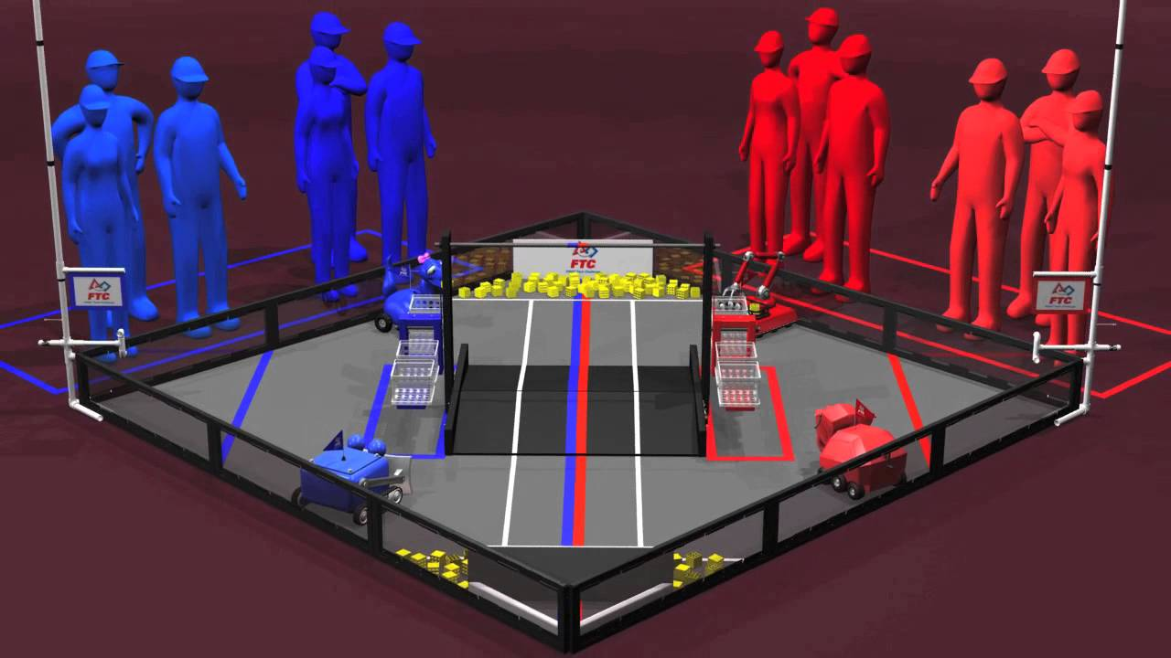

**FIRST Block Party (2013-2014)**

The field in this game was dominated by a large ramp in the center. This means that maneuverability was key for success in this game because of the small space that robots had to move.

When analyzing the successful robot chassis from this competition year, maneuverability was apparent. Teams often were able to meet this goal through the use Omni-directional wheels and standard Tetrix wheels, configured in sets of 4 or 6 depending on the platform.



**FIRST Get Over It (2010-2011)**

2010-2011 FIRST challenge called “Get Over It”. This year’s challenge consisted of the robots going over small hills and seesaws in the middle of the field. The robots had to be able to grab and rotate small PVC batons out on slots on the walls and drop them on rolling goals. This meant that the robots needed to have extra motors and moving parts compared to previous seasons making spacing and cable management very important.

Some working designs that I found:

* Side Mounted Electronics
* Expanding Design
* Combine-type Harvester
* Hinged & Rotate-able Arm
* 4 wheels and 4 motors
* Bottom/Internal Electronics (Gives Limited Access)
* Smaller Compact Design
* Electronics Bundled
* Electronics Mounted Underneath Robot with a Panel for Protection



**FIRST Ring it UP (2012-2013)**

Common Designs

* Square base
* All wheel drive
* 4 omni-directional wheels
* Diagonal drift wheels
* 3 jointed arm and hand

### Date: 9/1/2016

Attendance: Mike, Arjun, Max, Maheep, Victor, Troy, Reed, Tiree

#### Designing a Chassis

Reflections:

After looking at successful chassis from previous games, we began to develop ideas that we could approach and build while using the design process. We eventually made the decision that a platform consisting of 6 wheels with the center two wheels offset. This would reduce the friction during rotation leading to greater performance and speed.

* -6 Wheels
* -Only 2 wheels will be driven for the initial prototype.
* -Gearing is for speed rather than torque, unless future design carries weight.

We split up into groups of three and set off to design a chassis. My group of Max, Reed, and myself decided to go with a 4 motor 8 wheel design based off the West Coast Chassis. We started by sketching out a rough design of our idea.

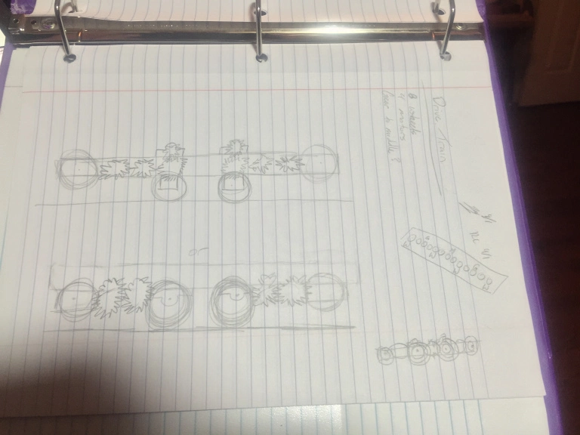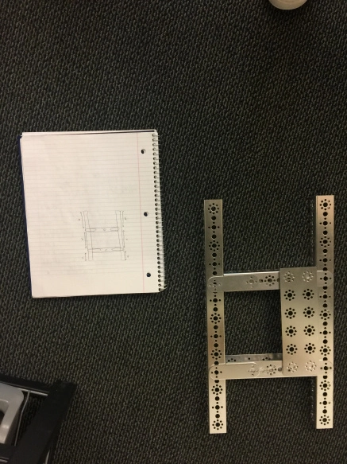

*Group 1 - “West Coast” chassis sketch Group 2 - “Sumo” chassis design*

### Date: 9/2/2016

Attendance: Mike, Arjun, Max, Maheep, Victor, Troy, Reed, Tiree

#### Building a Chassis

Reflections:

We made a basic layout of the frame in order to find a wheel and motor layout. After we established the outer frame we added a center reinforcement beam and the axle brackets. The center bracket was offset by ~3/16in, as shown below. This was to allow less friction when pivoting by lifting off the back set of wheels.

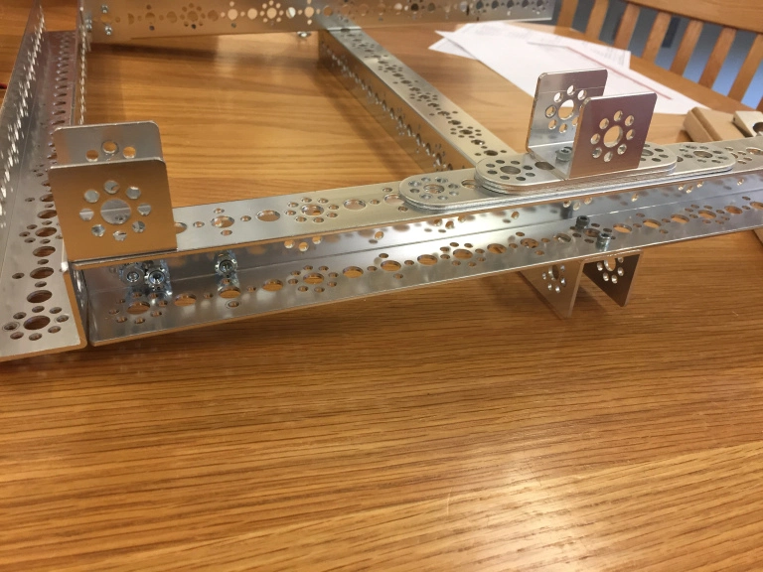

*Group 3 - “West Coast” chassis build*

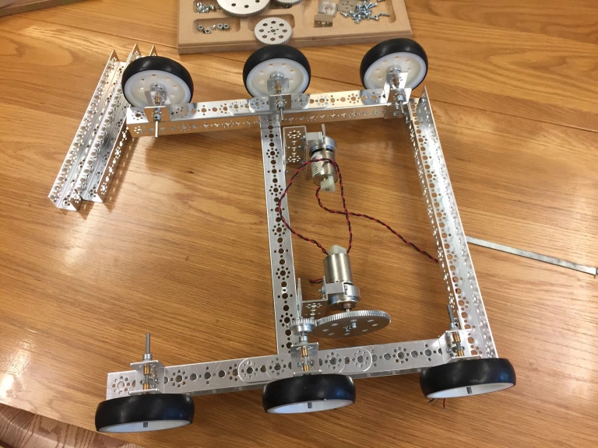 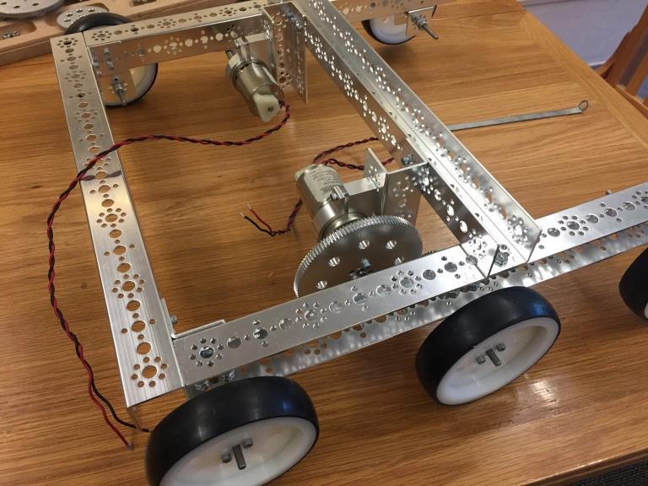

*Group 3 – West Coast chassis build*

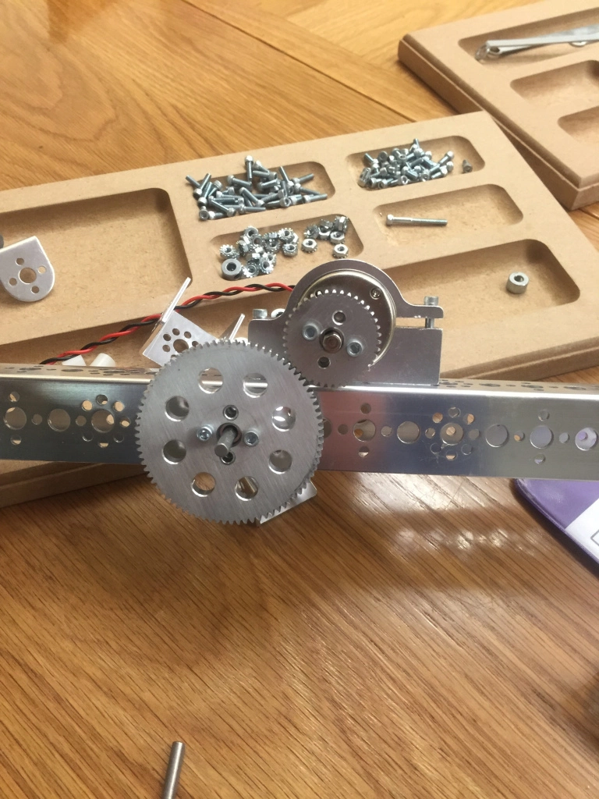 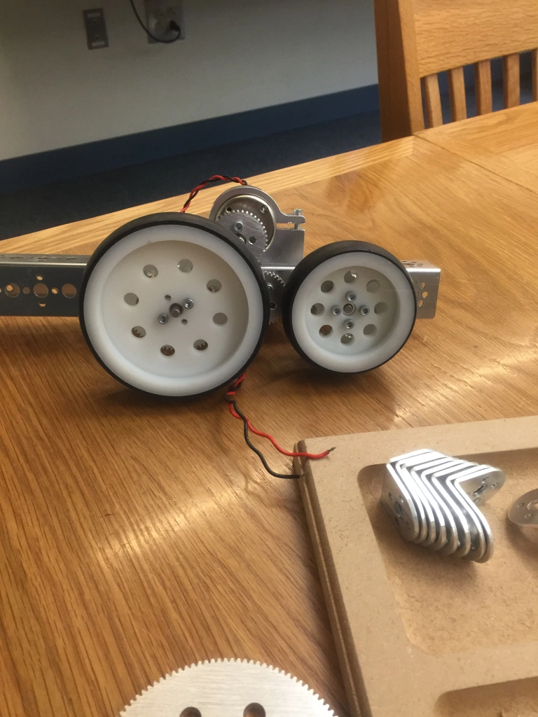 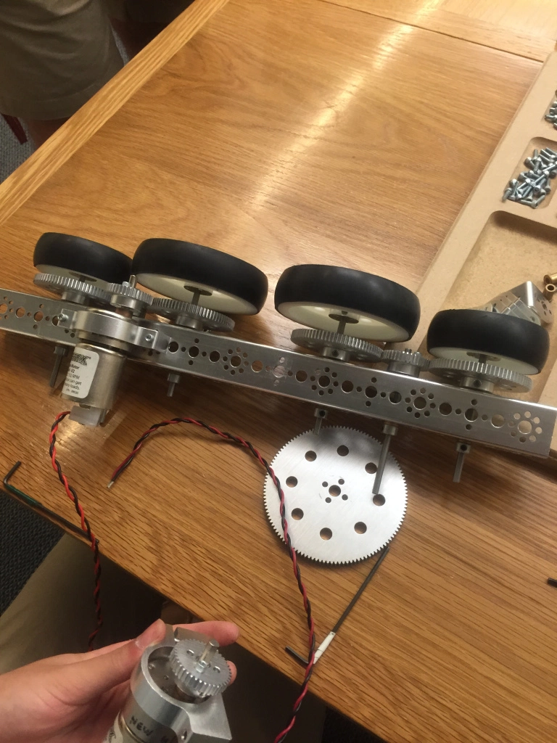

*Group 1– West Coast chassis build*

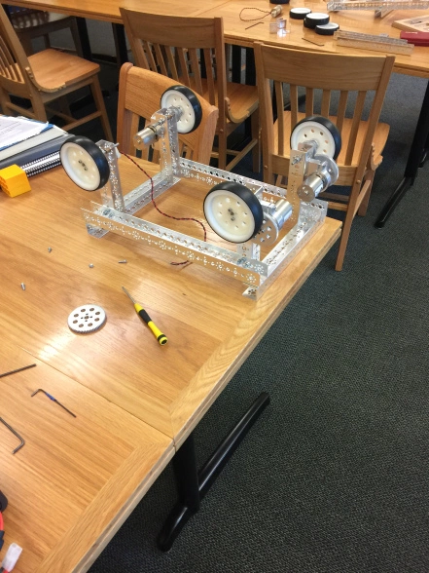 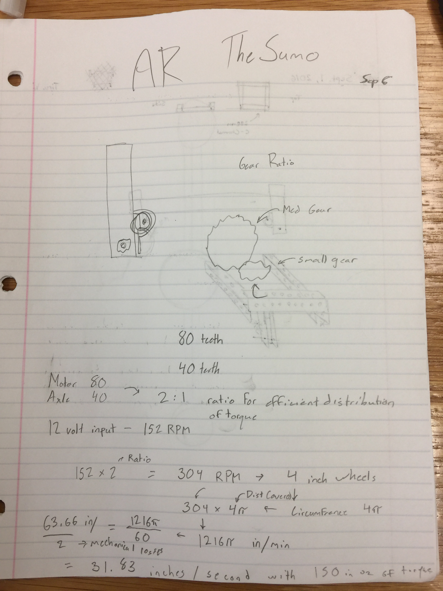 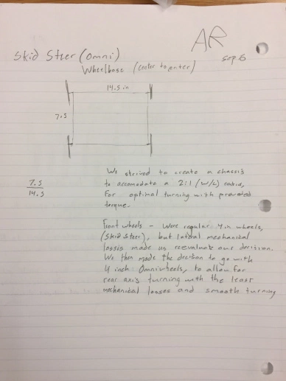

*Group 2 – “Sumo” chassis build*

### Date: 9/5/2016

Attendance: Mike, Arjun, Max, Maheep, Victor, Troy, Reed

#### Corrections & Improved Chassis Design

After a basic chassis was built we began to refine our prototype. This would include adjustments for sizing restrictions but also adding functionality to meet previous design challenges. After assembly of our frame we realized that the wheelbase extended the width of the chassis, making it larger than FTC regulations allowed. We preceded to re-assembly the frame for a narrower stance that would allow us to conform to regulations.

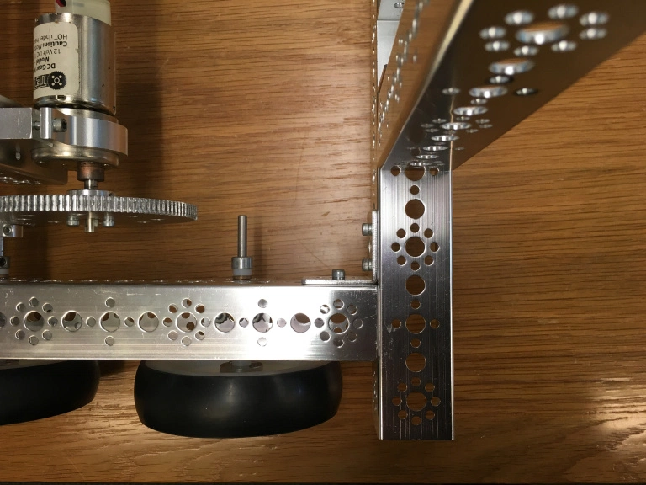 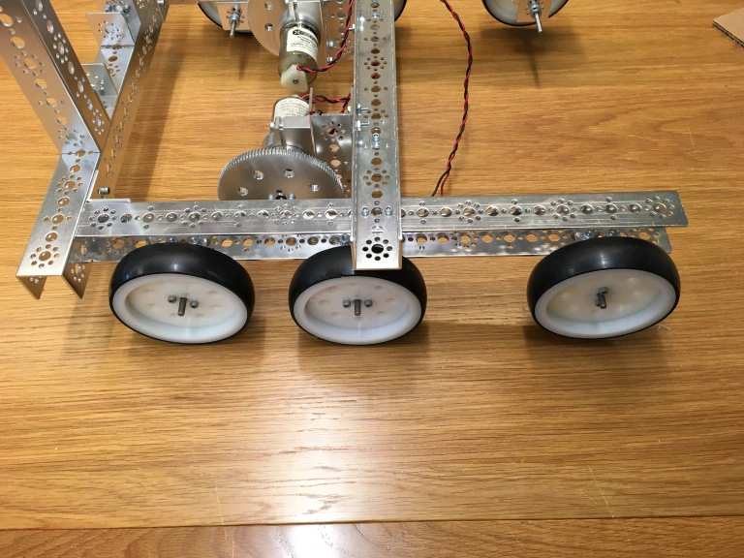

*Group 3 – West Coast chassis build*

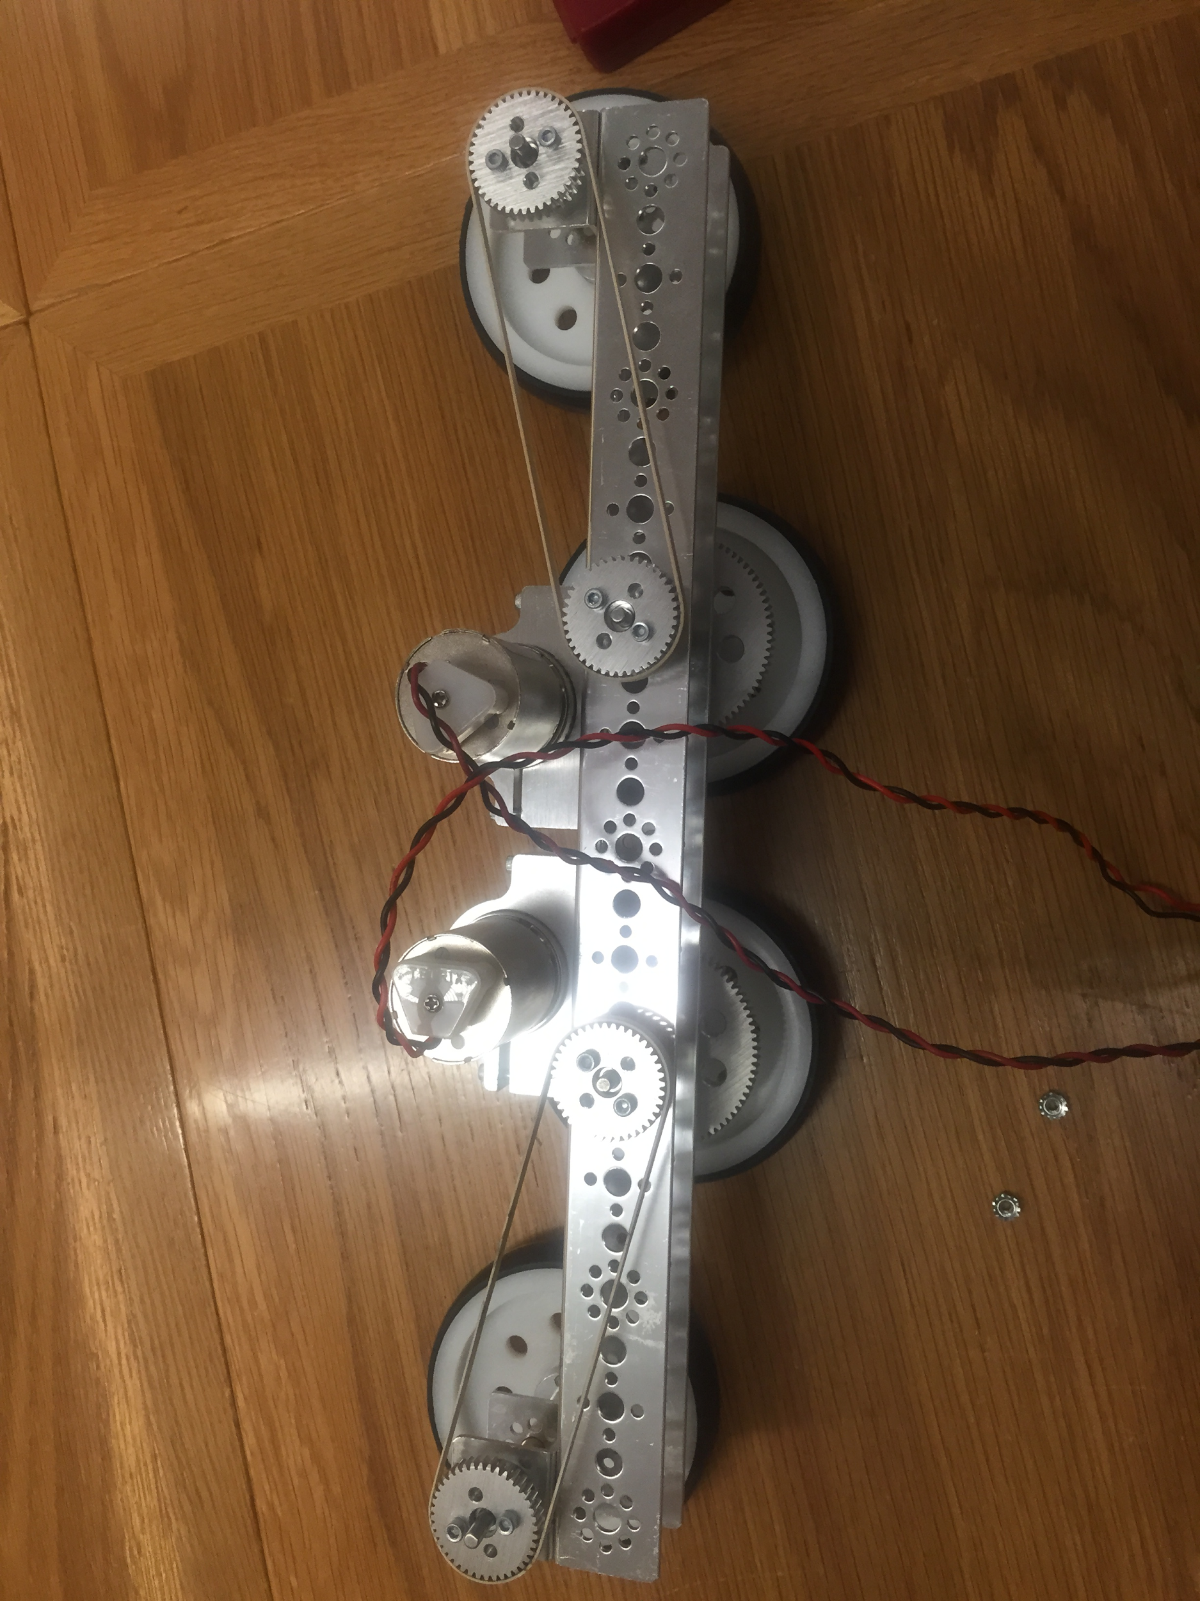

*Group 1– West Coast chassis build*

# SEASON BEGINS



### Date: 9/7/2016

Attendance: Mike Letterio, Arjun Ramachandran, Max, Maheep Brar, Victor, Troy Young, Reed Chen, Henry Michaelson, Tyler Nettis, Dylan Siegler, Andrew Heater, Max Borsch, Seamus Kanlkner, John Hollinkton, Tinashe Handina, Victor Leweke, Max Adelstein, Tiree Walker, Daniel Pichkar

#### First Official Robotics Team Meeting.

* Plan for Parent Curriculum night - Dylan, Troy, Arjun, Daniel P.
* Plan for Kickoff event - Dylan, Mike, Arjun, Troy, Maheep, Daniel. @ 8:00 AM
* Set Schedule for next week.
* Break-up into 3 teams: explain individual drivetrain ideas

Reflections:

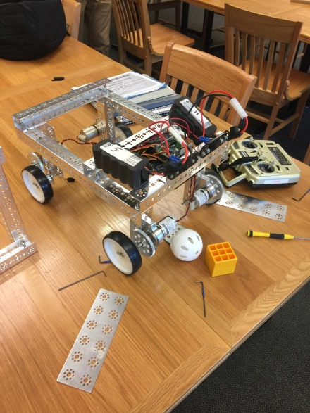 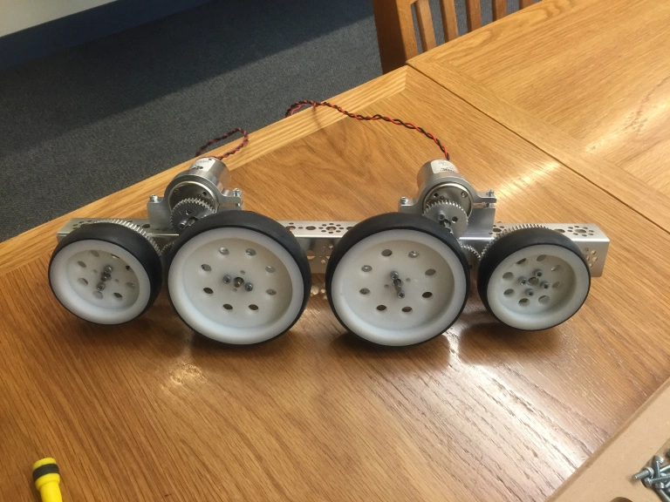

*“Sumo” design to high and fell over. “West Coast” design looks promising.*

### Date: 9/8/2016

Attendance: Mike, Arjun, Troy, Dylan, Daniel P.

#### Host Robotics Table at Parent Curriculum Night.

Reflections:

* Talked to parents about sons joining the team.
* Explained about the FIRST organization.
* Drove last year’s robot and let some parents drive it.

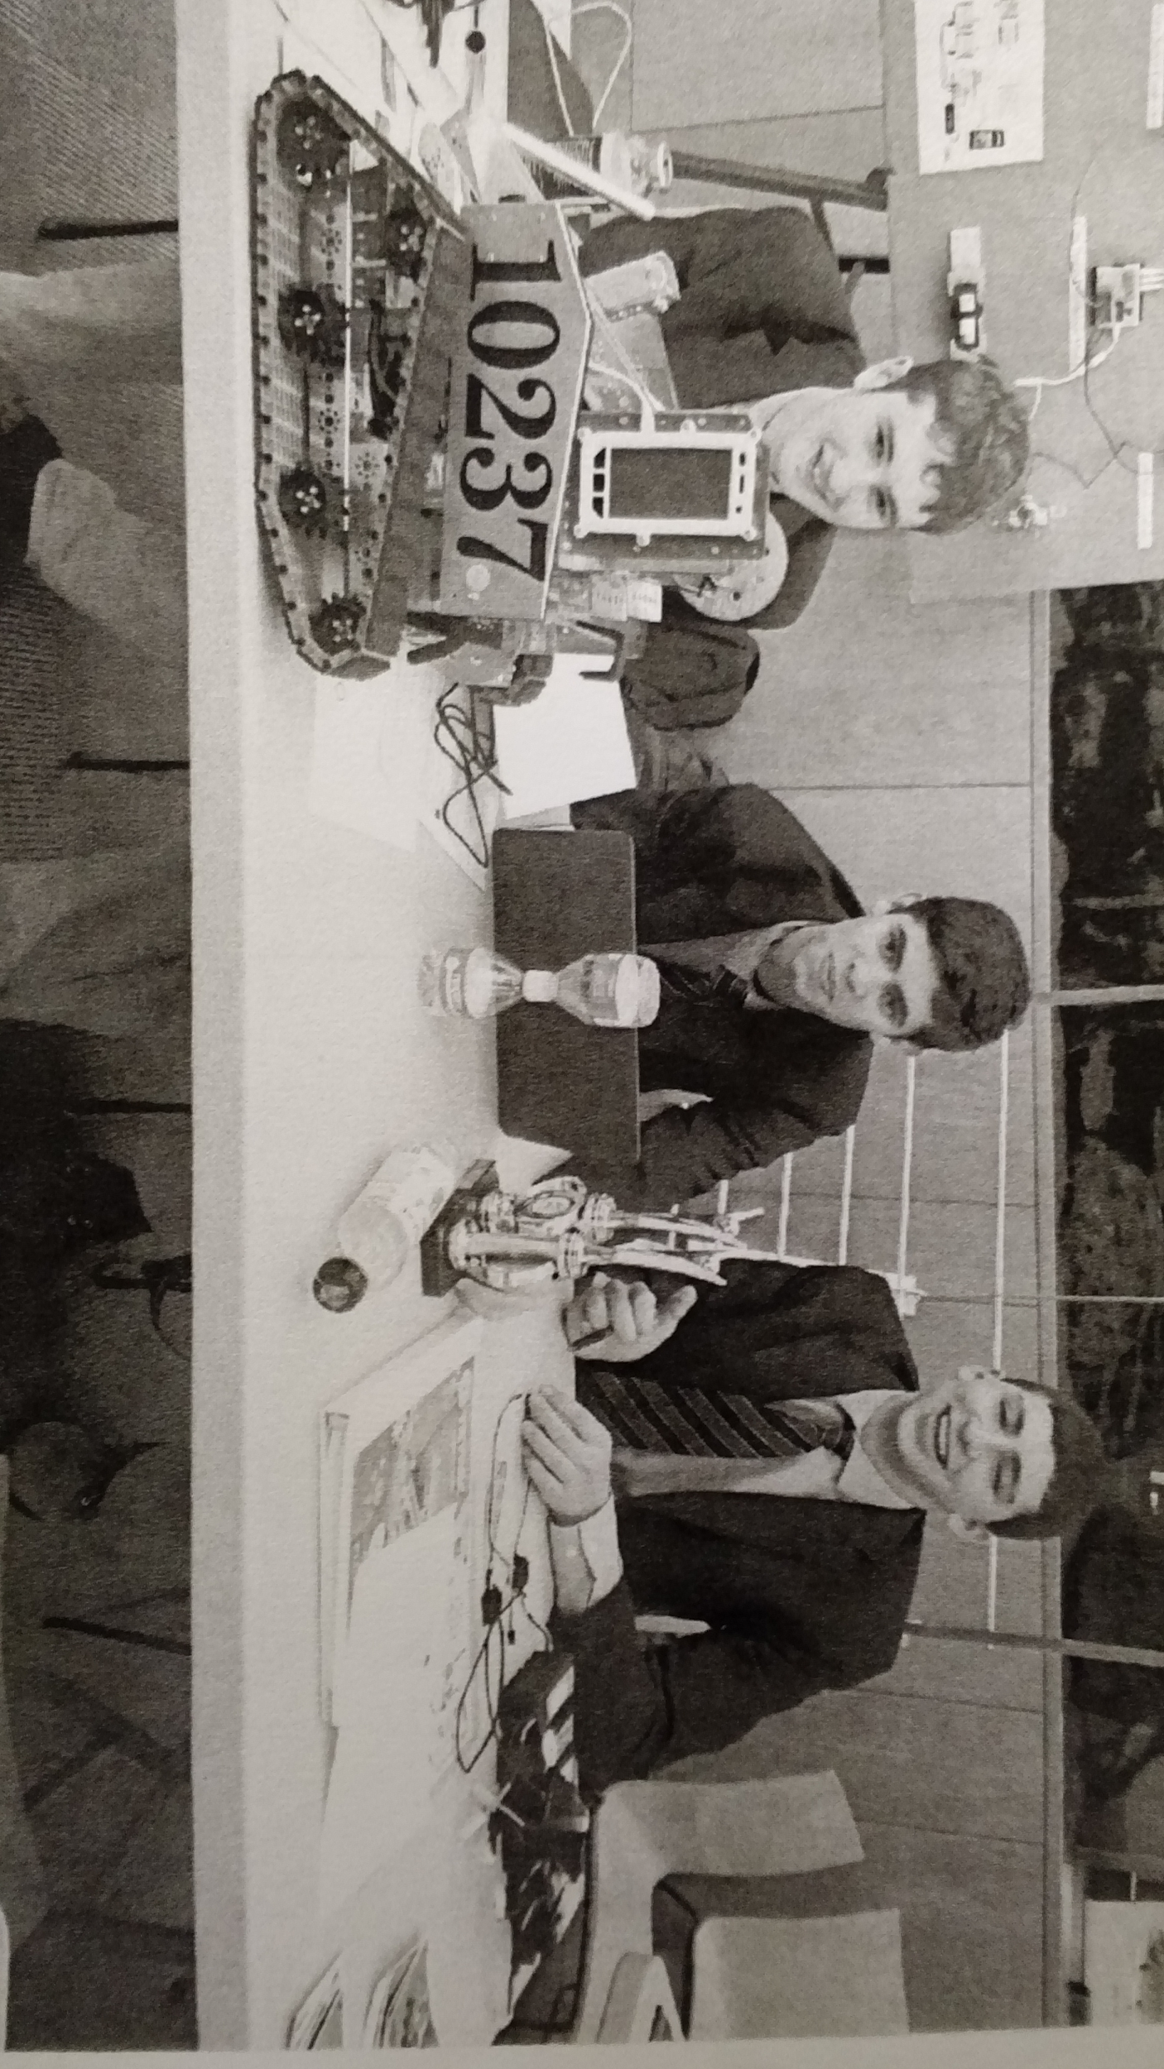

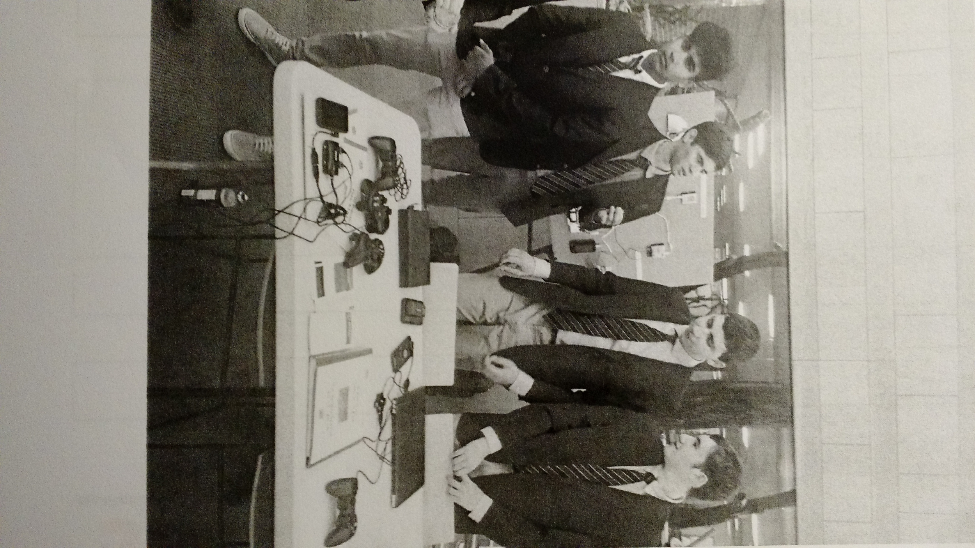

### Date: 9/10/2016

Attendance: Mike, Arjun, Troy, Dylan, Daniel, Maheep

#### FTC KICK OFF at Rockwell Automation!!!!

Reflections:

* Networked with other teams.
* Brainstormed ideas for new game.
* Toured the robotics/automation facilities.

Mr. Sweeney and Dylan taught the “Beginners Java” workshop.

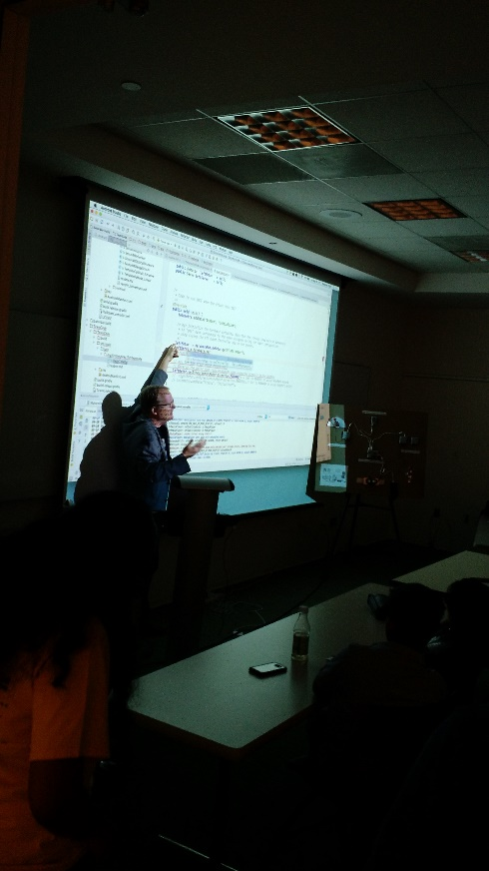

*Mr. Sweeney lecturing*

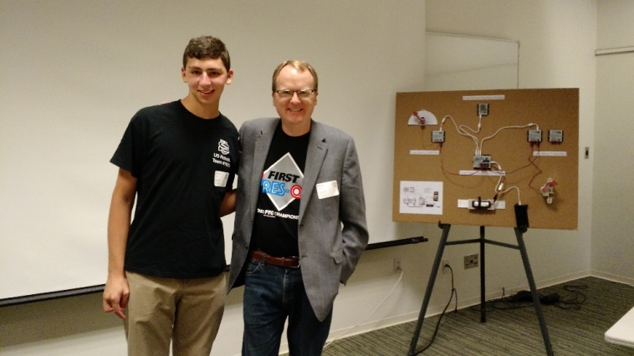

*Dylan and Mr. Sweeney*

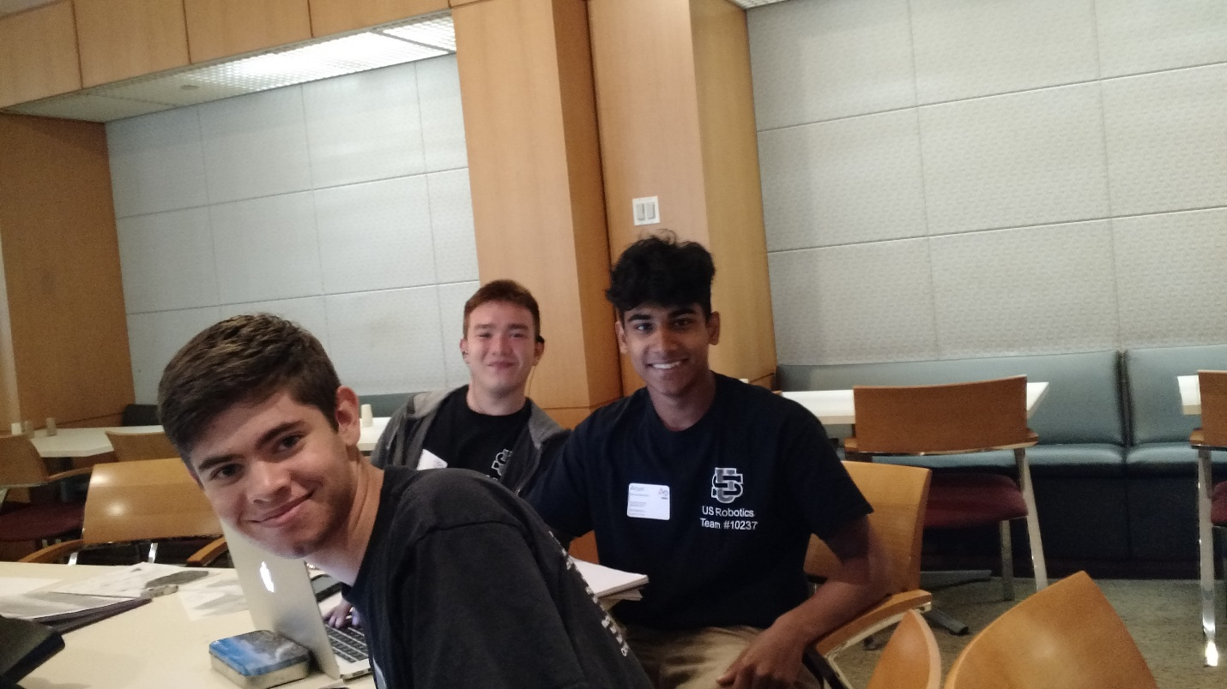

*Mike, Arjun, and Troy waiting for the game release*

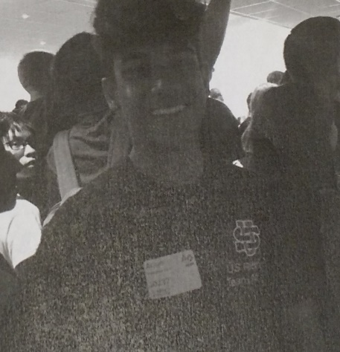 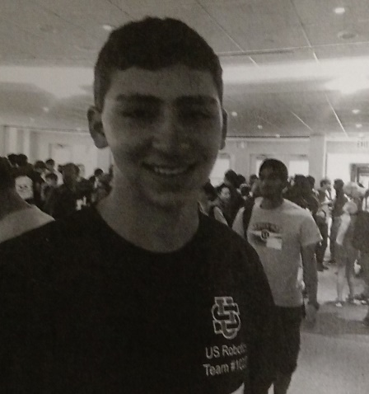

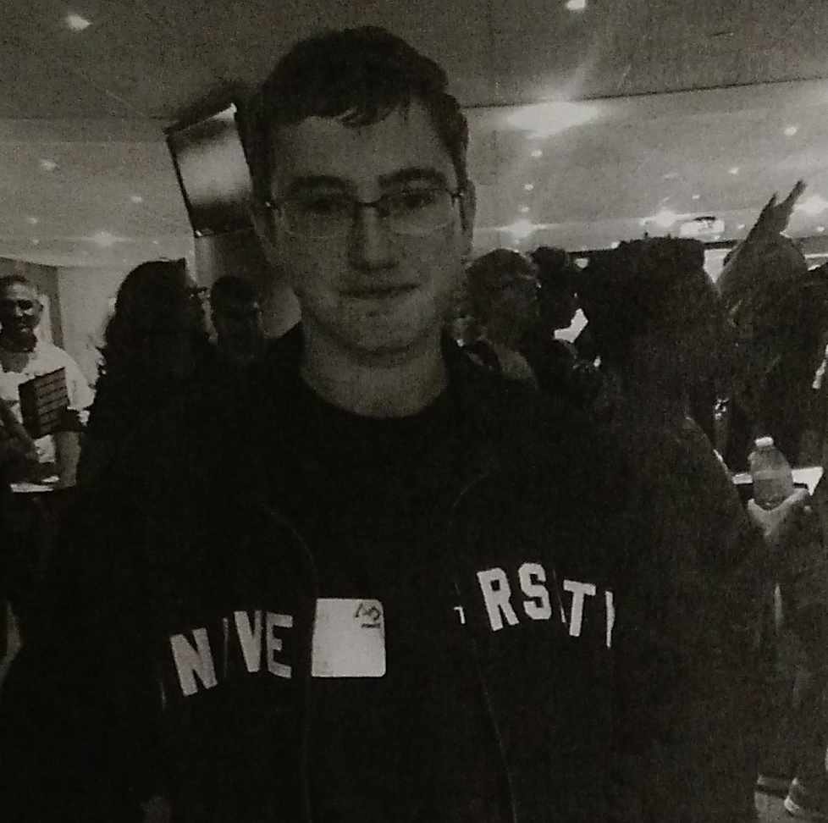

*Arjun Daniel Dylan*

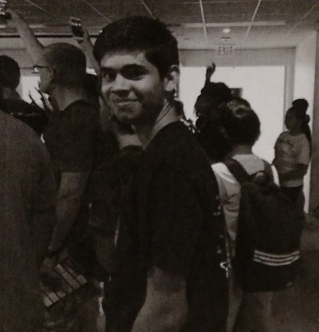 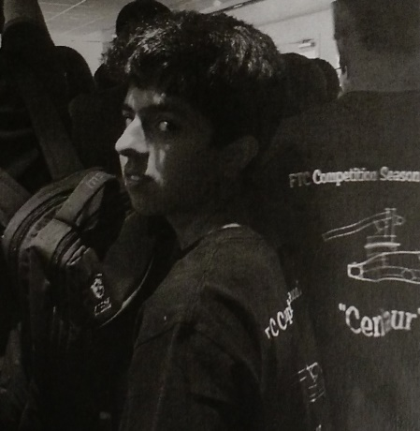 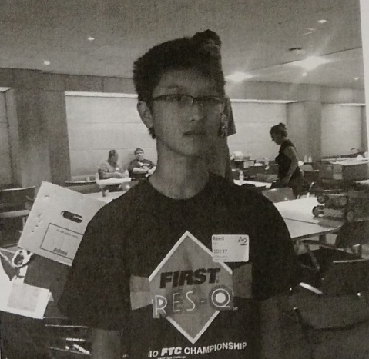

*Mike Maheep Reed*

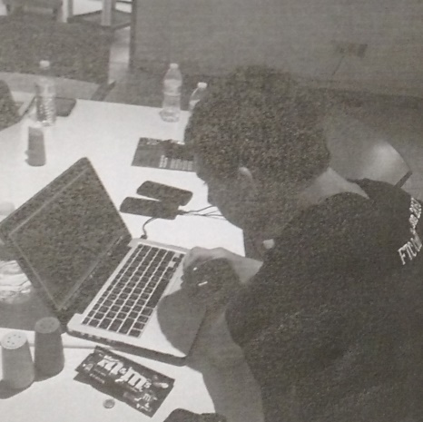 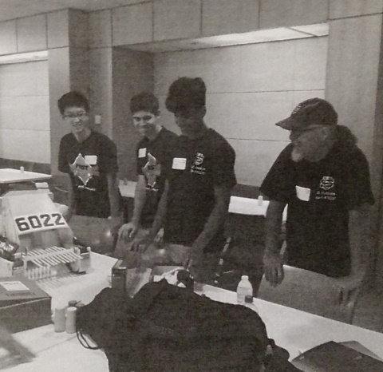 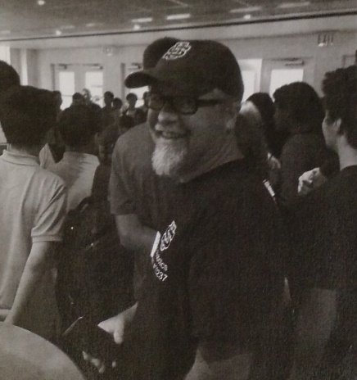

*Dylan Advice from team FTC 6022 Mr. Brodie*

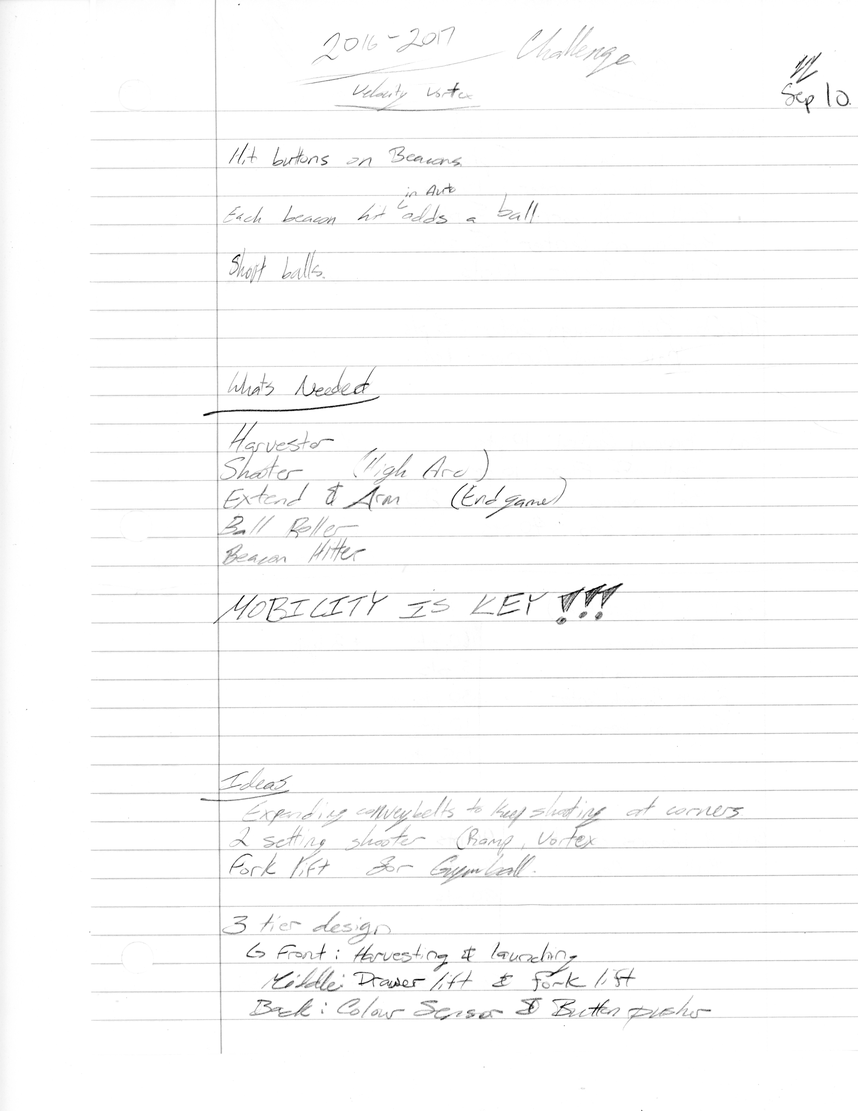

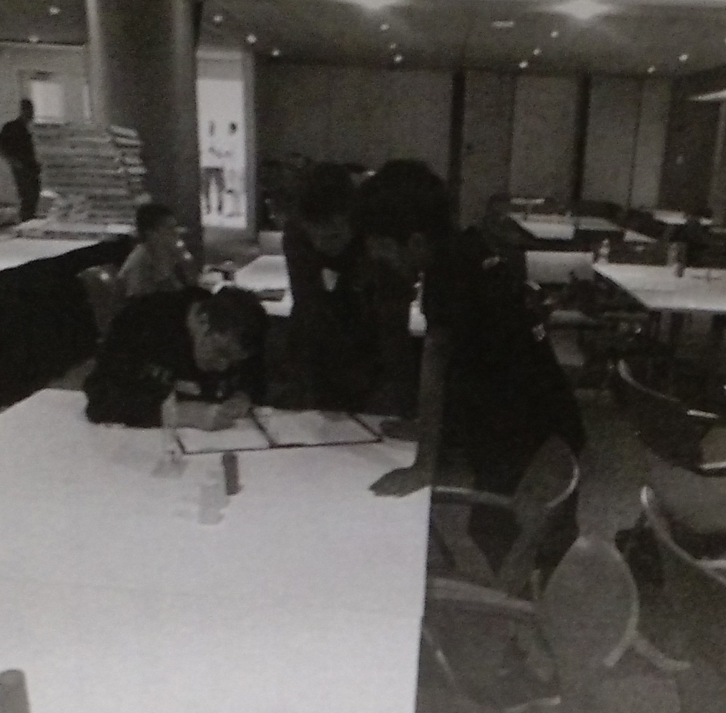

*Daniel, Troy, and Maheep brainstorming ideas after game release*

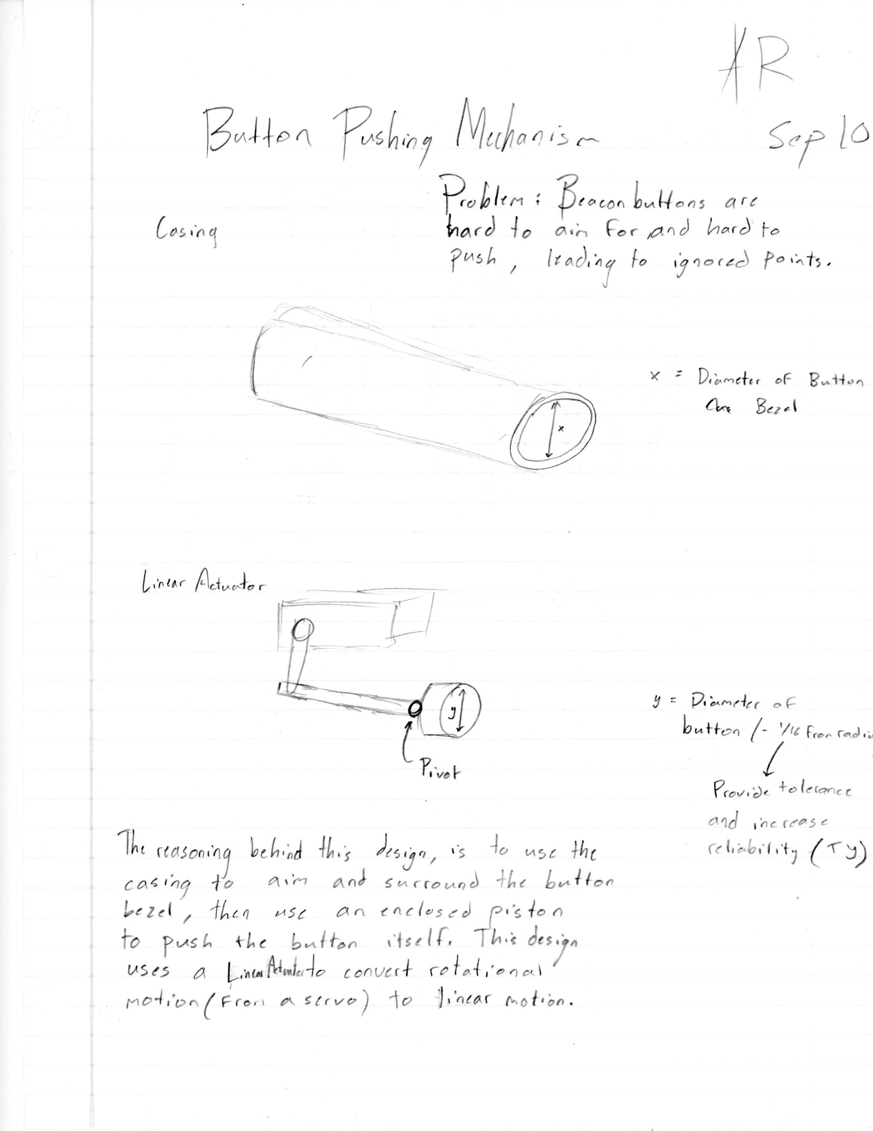 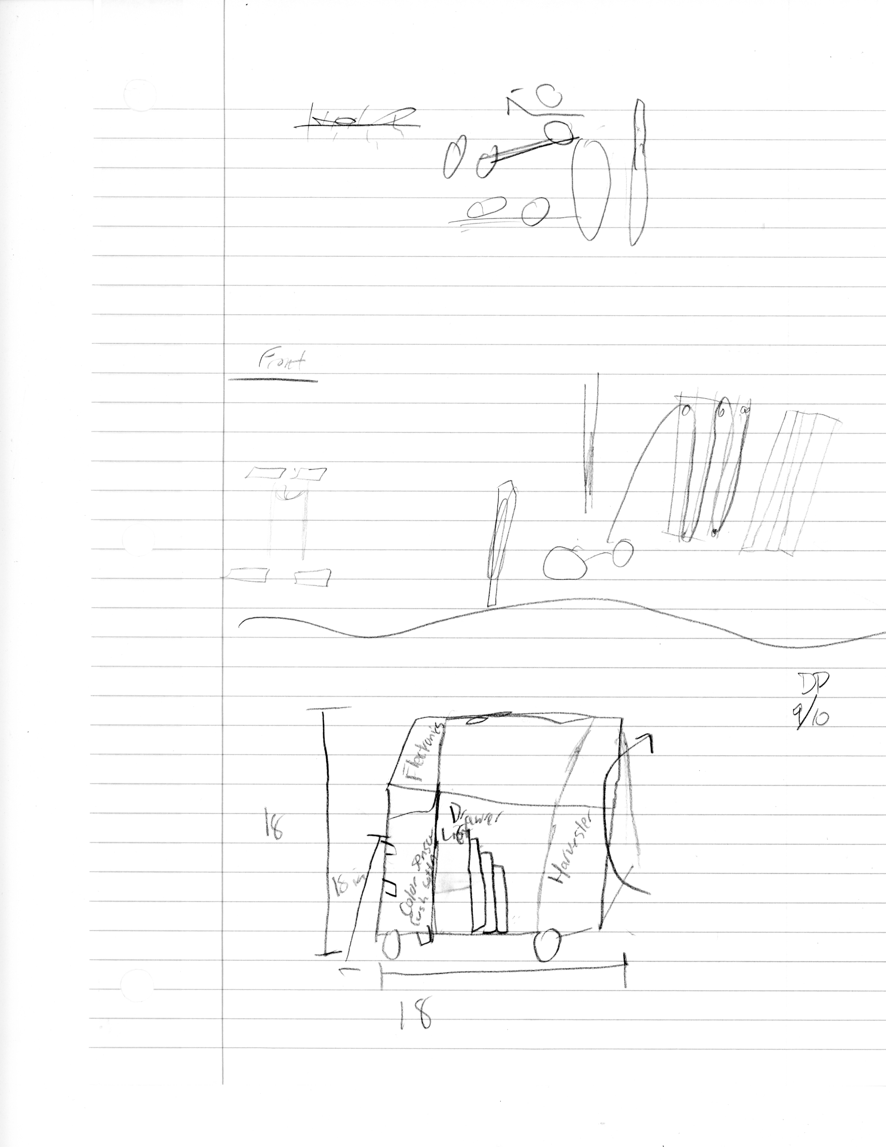

C*cConcept sketches from game release day.*

### Date: 9/12/2016

Attendance: Reed, Mike, Arjun, Troy, Dylan, Daniel, Maheep, Tiree

#### Brainstorming session.

Break up into 3 teams and strategize how to score highest number of points according to rules of the game.

Reflections:

* Dylan and Mike – 185 pts.
* Troy, Tiree, and Arjun – 197 pts.
* Reed, Maheep, and Daniel – 325 pts.
* Recycling idea – park at corner vortex and collect particles as soon as they come back down ramp.

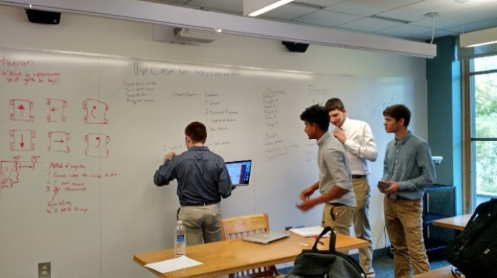

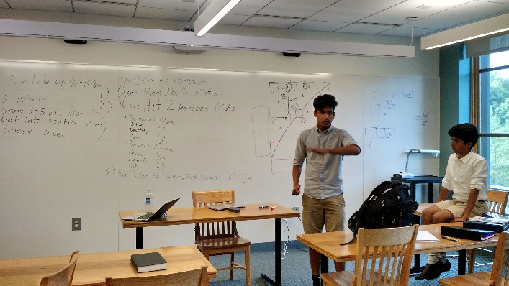 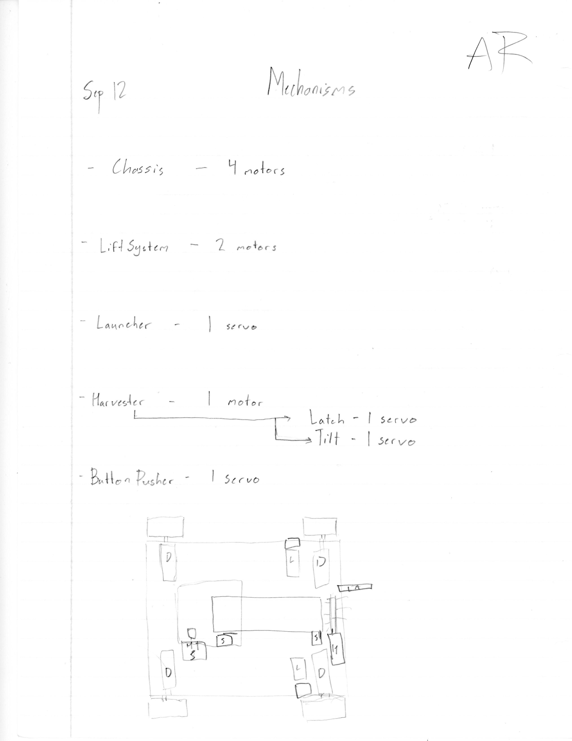

*Arjun pitching his ideas at brainstorming seassion.*

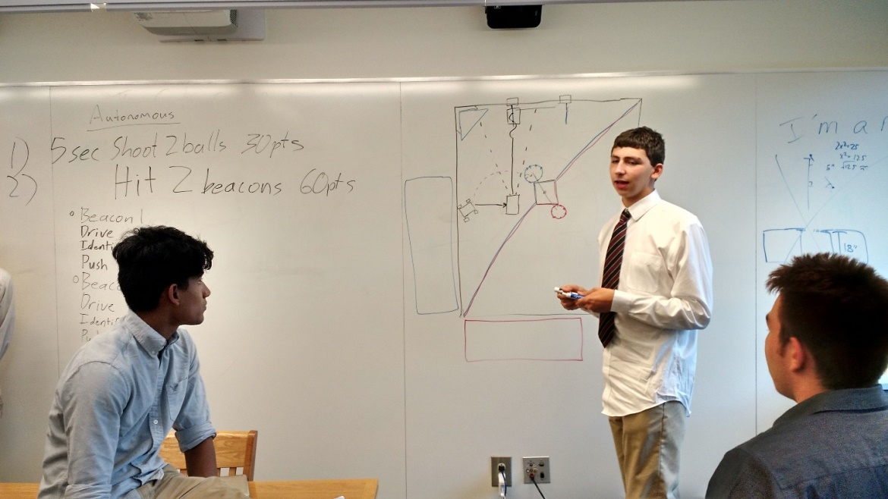

*Dylan who is one of the main programers, explaining his ideas for autonomous mode.*

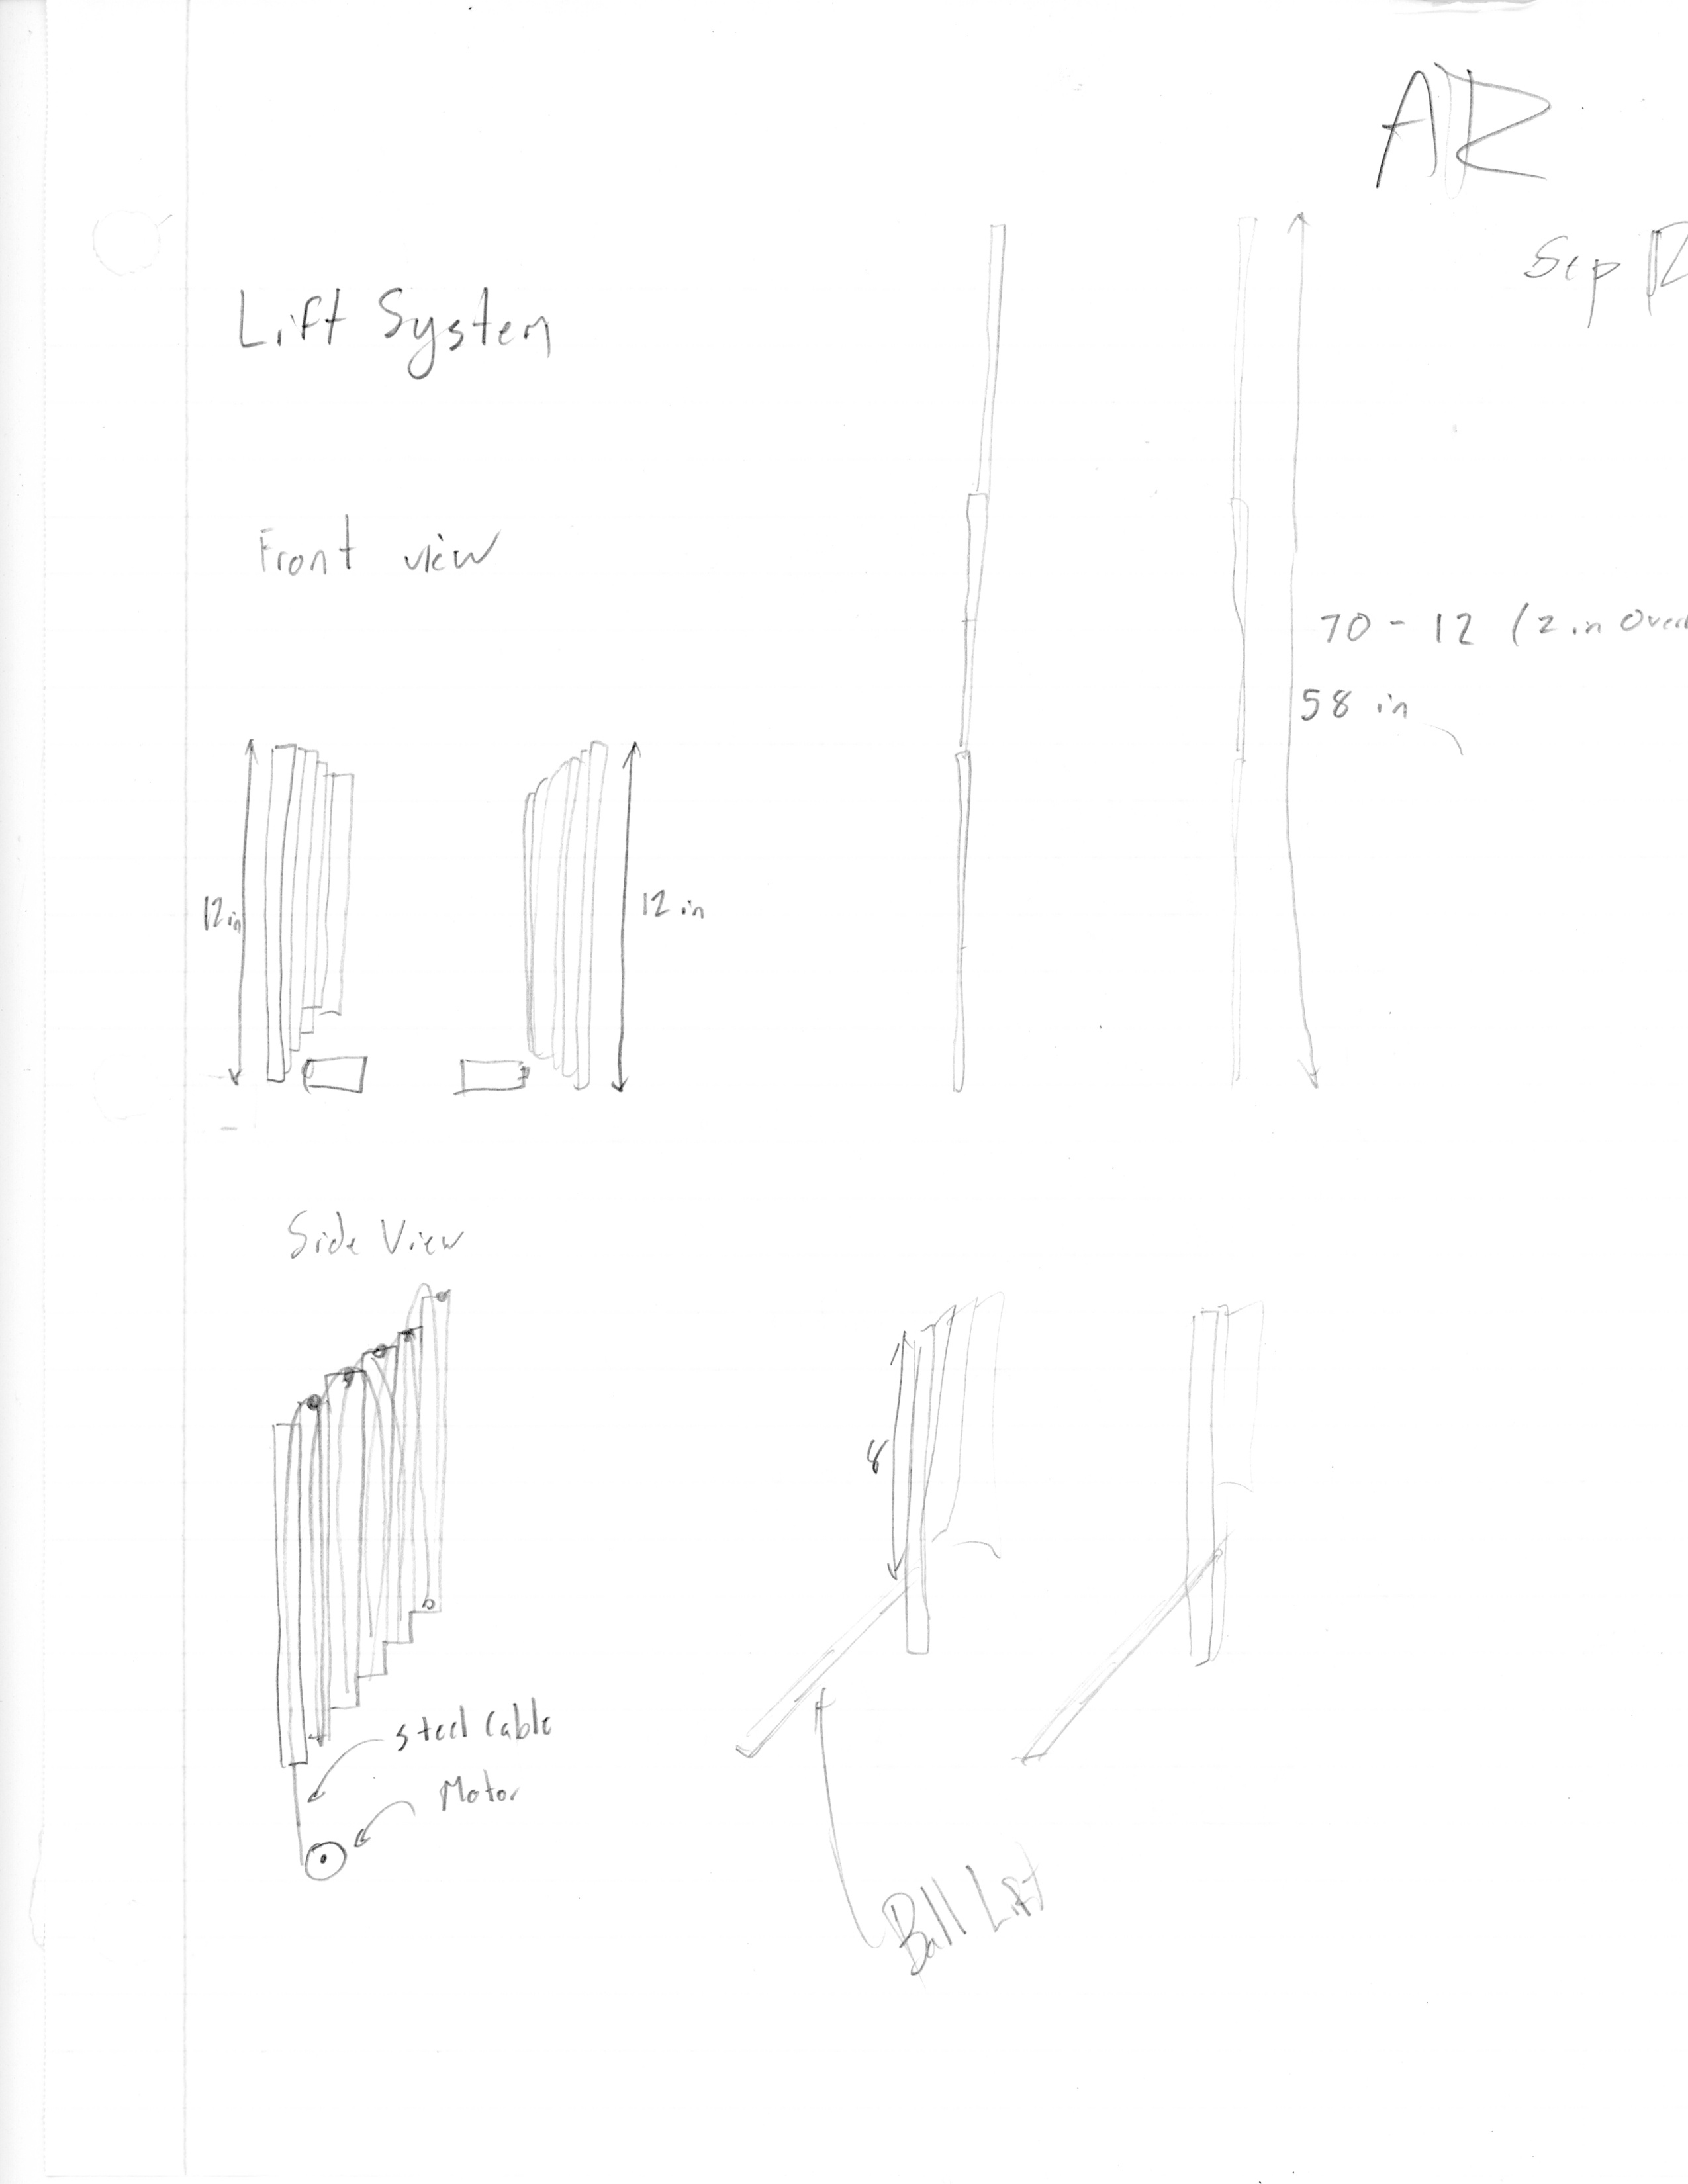

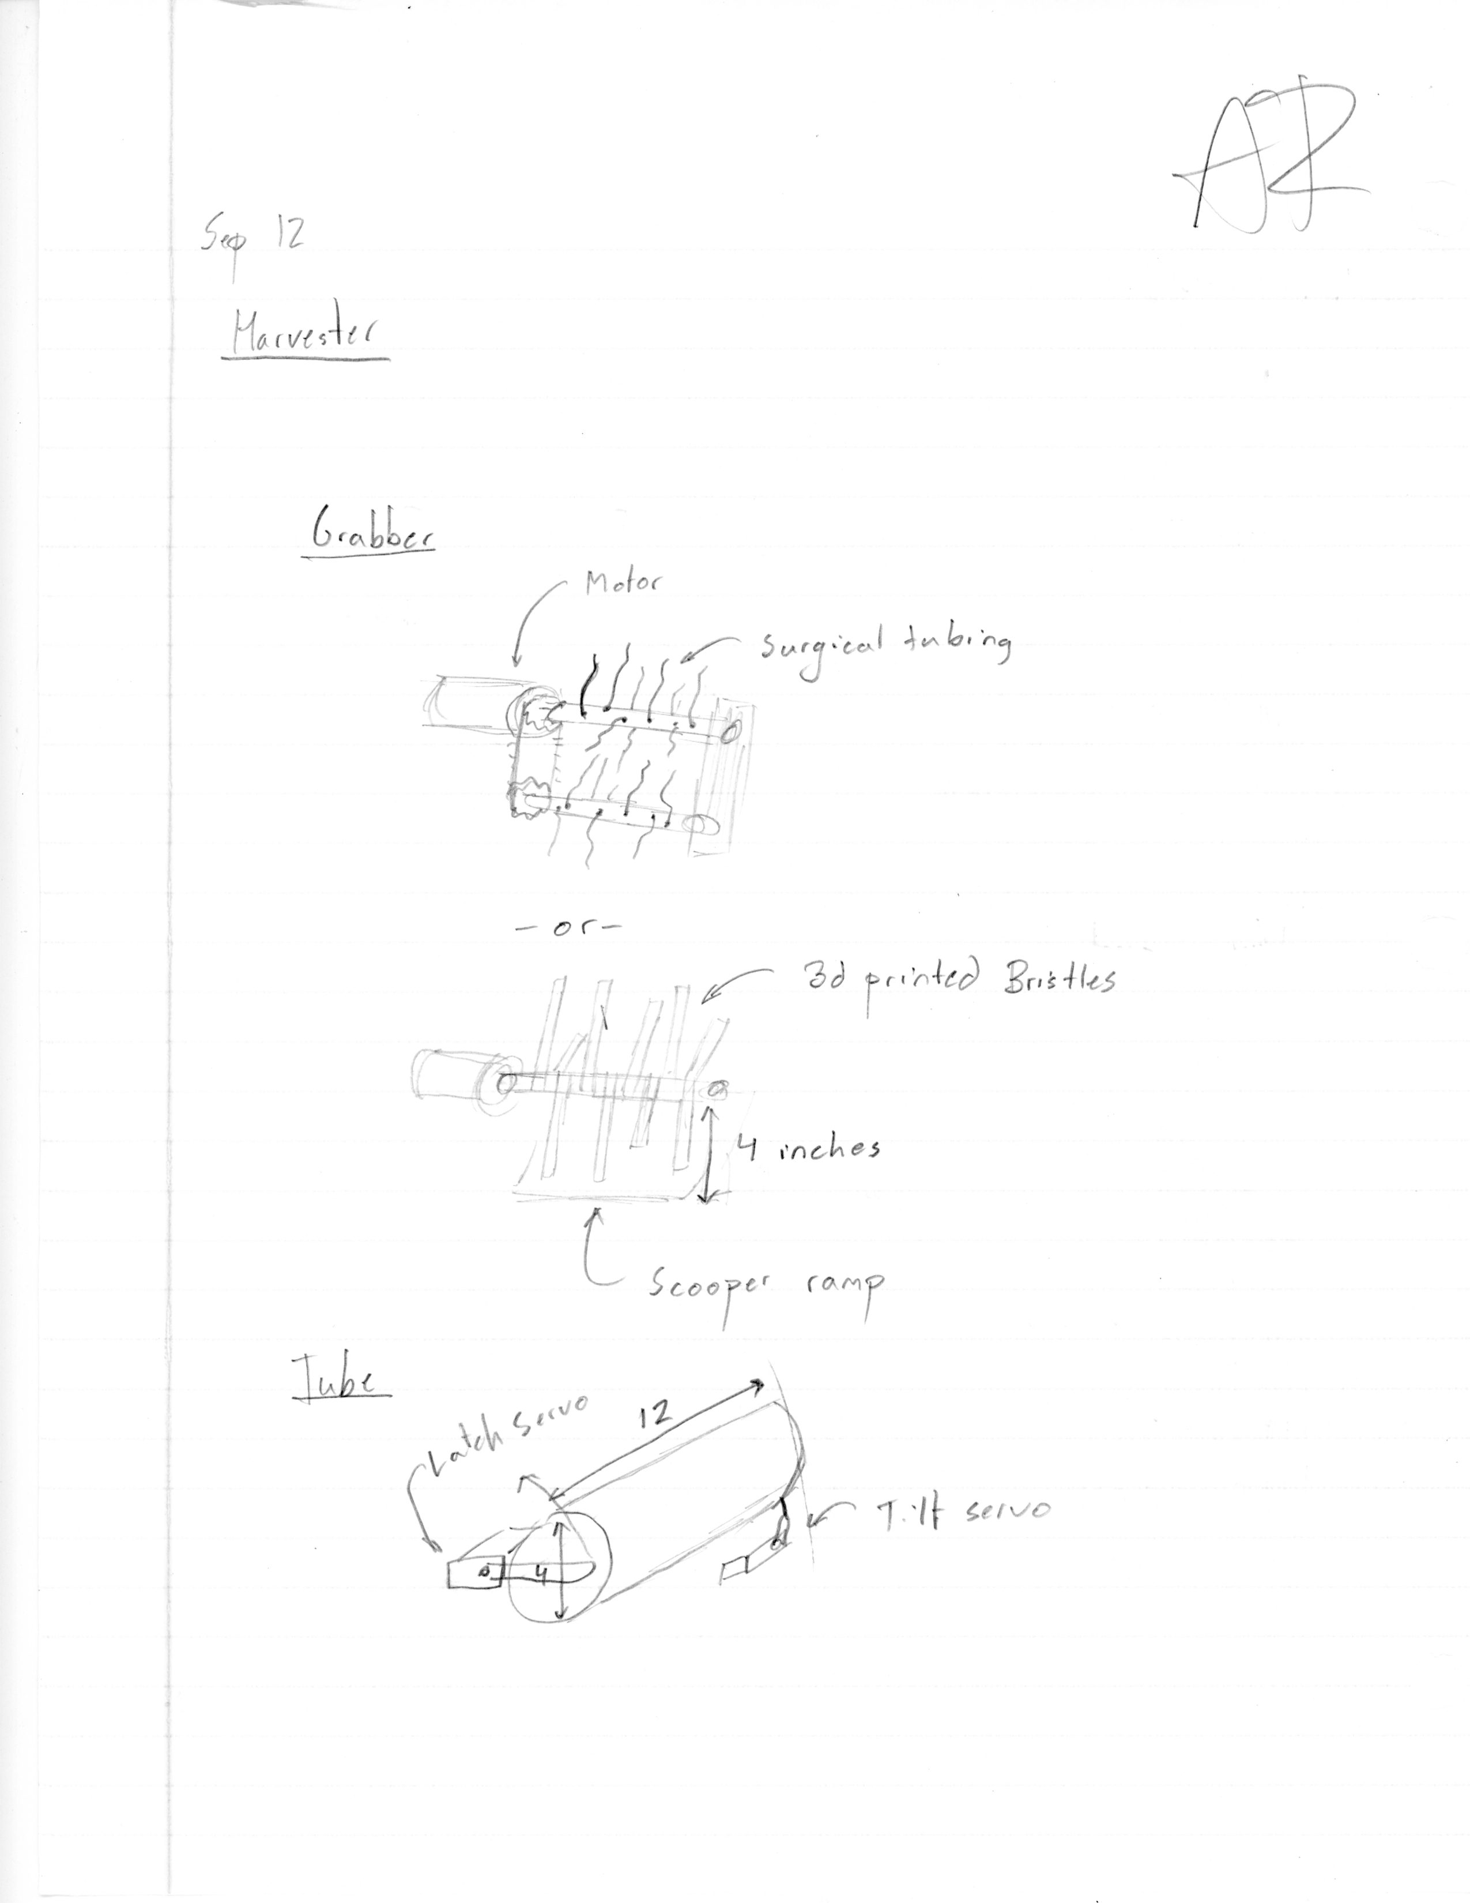 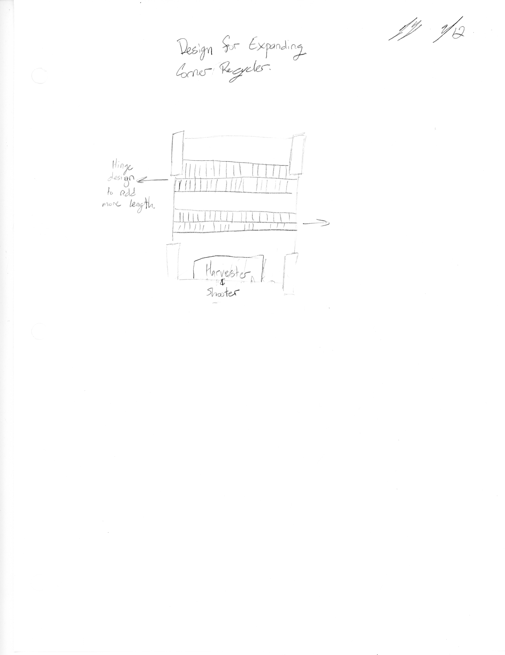

### Date: 9/13/2016

Attendance: Dylan, Troy, Mike, Arjun, Tiree, John, Seamus, Faulkner, Reed, Daniel, Maheep

#### Clean and organize the robotics room.

Reflections:

* Snacks – good time was had by all.
* Disassembled several old bots.

### Date: Week of 9/ 19 – 9/23/2016

Attendance: Troy, Mike, Arjun, Reed, Maheep, Max, Victor

#### Learning Autodesk Inventor Software Basics.

Reflections:

While researching our chassis designs in the pre-season, we had the good fortune to discover Basilisks (FTC 6002) website. In their engineering journal for ‘Block Party’ there was a section entitled Lessons Learned from the World Championships. One of the lessons learned was that “CAD is a far superior tool when used to create robots before their construction, as opposed to being used as a source for documenting.”

During this week we began to learn useful skills in both Inventor and Rhino that would help us thoroughly, and efficiently design the robot as a whole along with the subassemblies and parts that will make it up.  We started by taking the previous west coast chassis design and recreating it within inventor. Recreating an already familiar and physical design would further aid us in the process of learning inventor.

We started with recreating the wheel subassemblies on the west coast chassis. The benefit of using a physical model was to understand not only how the parts fit together but also to understand a 3D software environment, and the importance of working orthographically. When working orthographically you have a better understanding of navigating in the virtual space and part layout.

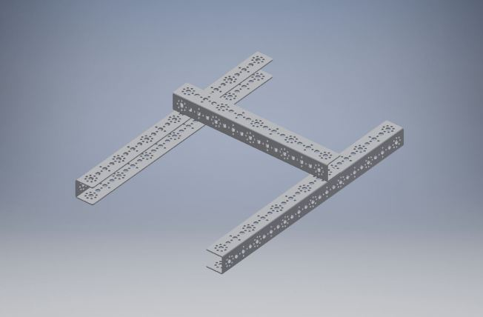 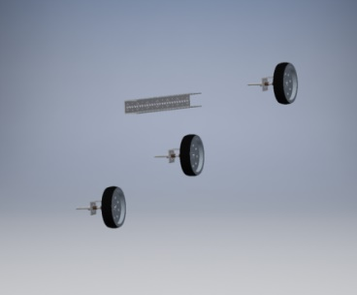

*Learning constraints in Autodesk Inventor.*

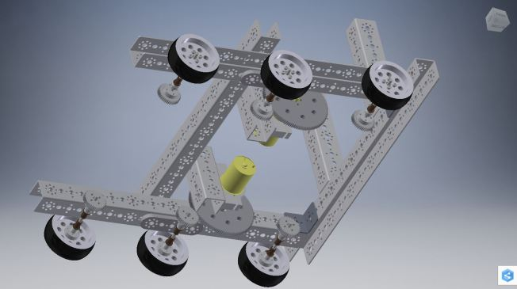 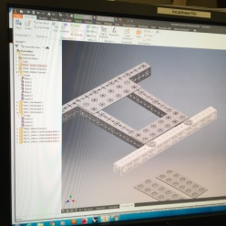

*West Coast chassis layout in Inventor*

# DESIGN/FABRICATON SUBASSEMBLIES



## Chassis/Drivetrain Version 1.0

### Date: Week of 9/ 26 – 9/30/2016

Attendance: Troy, Mike, Arjun, Reed, Maheep, Max, Victor

#### Chassis/Drivetrain – Layout and Design V.1

Now that we have learned the basics of Autodesk Inventor, we started to identify the major sub-assemblies of the robot. Using what we discovered from defining the problems associated with the game we broke the full robot design into five major components, a chassis, particle harvester, particle shooter, cap ball lift, & beacon button pusher. One of the most important and challenging aspects of the design process will be to effectively communicate between each sub-assembly design team.

After the initial frame was pieced together in inventor, we began to take into consideration the wheel base. After research on wheel types and chassis types we determined that the ability to move laterally would be beneficial for components of this year’s game. We found that RobotShop mecanum wheels provided the best stability and traction while allowing us to move laterally

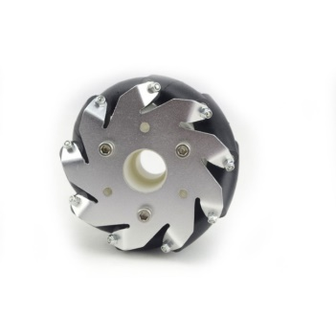 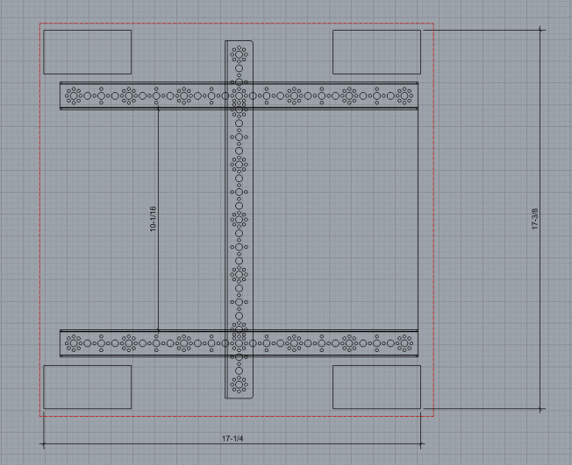

*Chassis width & height inside an 18″ x 18″ Size Constraint*

We finalized the width and length the chassis in Rhino by placing c-channel & mock wheels in a 2D plane.

### Date: Week of 10/ 3 – 10/7/2016

Attendance: Troy, Mike, Arjun, Reed, Maheep, Max, Victor

#### Chassis/Drivetrain - Motor Configurations V.1

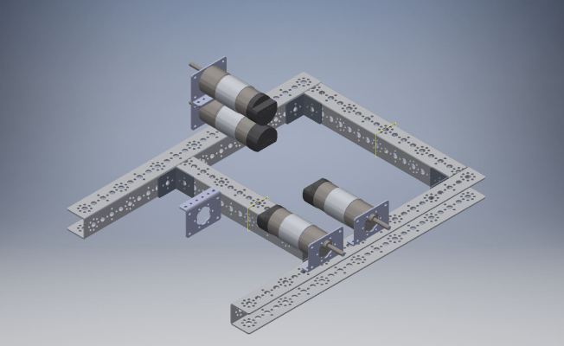

*Two different motor configurations*

The image above depicts the different orientations that we considered in Inventor. We ultimately chose a motor placement where they are next to each other and offset in height slightly. After we had finalized the motor placement we began make a sketch, a 2D model of a part or system of parts. This was a sketch of our powertrain system and their mount points to the chassis.

We then finalized our motor placement by talking to other subassembly teams on their mount to the chassis. We began to debate over the medium in which powered would be transferred the wheels. These included gears, chains, and belts, vertically mounted motors with bevel gears or direct drive.

By using CAD mockups of other subassemblies we were able to finalize motor placement and the means of transferring power to the wheels. We decided upon using a belt drive system, this would allow for flexible motor placement while accommodating for other subassembly teams components to fit within the small chassis. This in turn creates a very dense assembly that could only first be modeled in CAD. Now that our motor placement was finalized, we began power train design process in Inventor.

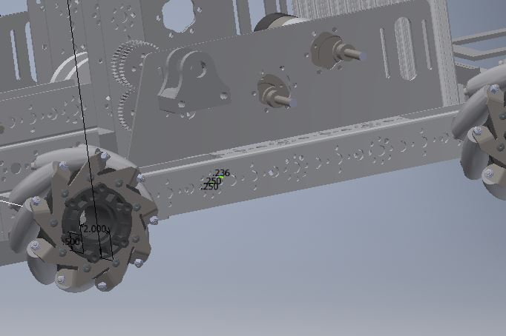 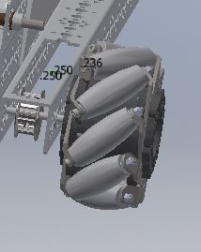

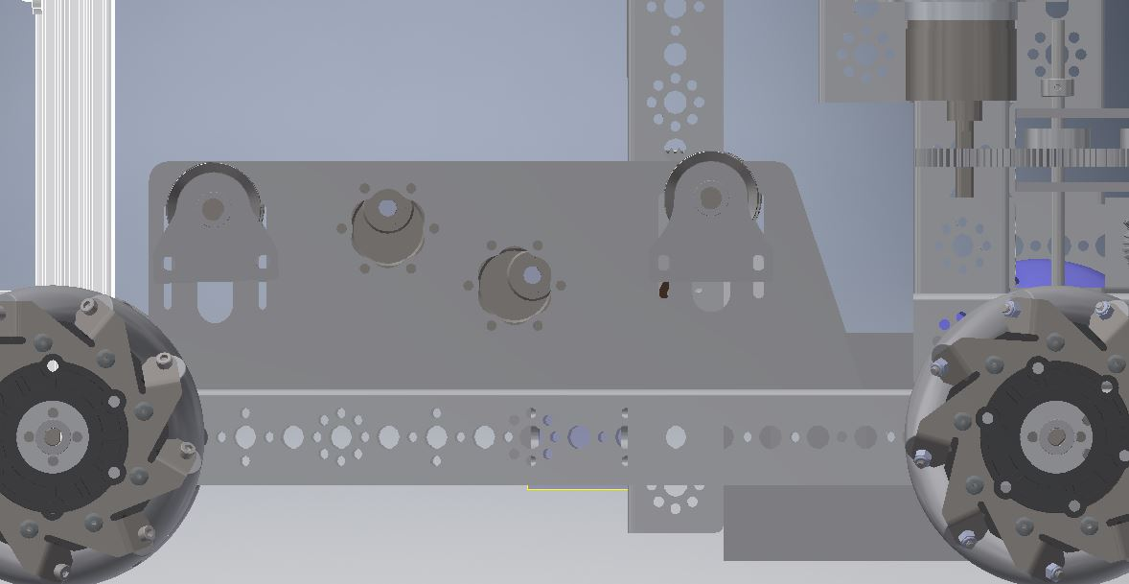

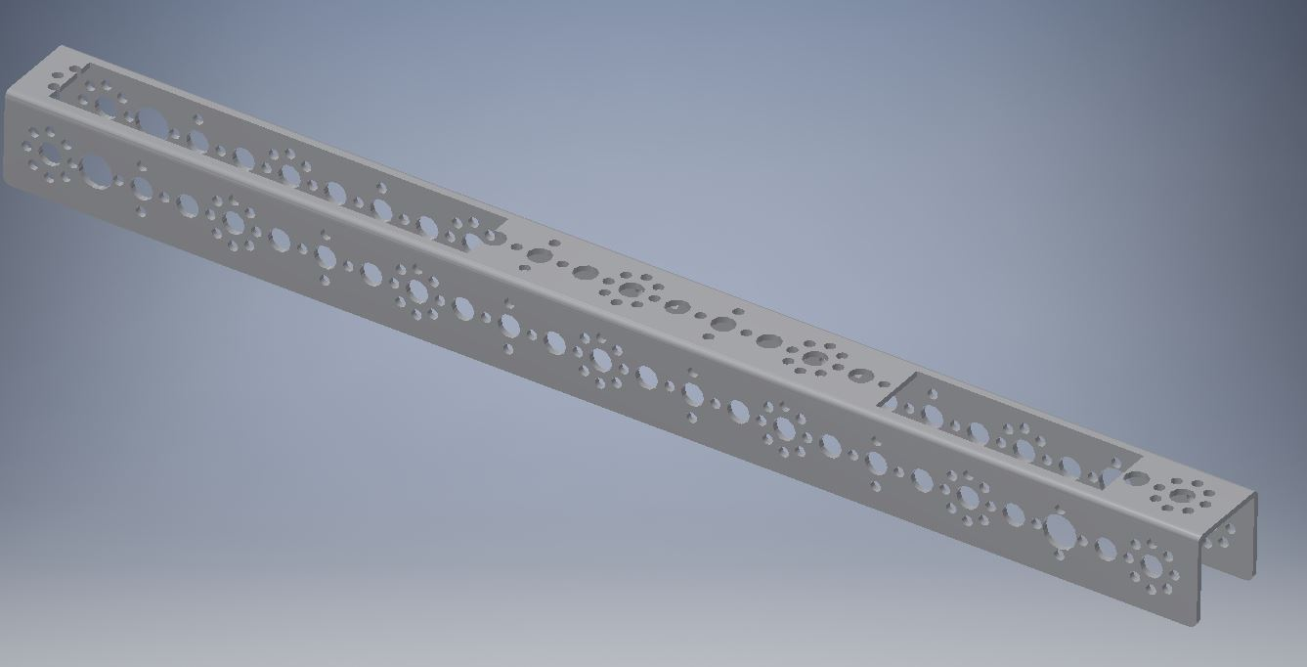

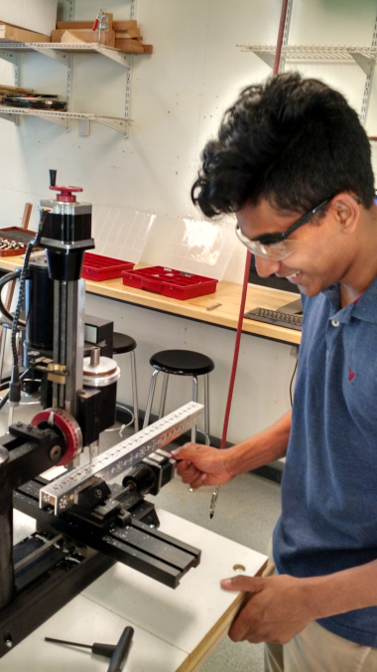 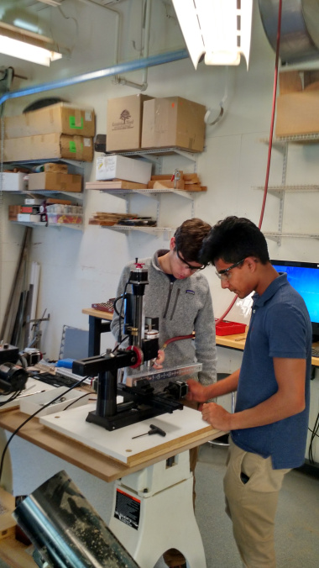

*Arjun and Mike use vertical mill to cut slots in C channel.*

### Date: Week of 10/ 10 – 10/14/2016

Attendance: Troy, Mike, Arjun, Reed, Maheep, Max, Victor

#### Chassis/Drivetrain - Power Plate Design V.1

Inventor allowed us to projected existing hole patterns and cutouts from our mockup chassis. This creates a “sketch” in Inventor which we can export into Rhino for further modification. After creating a 2D prototype in Rhino, we proceeded with physical prototypes cut out of wood on the CNC laser.

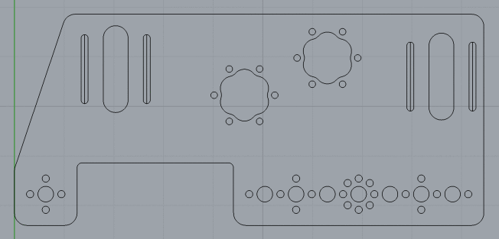

*Final 2D mockup of “power plate”*

The picture above depicts the final “Power Plate”. The plate has mount points for attachment to the main chassis, along with cutouts for motors, belt tension assembly and their mount points to the plate. The Picture below shows the process of cutting out the piece using the CNC laser cutter.

### Date: Week of 10/ 17 – 10/21/2016

Attendance: Troy, Mike, Arjun, Reed, Maheep, Max, Victor

#### Chassis/Drivetrain - Power Plate Fabrication V.1

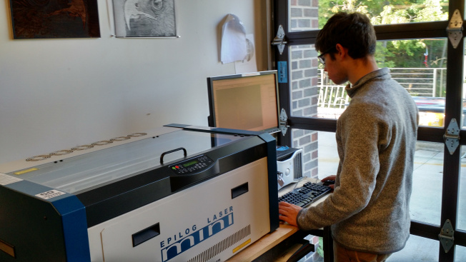

*Mike using the laser cutter to protoype parts*.

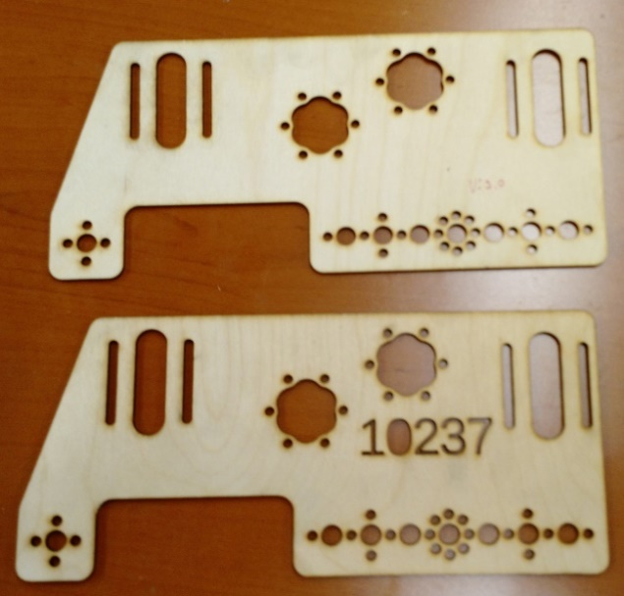

*Version 1 & 2 of drive train prototypes*

By using wood to prototype drive-train components, we can iterate faster and more often with lower cost materials that are easy to fabricate.

Once we finalized the design of the drive-train plate, we proceeded to cut it out of an aluminum plate. We used the ShopBot with a specialized aluminum milling bit.

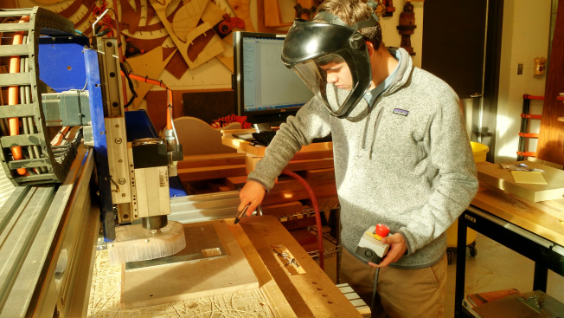

*Mike using the ShopBot CNC Mill to cut aluminum parts for belt drive system.*

*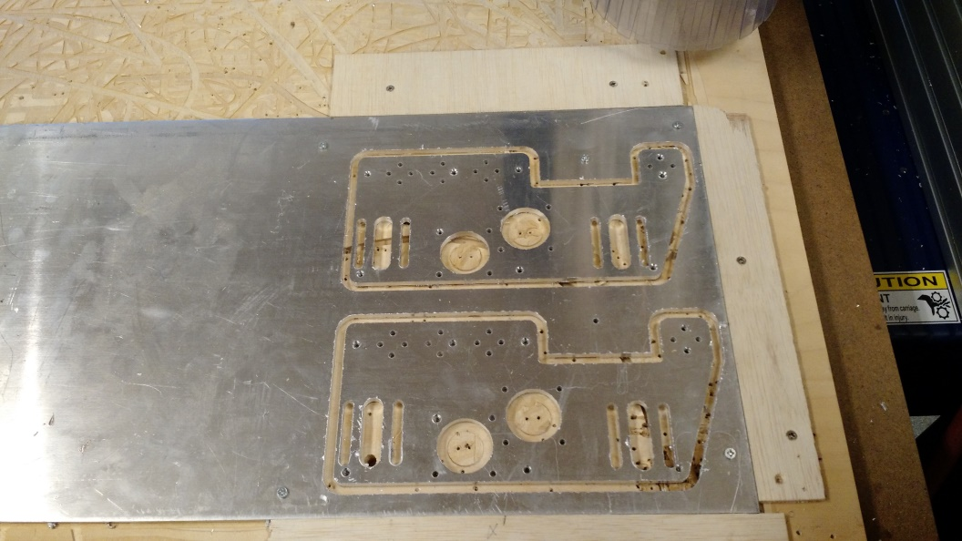*

### Date: Week of 10/24 – 10/28/2016

Attendance: Troy, Mike, Arjun, Reed, Maheep, Max, Victor

#### Chassis/Drivetrain - Layout Belt Tensioners V.1

Once we finished the main plate that had mounting points for motors and a tensioning system, we began to focus our efforts towards a system for tensioning the belts that would drive the wheels.

The belt tension system presented a few problems when designing it. One of the most problematic was that we had to design the system without it interfering with the rotation of the belt. To overcome this we designed the rear and forward tensioners separately. The rear tensioner set was shorter allowing for room underneath for the belt to freely rotate and without over tensioning the belt. After understanding the obstacles and clearly defining the problem we began to model the tensioners in Rhino.

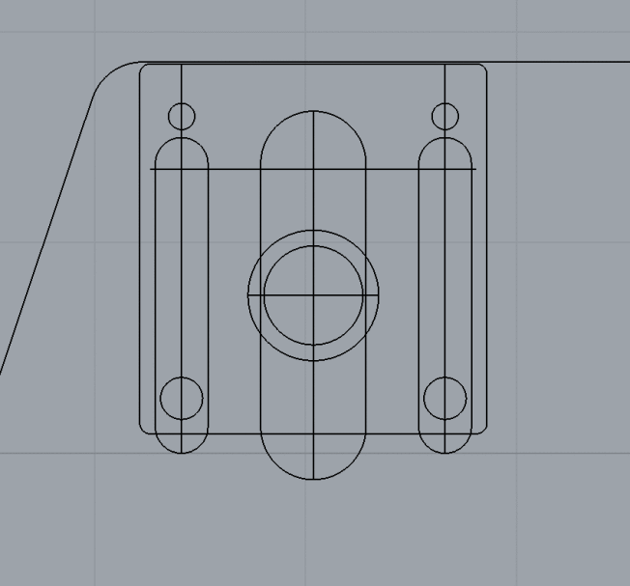

*Using drivetrain plate as a reference when designing tensioner*

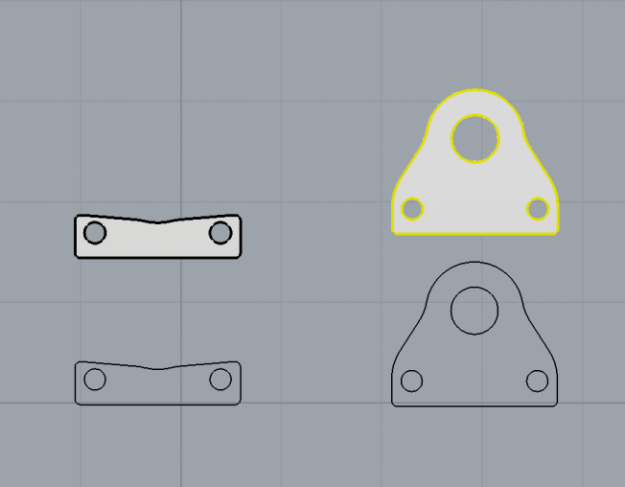

*The 2D drawing & 3D extrusions for rear tensioner created in Rhino 3D*

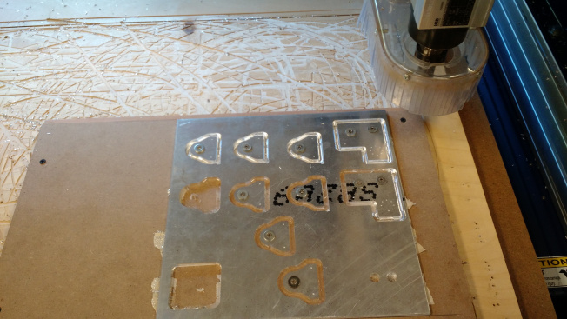

*Milling components for belt tension system on ShopBot CNC*

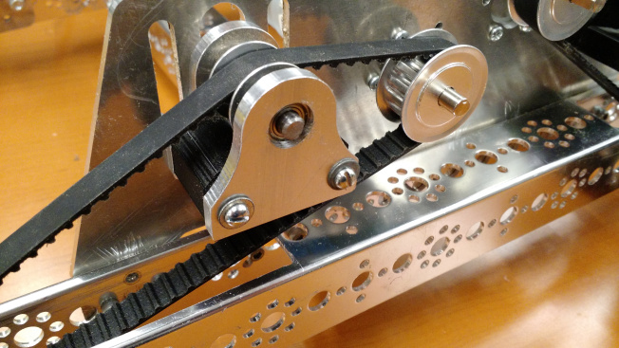

*Front belt tension system fully assembled*

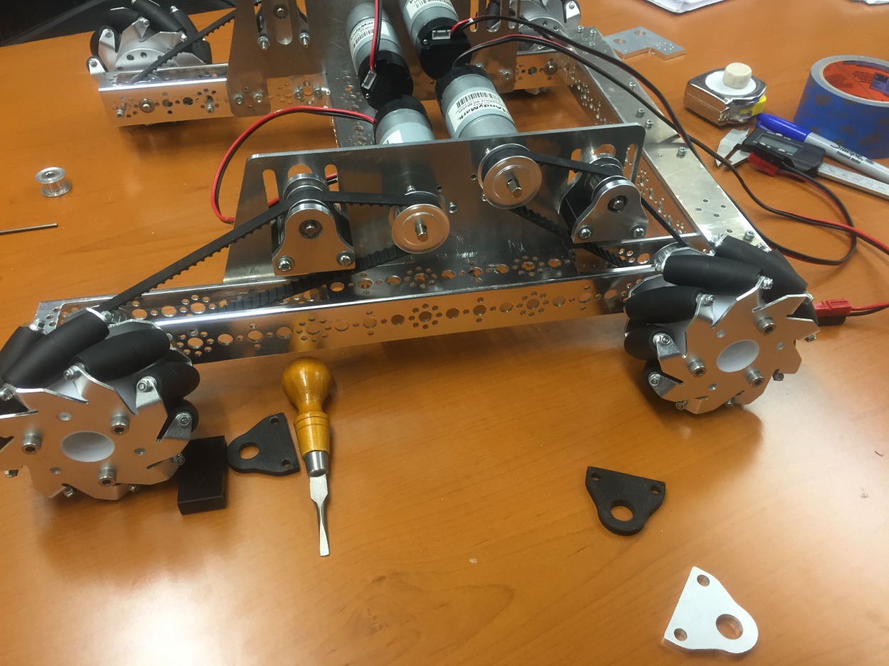

*Tension system mounted on chassis*

### Date: Week of 10/31 – 11/4/2016

Attendance: Troy, Mike, Arjun, Reed, Maheep, Max, Victor

#### Chassis/Drivetrain - Electronics Mounting V.1

Now that most of the main components have been tested and assembled together on the chassis, it was time to tackle the challenge of mounting electronics onto the robot. One of the main goals we had in mounting electronics is to keep them accessible, so they could be easily serviced if needed. One of the initial ideas was to use the center tower on the robot to mount all of the electronics. The photo below shows motor controllers mounted on the center tower.

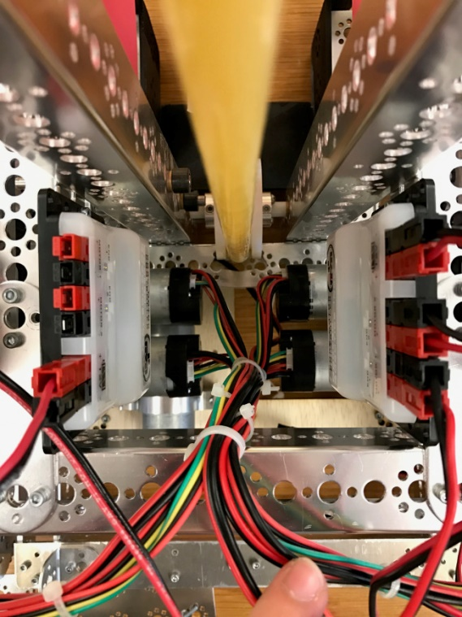 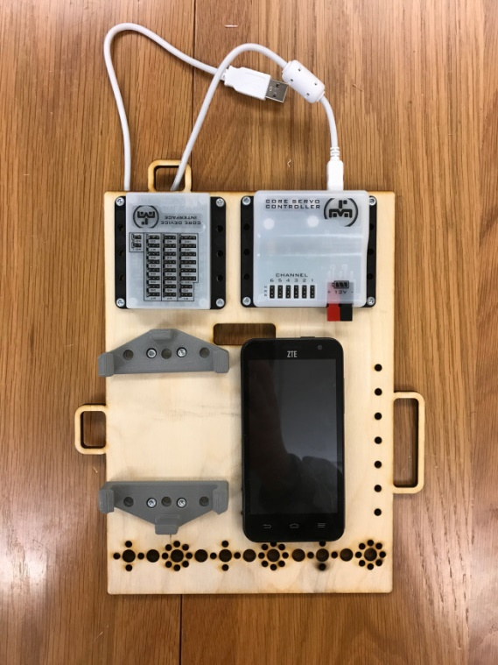

*Motor controllers mounted on center tower. Plate V.1, showing incorrectly spaced phone mount*

Mounting components in this way proved to be beneficial in a few aspects. The cables could be kept away from moving components, the system was very compact and it gave us room to work on mechanical components. However it was far from being easily accessible.

Having learned from our previous method we began to look at a component plate design and its benefits. We started with one plate that could mount the phone, sensor module, servo module, and the core interface module.

We proceeded to redesign the previously shown plate along with creating a new plate for all four of the motor controllers.

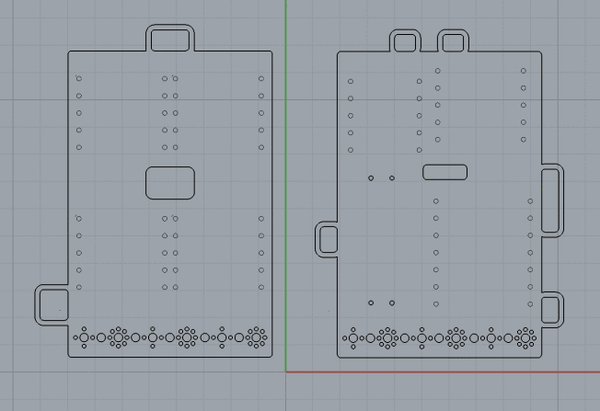

*New motor controller plate (left) & redesigned phone, sensor, servo, & core controller modules*

We proceeded to mount both plates onto the robot with electronics and wiring. After both plates were mounted, we noticed that cables did not have the proper length needed to reach across the robot. Therefore we could not bring data or power to all of the motor controllers. The photo below shows the plates with electronics attached. It also shows the wires, specifically the Anderson power cables, needing to be extended to reach the other board.

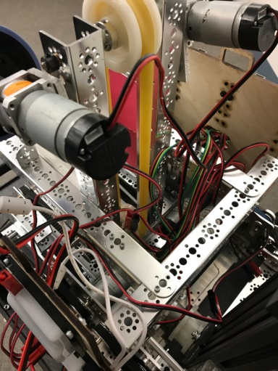 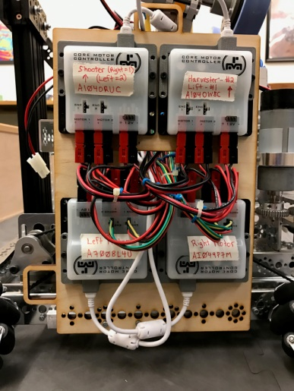 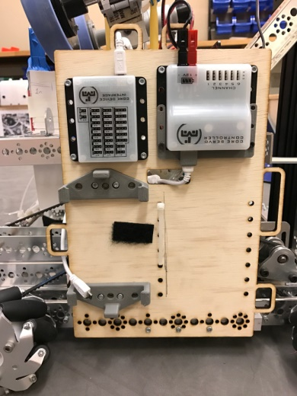

*motor controller plates*

## Chassis/Drivetrain Version 2.0

Date: Week of 11/14 – 11/18/2016

Attendance: Troy, Mike, Arjun, Reed, Maheep, Max, Victor

#### Chassis/Drivetrain – New Drive Plate Design V.2

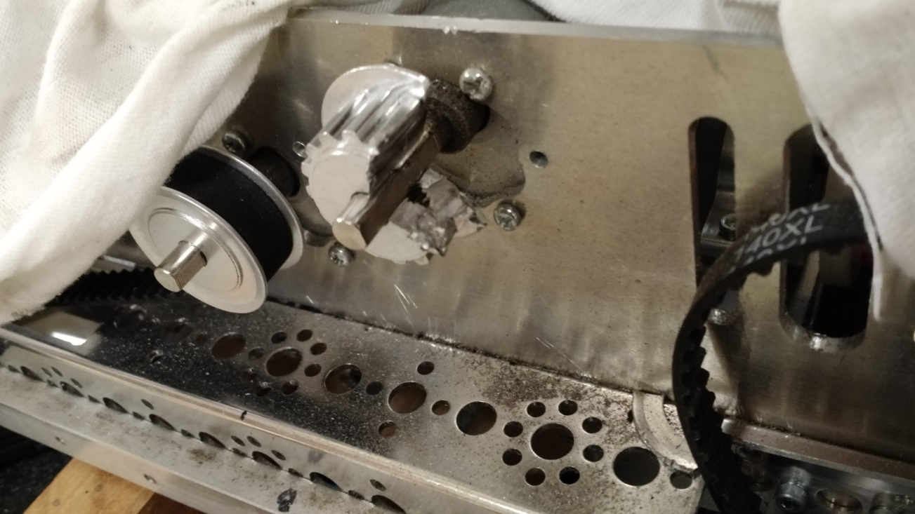

*Replacing bad motor required cutting off pulley.*

To address this issue we changed the plate design for V.2 so we could quickly swap out the motors in the case of a failure. We were able to do this through a dual plate design. A smaller plate would be fastened to the motor with the smaller screws. That smaller plate would then be attached using larger and easier to remove bolts.

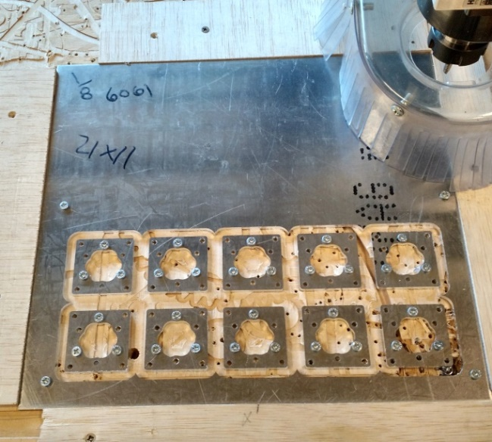

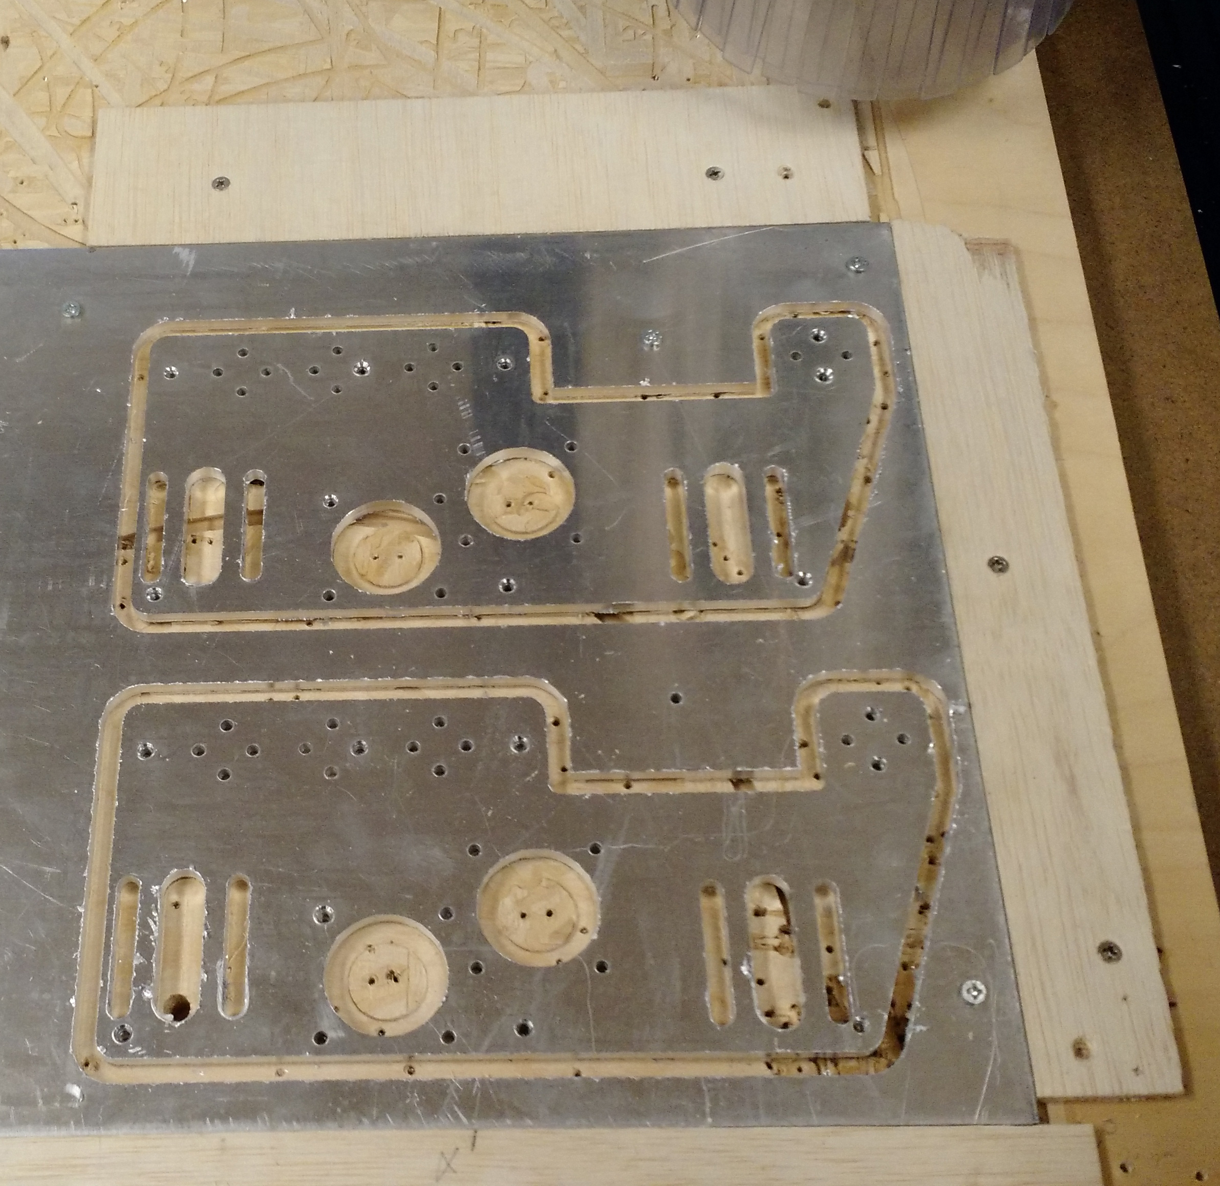

*New V.2 motor plates cut on CNC machine*

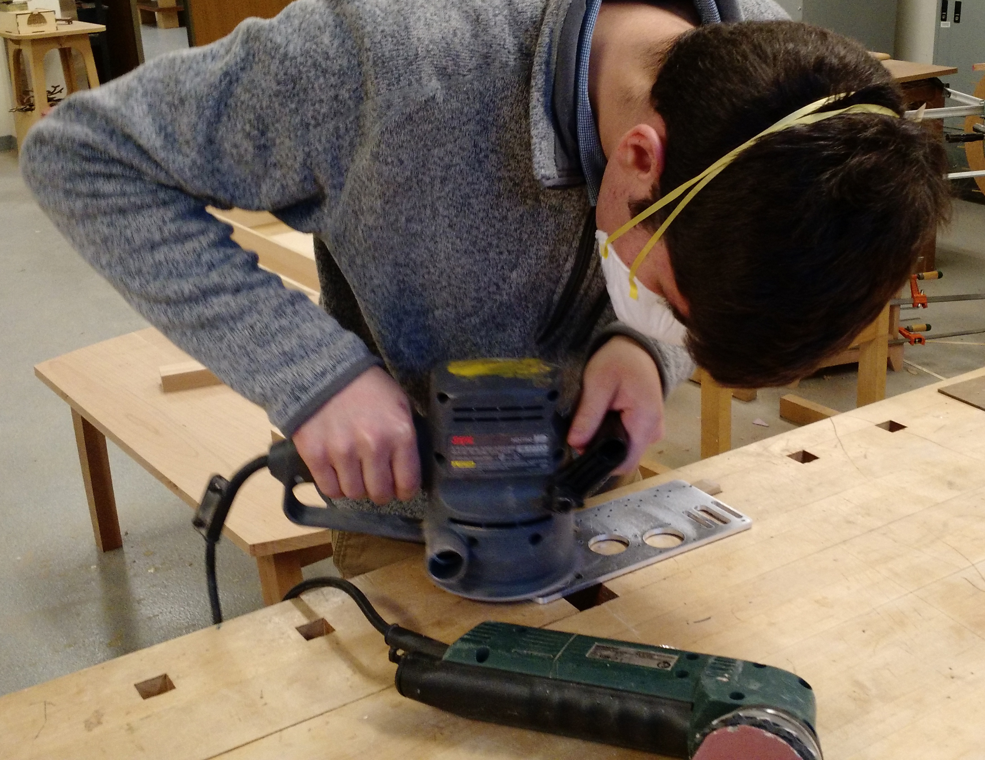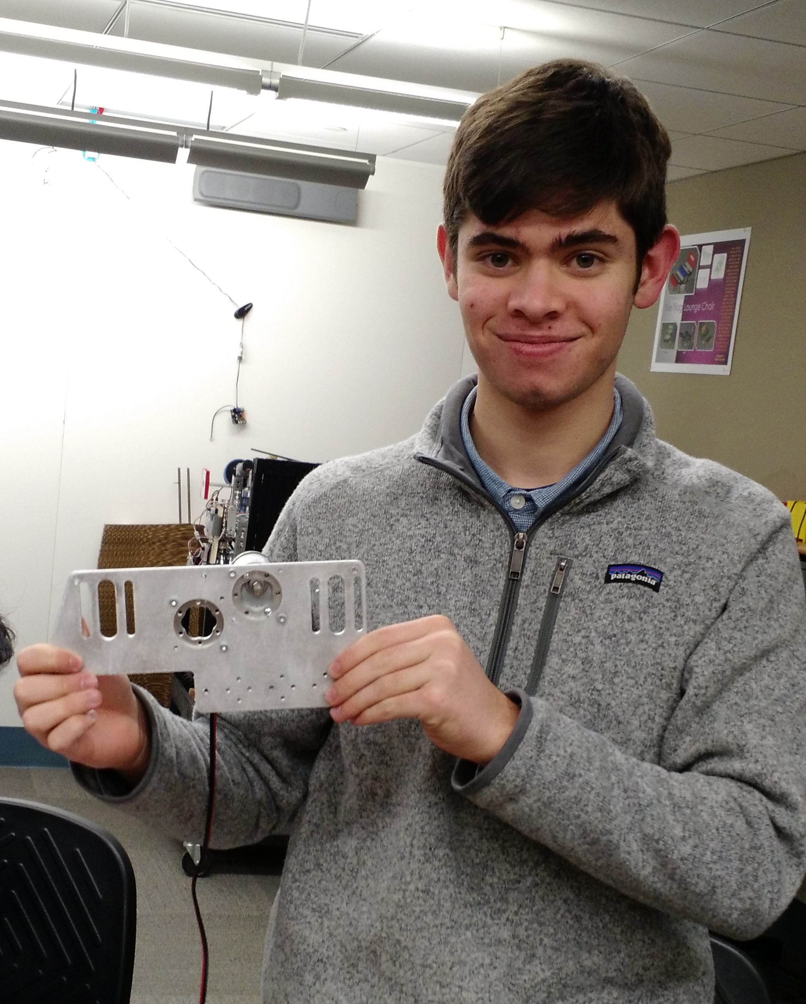

After milling the plates, we sanded them because of the sharp edges that were created during the process. This sanding also produced a brushed textured finish. This finish can be seen below in the images.

The dual plate design proved to work well when needing to quickly swap out motors if problems were to occur. Below are images of both the small and large plates attached with the motor.

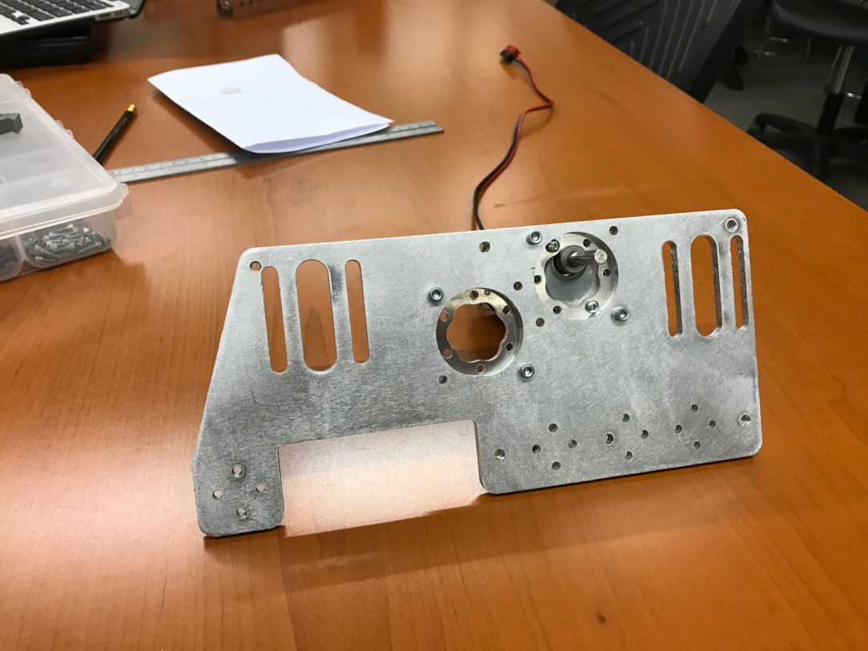

Front view of new V.2 Assembly

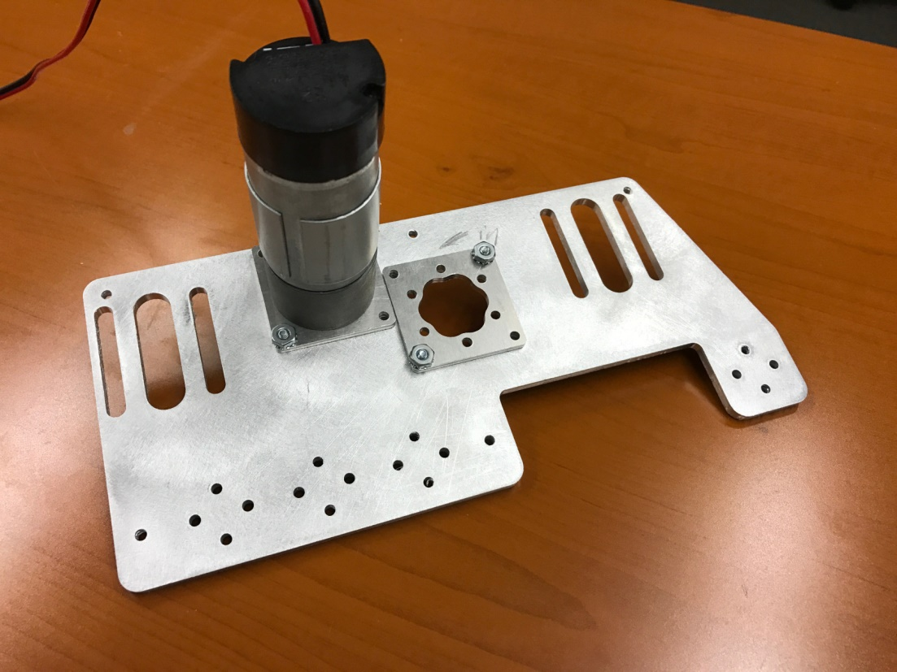

Date: Week of 11/21 – 11/25/2016

Attendance: Troy, Mike, Arjun, Reed, Maheep, Max, Victor

#### Chassis/Drivetrain – Structural Blocks V.2

After finishing and testing V1, we found that the c-channels flexed a lot under the force we were putting on them. This caused issues such as our wheel axles bending. When we started V2, we wanted a way to stop this flex and decided to use aluminum blocks that we milled down to the correct dimensions on a vertical mill. We then drilled and tapped the blocks to secure them to the c-channels. Not only did this make our robot more structurally strong, but also allowed us other opportunities such as mitering c-channels instead of overlapping them.

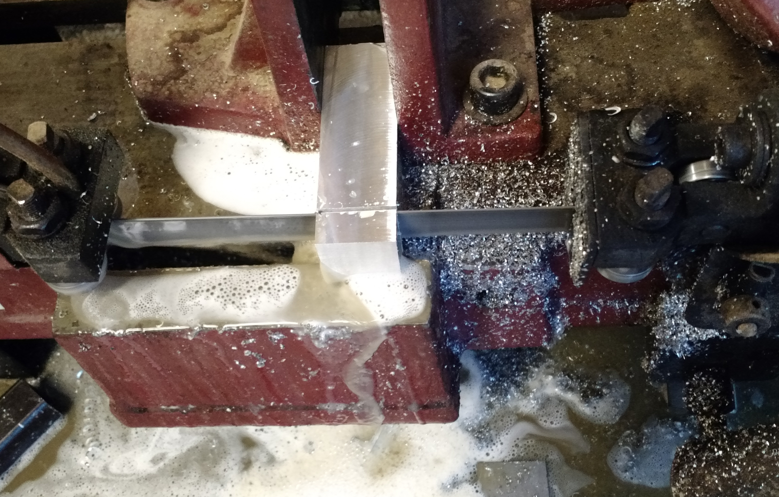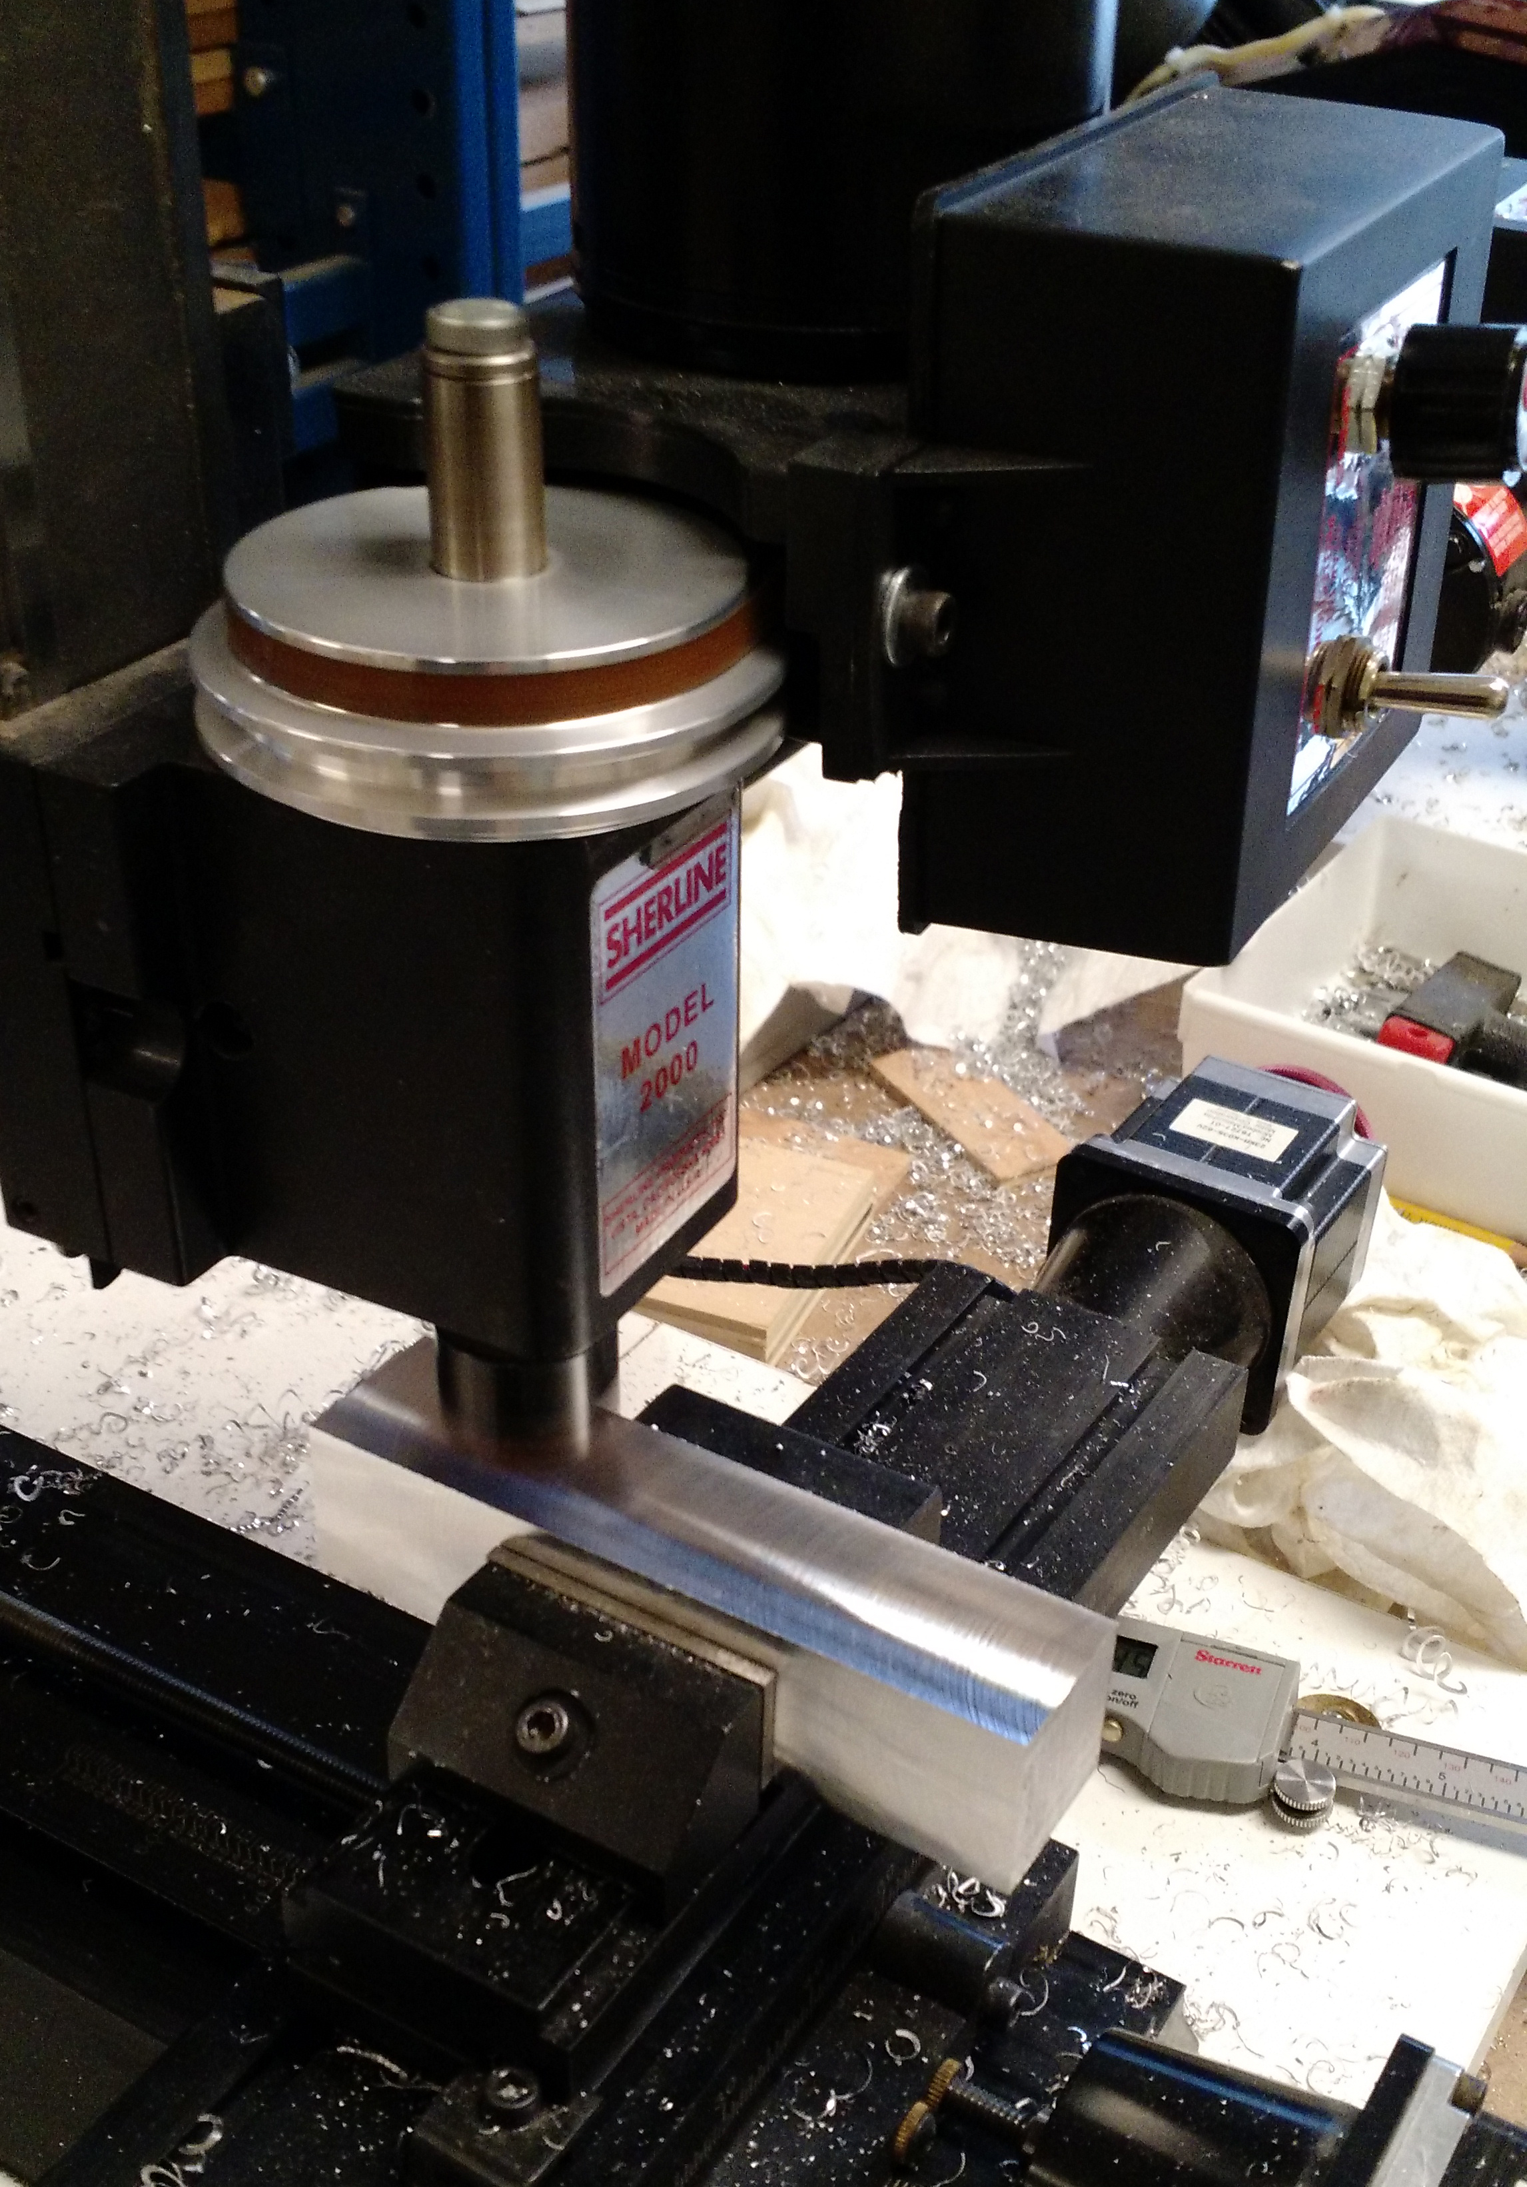

*We cut 1.25” square aluminum stock on the horizontal metal band saw and then used the vertical milling machine to finish dimension structural blocks.*

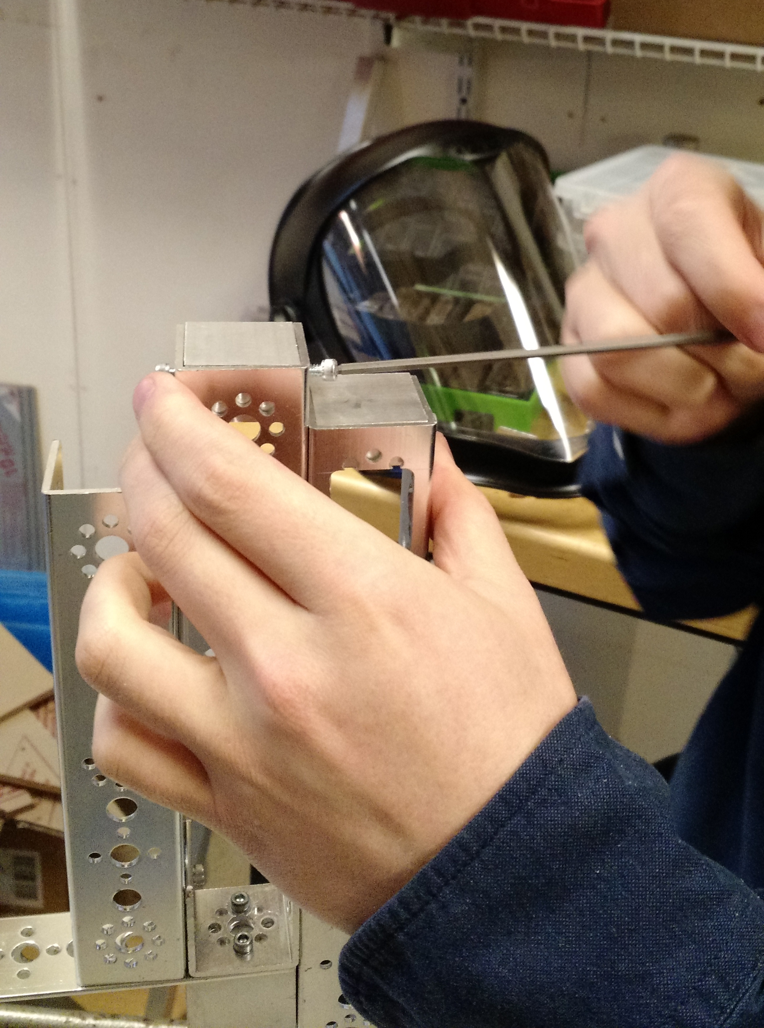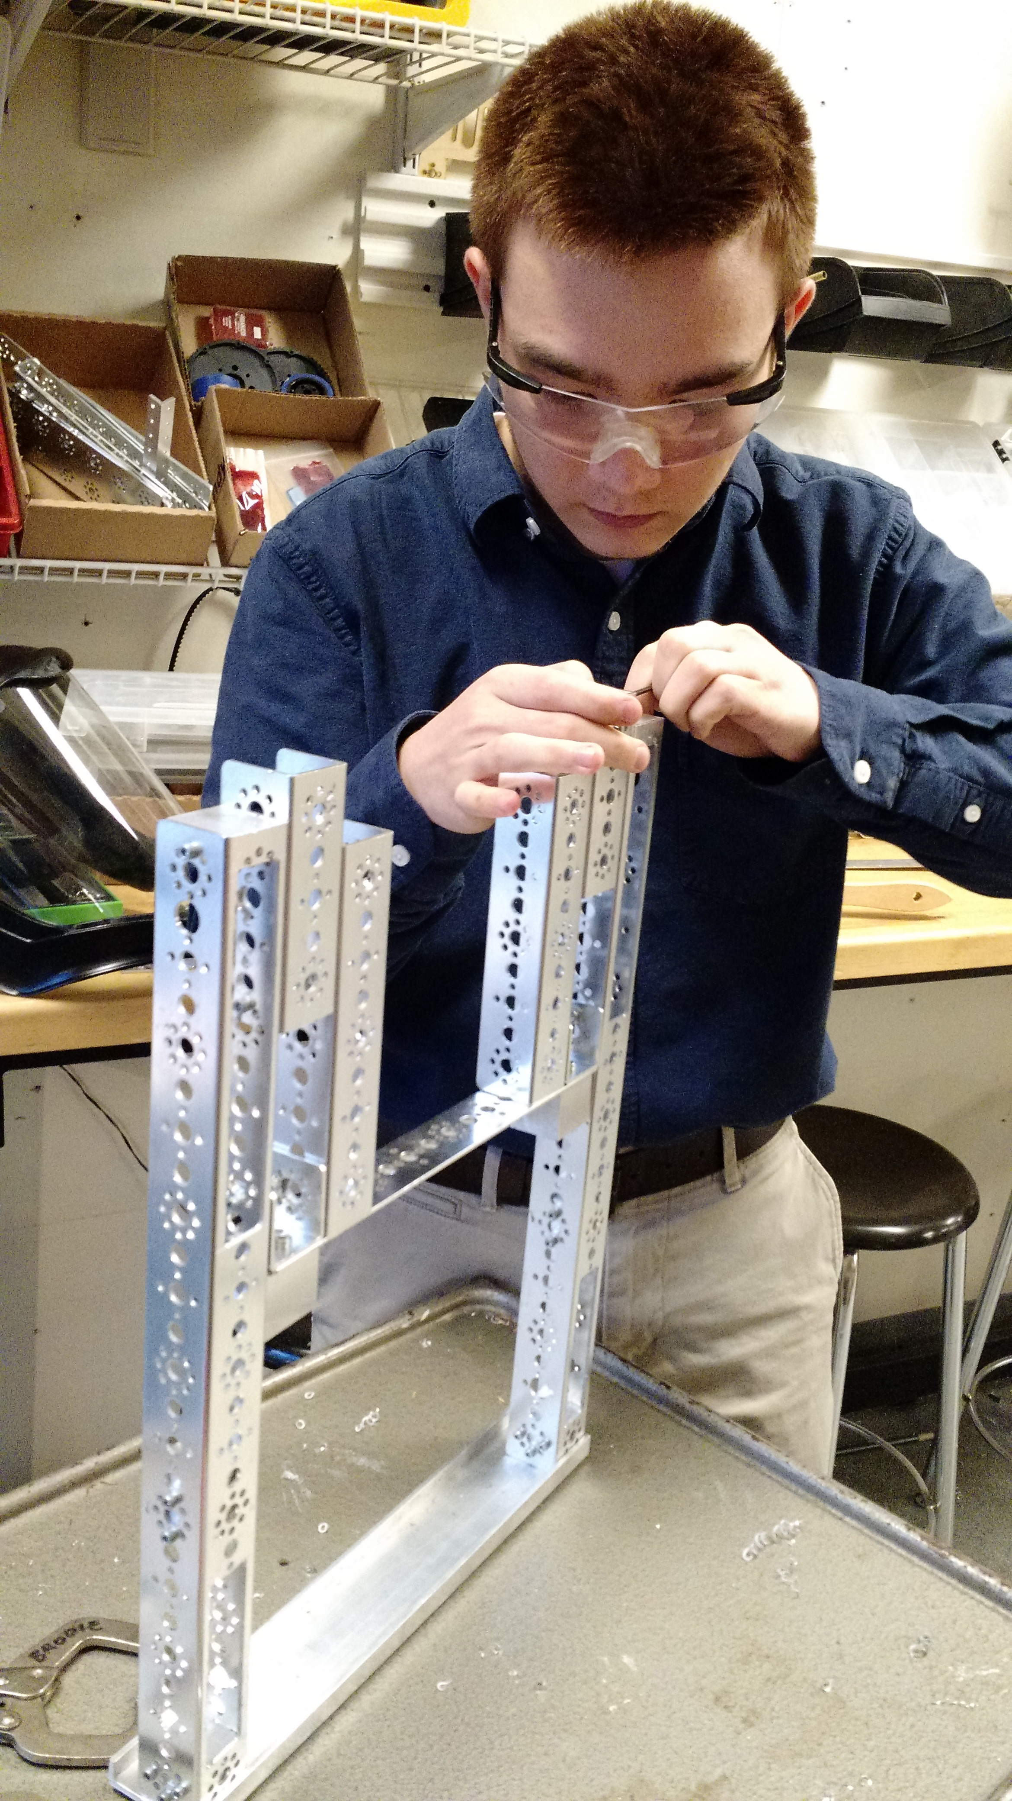

Date: Week of 11/28 – 12/2/2016

### Date: Week of 12/5 – 12/9/2016

Attendance: Troy, Mike, Arjun, Reed, Maheep, Max, Victor

#### Chassis/Drivetrain – Fabrication

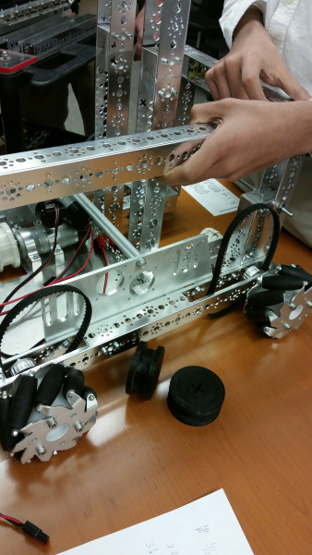 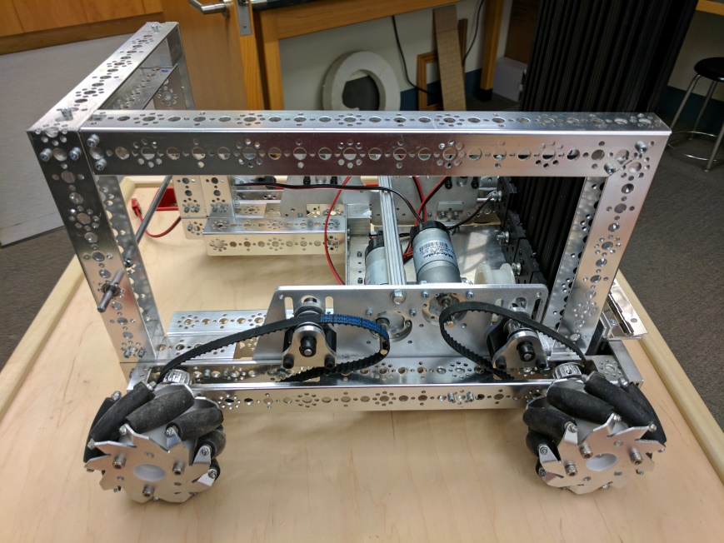

Working on Cover Plate

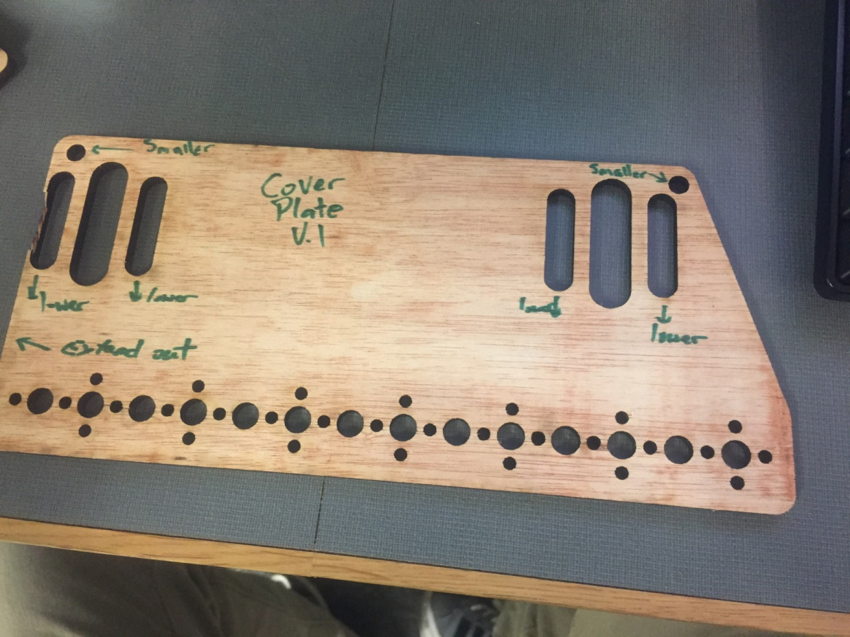

We created a cover plate to put in front of the drive belts to protect them. Used Mikes design for the drive motors as a starting point and enlarged the ovals to give more tolerance. Cut out the first draft and held it up to the robot to see how it fit. We needed to make a couple of modifications to make a better fit.

### Date: Week of 12/26 – 12/30/2016

Working on Cover Plates

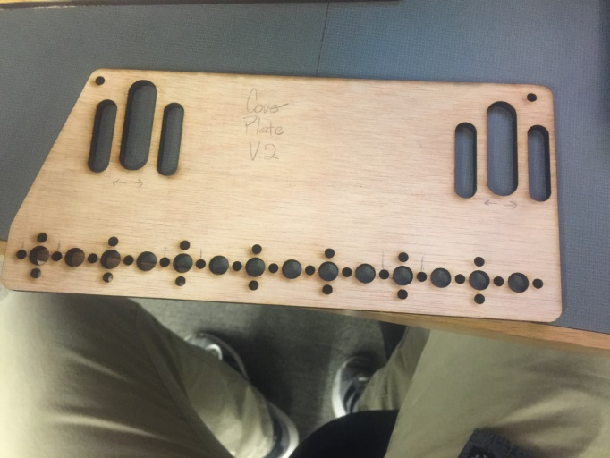 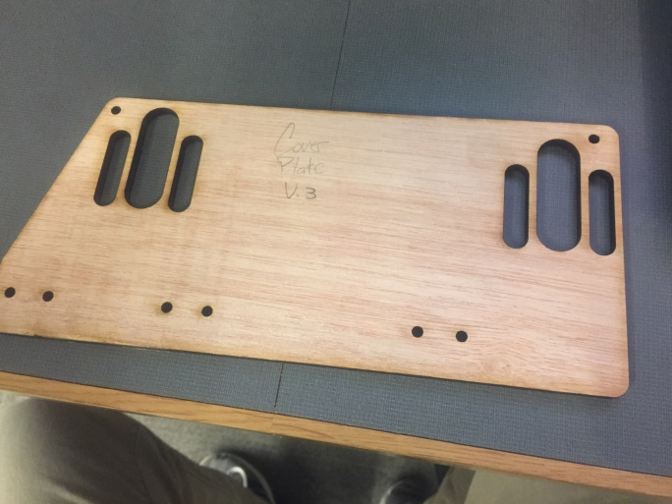

Made the previous modifications and retested the design. Found that the middle ovals were too tight around the axle collars so I marked that for modification. We also decided to cut out most of the holes along the bottom so I marked out the holes we needed.

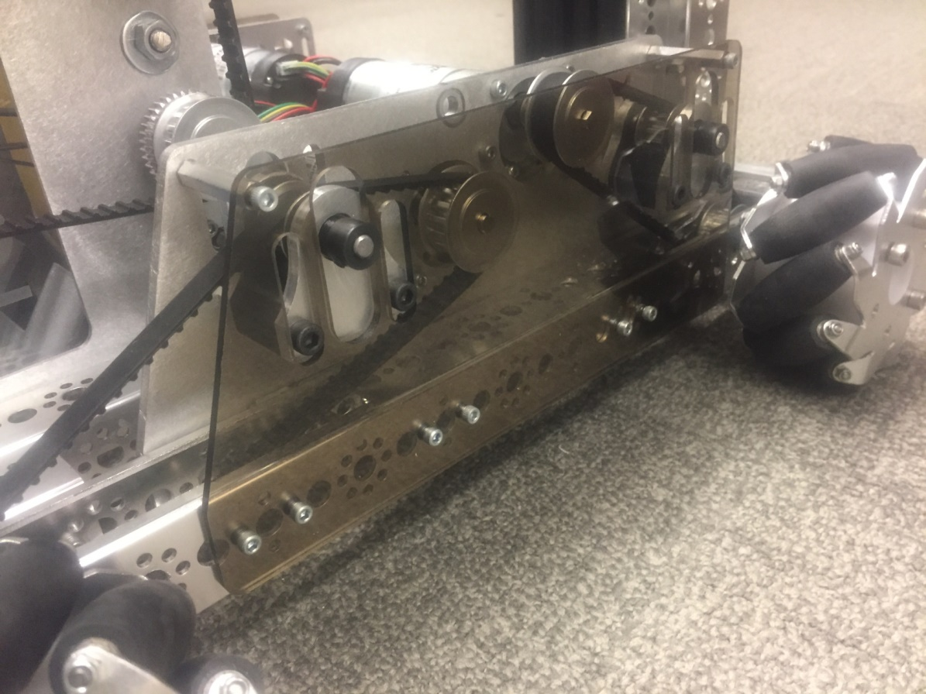

Cut plate attached to robot.

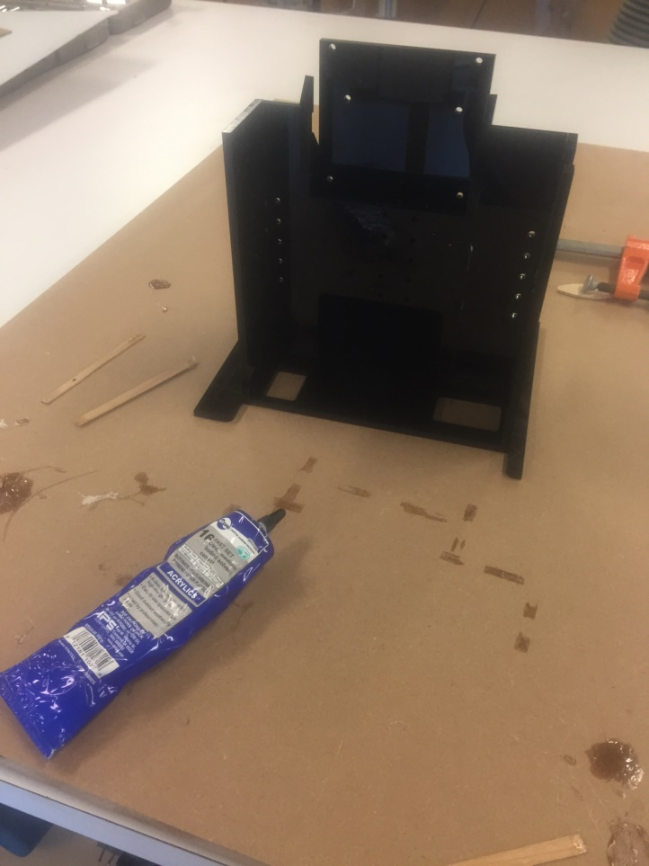

We glued together the Electronics Housing box using acrylic cement. We did this in parts using the bottom plate to keep everything square.

### Date: Week of 1/2/2017 – 1/ 6/2017

## Particle Harvester Version 1.0

### Date: Week of 9/ 26 – 9/30/2016

Attendance: Troy, Mike, Arjun, Reed, Maheep, Max, Victor

#### Particle Harvester - Layout and Design V.1

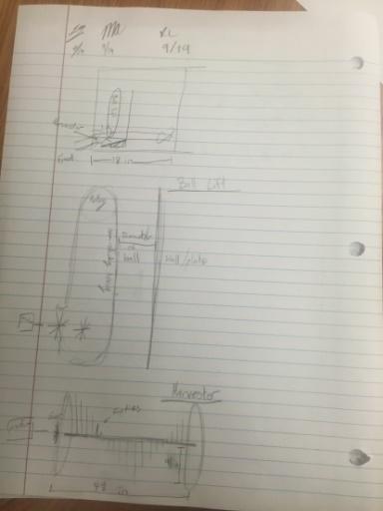

We want to go for a rotating harvester similar to a combine. We chose to go with a opening height of 4.5 inches to easily be able to accept the 3.75 diameter balls. The balls would then go to a lift consisting of two pulleys with a semi-sticky material, such as surgical tubing or treads, between them and a wall 3.75 in. from the lift. This would cause tight fit between the ball and the lift allowing the ball to rise as the lift did. We’re thinking that we would need two motors for this – one for the combine and one for the lift.

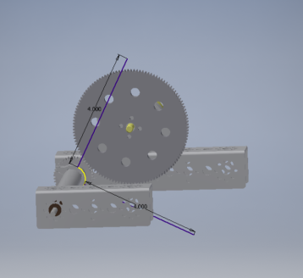 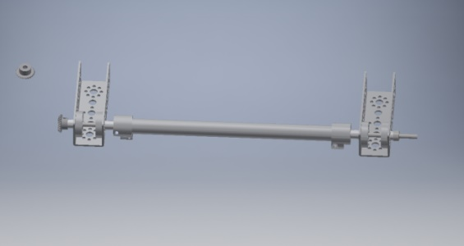

I used one of the Tetrix aluminum tubes as the rotating part of the harvester and I’m thinking that we would drill some holes in it to feed zip ties through (represented by the purple lines). I also realized that the predicted 4.5 in. seemed too long and would take up to much space so I scaled them back to 4 in. I decided to go with a 3:1 ratio for the gears since we would want the harvester to spin quickly to propel the balls to the lift.

### Date: Week of 10/ 3 – 10/7/2016

Attendance: Troy, Mike, Arjun, Reed, Maheep, Max, Victor

#### Particle Harvester - Custom Bearing Plate V.1

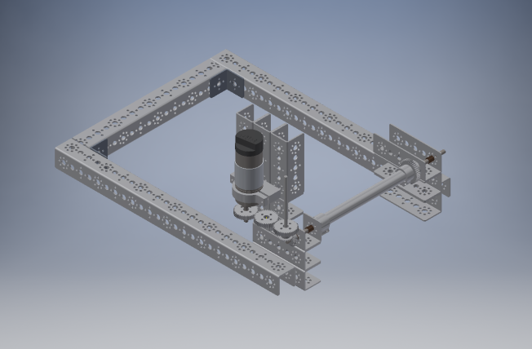

Realized that the spacing using the c-channels would not work so I aligned the gears in space and started to design a custom plate to hold the gears in place. Also, I added a gear to the opposite side of the harvester tube to connect with Reed’s lift design with a belt drive in mind.

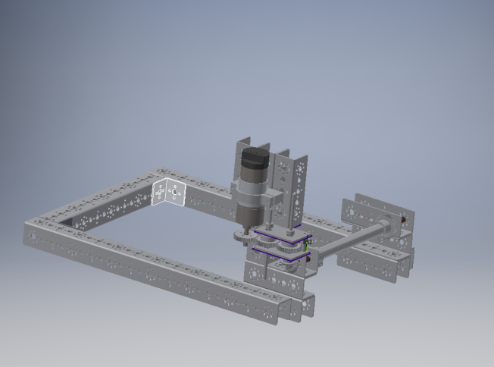

Put the plates on my design and custom cut a stand-off to fit between them. We then raised the motor mount higher to accommodate the plates and gears.

### Date: Week of 10/ 10 – 10/14/2016

Attendance: Troy, Mike, Arjun, Reed, Maheep, Max, Victor

#### Particle Harvester - Bearing Plate Fabrication V.1

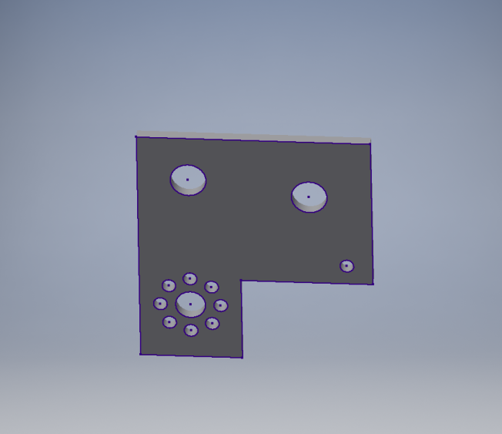 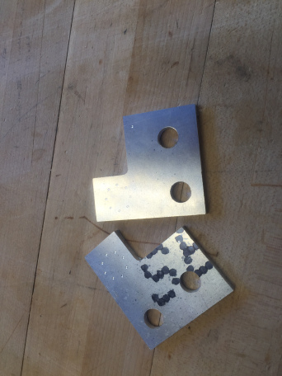

After going through multiple very similar versions this is the final design with the correct measurements, we finished the custom gear plate. We added an extra hole to put in a stand-off between the two plates to add structural stability.

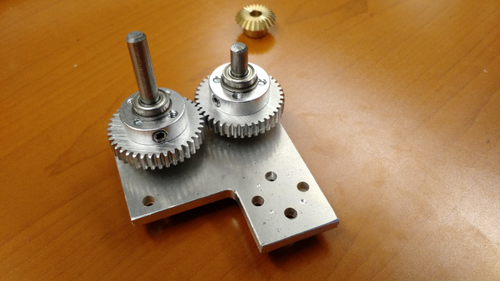

### Date: Week of 10/ 17 – 10/21/2016

Attendance: Troy, Mike, Arjun, Reed, Maheep, Max, Victor

#### Particle Harvester – Fabrication V.1

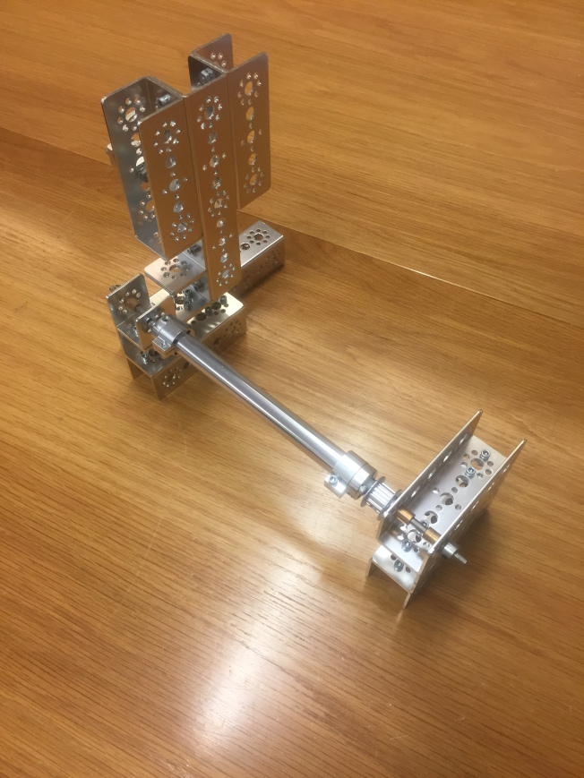

I built the physical harvester minus the custom parts. Realized after finishing that changing to the 6mm axle would be better. We can change the tube clamp hubs to the motor hubs to fit the new axle but we have to figure out a solution for the spacers and bushings.

### Date: Week of 10/ 24 – 10/28/2016

Attendance: Troy, Mike, Arjun, Reed, Maheep, Max, Victor

#### Particle Harvester - Fabrication Modification V.1

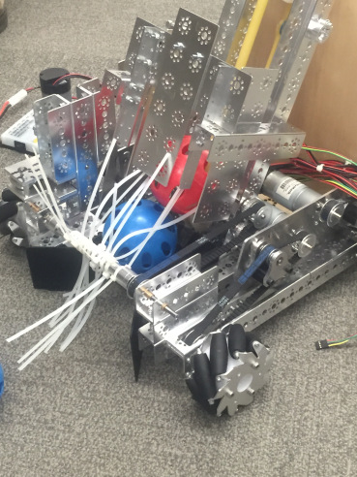 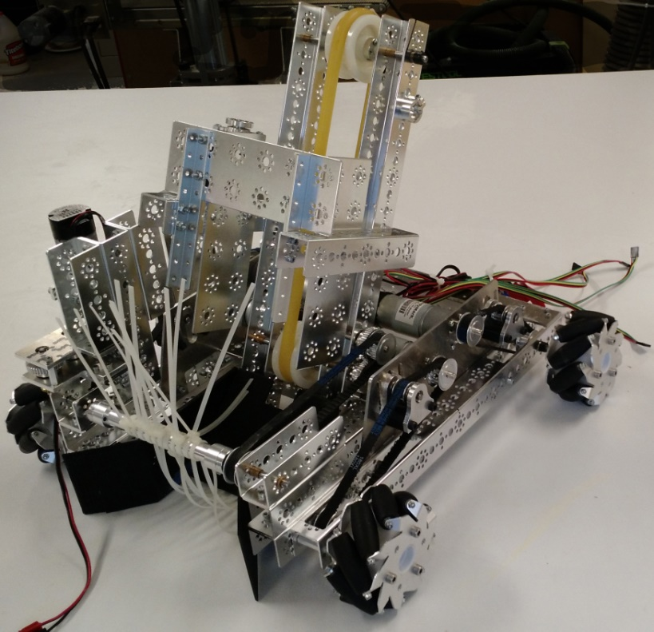

We found out that we needed to more space to accommodate the shooter mechanism. We played around with a few ideas and decided to try and tilt the lift back. This would give the shooter the angle it needs along with giving the needed space.

We also changed the paddles on the harvester since the other paddles were too stiff. We replaced them with zip ties and are working on a way to secure the zip ties down.

### Date: Week of 10/ 31 – 11/4/2016

Attendance: Troy, Mike, Arjun, Reed, Maheep, Max, Victor

#### Particle Harvester - Funnel Design and Fabrication V.1

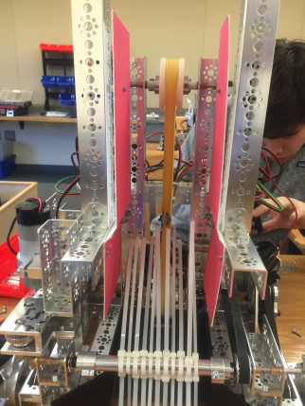 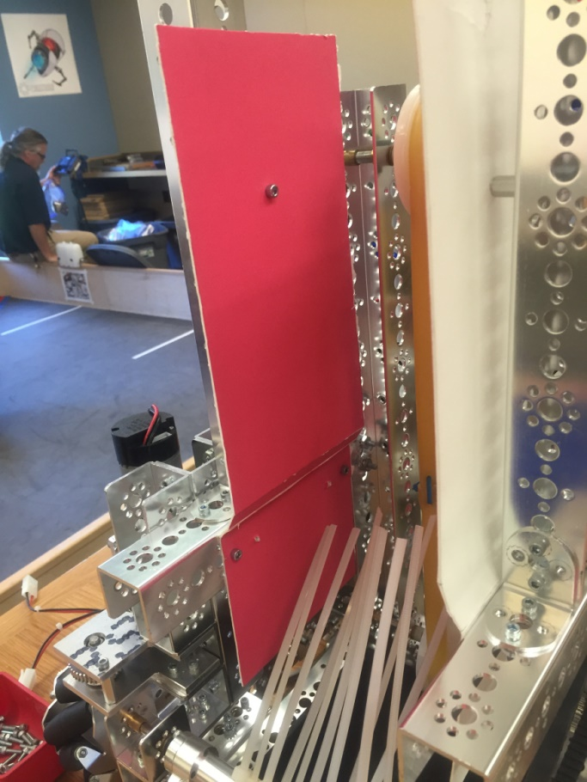

We used some foam-board to prototype an idea. I cut slits in the foam-board pieces to allow it to bend and guide the balls towards the middle of the lift so that they will align with the middle of the shooter.  I purposefully made the panels higher than I knew we needed since it would be easier to cut down than add more to.

Working on Ball Funnel

After talking with the members of the shooter group, I found out the height that the funnel needed to be cut down to. When that was done, we tested the harvester and found that the front plate didn’t reach down far enough. I added an extension to it and trimmed it up till it was at the proper length.

[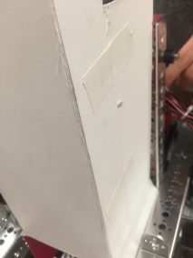](https://usroboticsclass.com/troy/img_1205/#main) [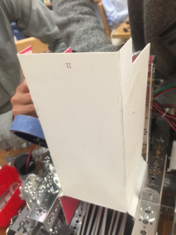](https://usroboticsclass.com/troy/img_1206/#main) [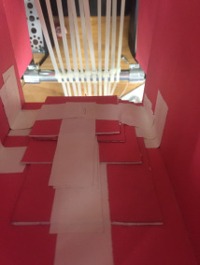](https://usroboticsclass.com/troy/img_1204/#main)

We then added a front portion to the funnel. I used the same scoring technique as the side panels on the sides of the front panel to allow it to form securing sections. I found that I had cut the side panels unevenly so that bottoms were farther out than the top. I cut smaller panels and secured them to the inside to account for the difference.

### Date: Week of 11/7 – 11/11/2016Date: Week of 11/14 – 11/18/2016

Attendance: Troy, Mike, Arjun, Reed, Maheep, Max, Victor

#### Particle Harvester - Temporary fix for Scrimmage

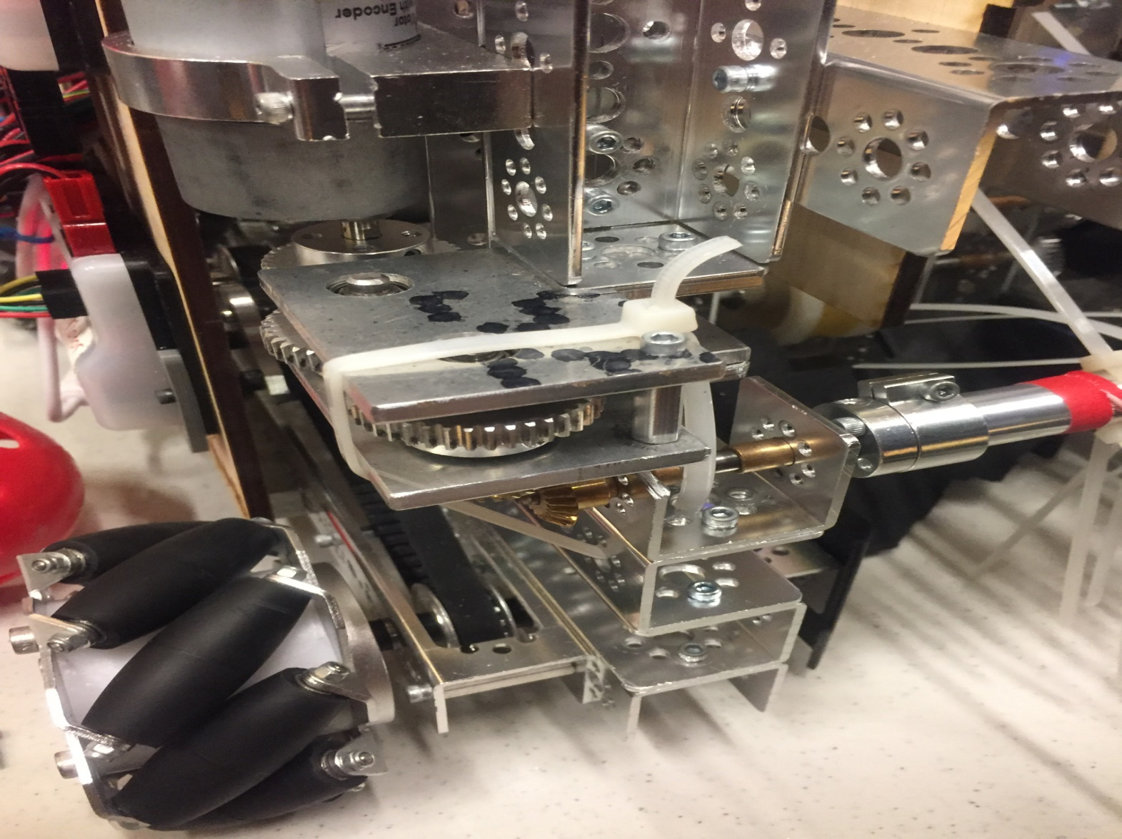

We went to the scrimmage at St. Vincent St. Mary high school. During a test run, we found that the harvester gears we grinding because the tube was now not even after the custom plate on the other side. This caused the c-channel on the gear end to bend and the gears to grind. We found a temporary fix by securing it down with a zip tie.

## Particle Harvester Version 2.0

Attendance: Troy, Mike, Arjun, Reed, Maheep, Max, Victor

### Date: Week of 12/5 – 12/9/2016

#### Particle Harvester - Redesign V.2

After out scrimmage, we started to come up with ideas to stop the gears from grinding by re-aligning them. We realized that the axle that the actual harvester was attached to was sitting too low so we started to design a plate to put under the c-channel to raise it to the proper height. We designed the plate in cad and made a wood mock-up for testing. We realized that we needed to drill out the holes in the c-channel to to piece it all together so we did that. At the scrimmage, we also found that the c-channel holding the belt side of the harvester was loose so we worked on securing that down more. We did this by drilling new holes in the c-channel to put in more screws as well as make a custom L-bracket to tie it together better. These designs seemed to work in small scale testing, but we waited until we could fully test them and gather more information before moving on to final design

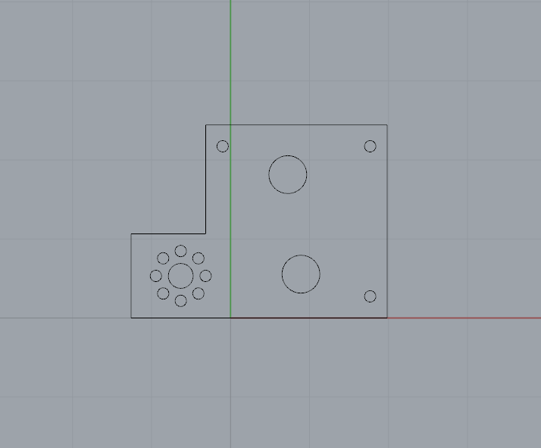 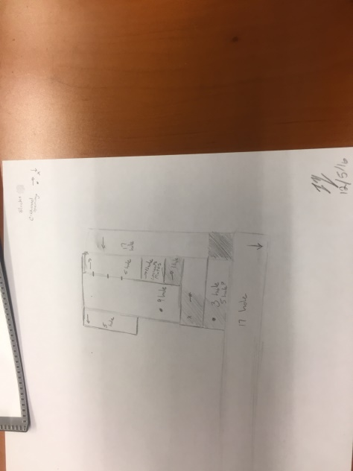

*We planned out a new design with a full front c-channel to add to overall stability of the robot and Troy sketched out a plan for remaking the harvester on V.2.*

### Date: Week of 12/12 – 12/16/2016

Attendance: Troy, Mike, Arjun, Reed, Maheep, Max, Victor

#### Particle Harvester - Fabrication V.2

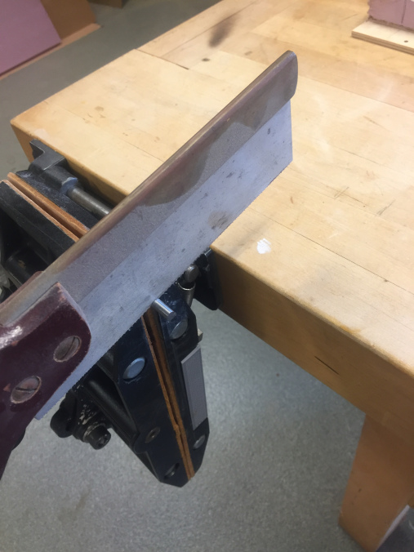 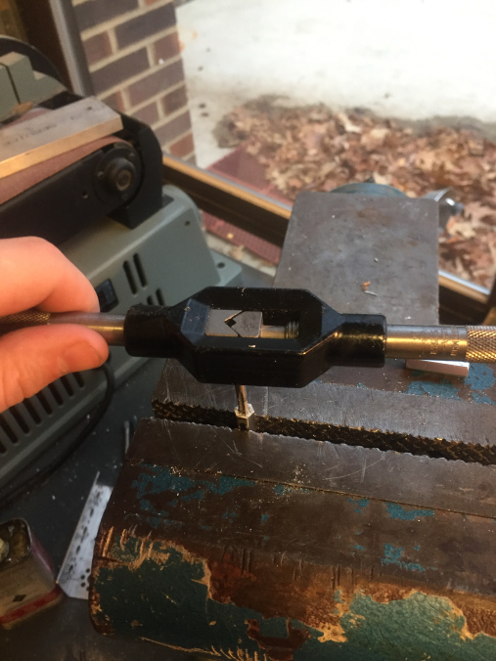

Lined up the gear plate on one of the structural blocks and determined where holes needed to be drilled. Drilled out two holes to align the plates and a third hole for extra support. After drilling the holes, I tapped them.

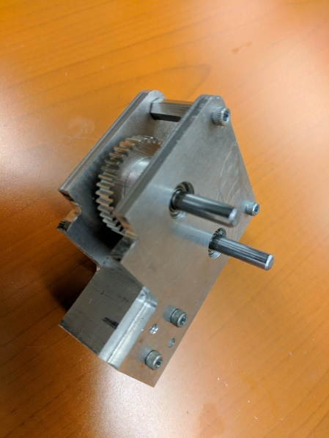 *Finished V.2 harvester gearbox*

### Date: Week of 12/ 19 – 12/23/2016

Attendance: Troy, Mike, Arjun, Reed, Maheep, Tiree

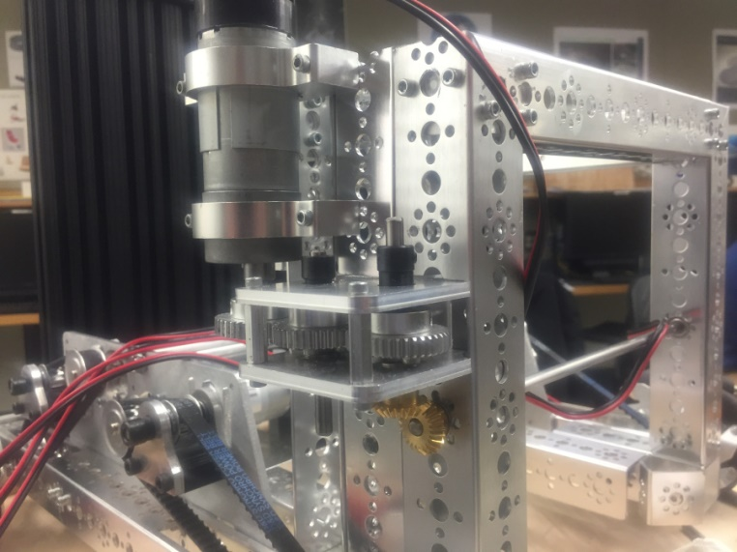

Finished and assembled bevel gear plate and attached motor. We cut the c-channels to put them all in line with the top of the bracing frame. We cut and drilled an additional block in the far c-channel for stability since we plan to add an extra c-channel to the back for support similar to the other side of the robot.

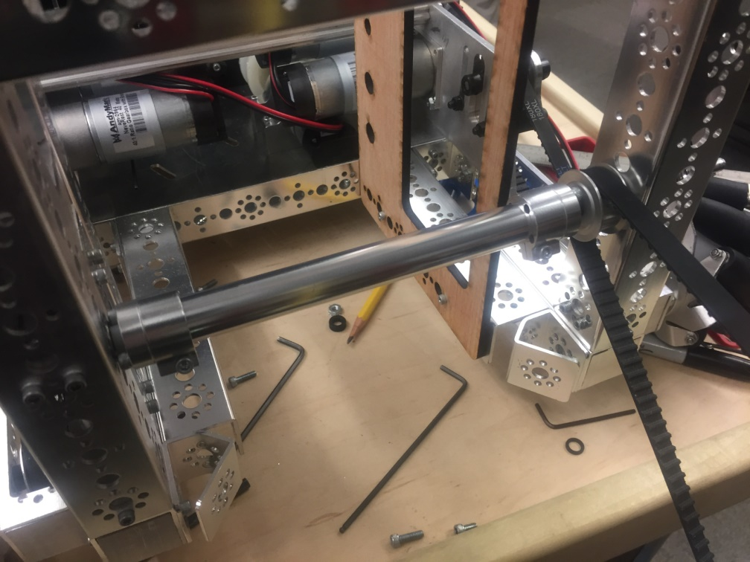

Ground flats into the axle to secure set screws. Drilled out the threading on the axle hubs to make them line up flush with the tube clamps. Put the tube and pulley onto V.2 following a similar layout to the spacers on V.1 adding extra spacers around the pulley to help it stay in line better. Tested it with the current mock-up of the ball lift to make sure everything was running smooth.

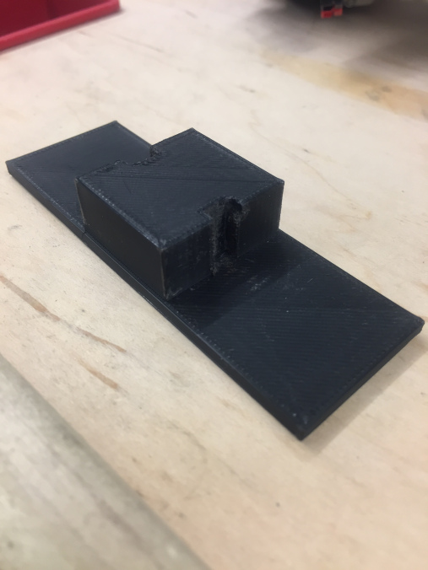 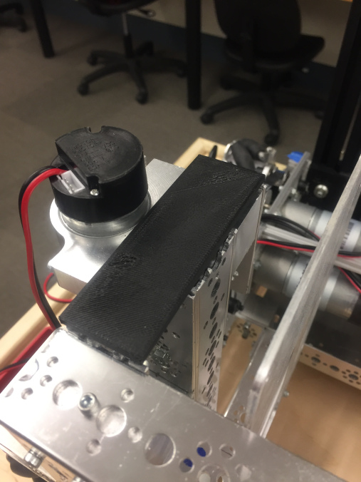

Tiree and I took measurements of the tops of the cut c-channels, went into inventor and designed a cap to cover the sharp edges. We designed it to plug in to the middle c-channel making it easily removable if we need to access the space. We were slightly off on our tolerances for the screw channels, forgetting that the 3d printer printed inside of our cad lines rather than outside. We took a file to these sections and made them large enough to slip over the screws.

## Particle Transfer Version 1.0

### Date: Week of 9/26 – 9/30/2016

Attendance: Troy, Mike, Arjun, Reed, Maheep, Max, Victor

#### Particle Transfer - Design V.1

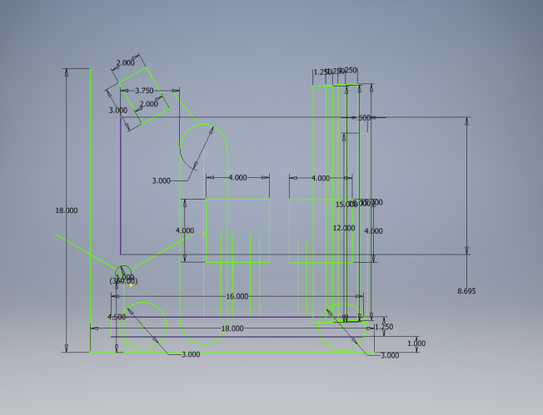

Bottom left corner: Small circle with 3 lines attached – Harvester

Top left corner: Slanted rectangle – Wheel launcher

Middle: Slot/oval – Lifting belt

Middle: 2 squares – Button pushers

Right: Rectangles – Lift

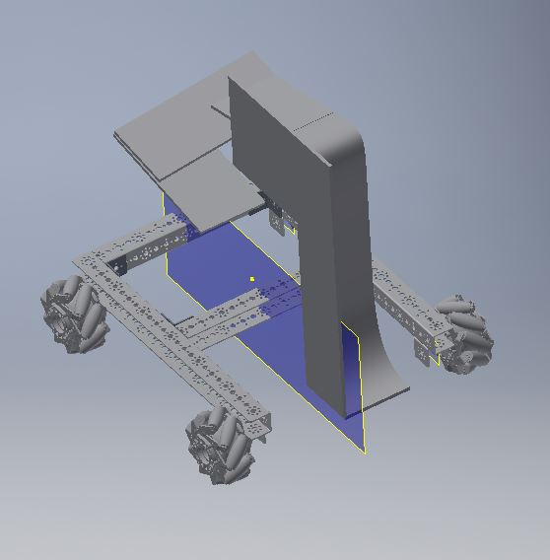

We designed a slope to move ball up, then down into a shooter.

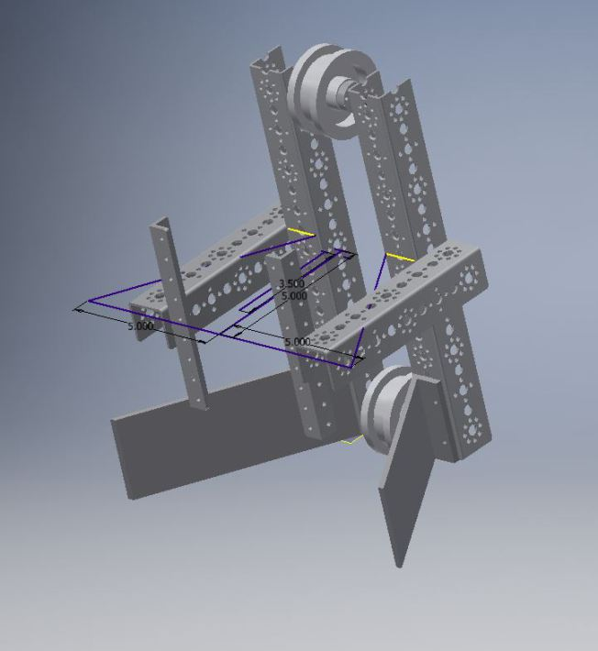

We realized the ball and shooter too big for previous version. This version will lift the ball directly into the shooter using a belt. Largely influence by team Ri1W’s video Robot in Three Days.

### Date Week of 10/3 – 10/7/2016

Attendance: Troy, Mike, Arjun, Reed, Maheep, Max, Victor

#### Particle Transfer – Redesign V.1

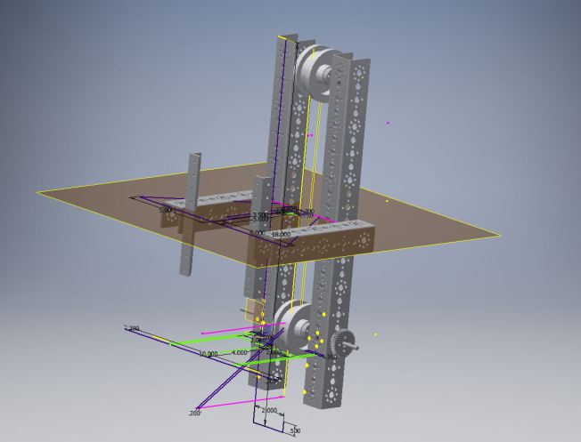

Improvements made to height, added a gear to turn belt, exchanged funnel extrusion for a more flexible sketch which can be modified to fit other components.

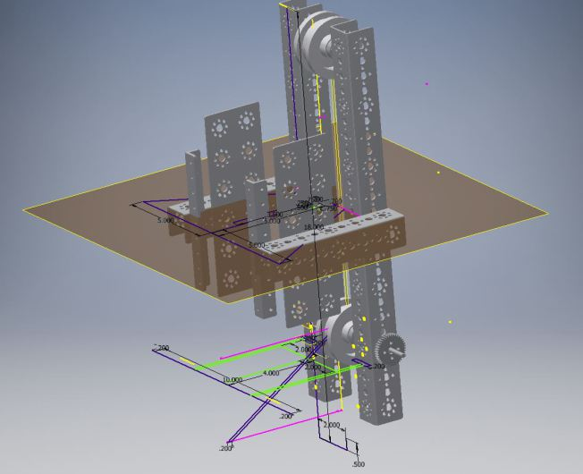

Added side plates to hold ball in.

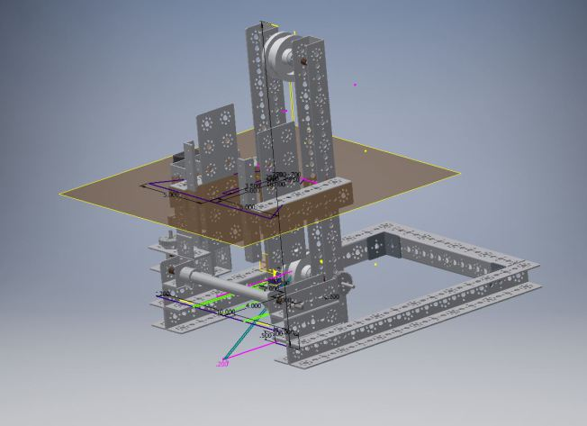

Begin positioning of transfer mechanism with harvester.

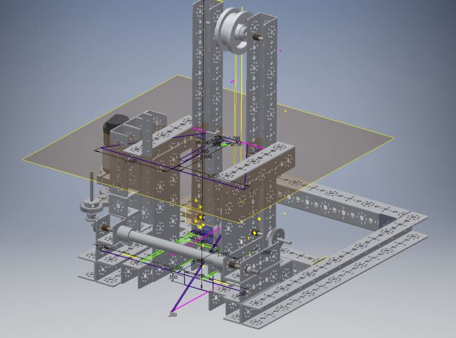

Securely attach transfer mechanism and harvester to chassis, made room for Mike’s design, optimized design.

### Date: Week of 10/10 – 10/14/2016

Attendance: Troy, Mike, Arjun, Reed, Maheep, Max, Victor

#### Particle Transfer – Second Redesign V.1

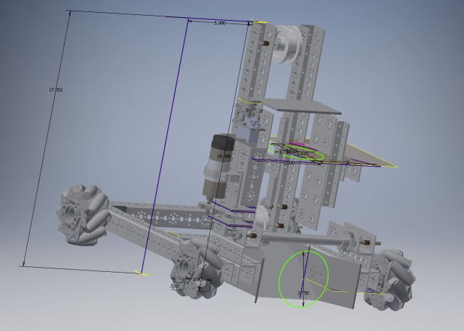 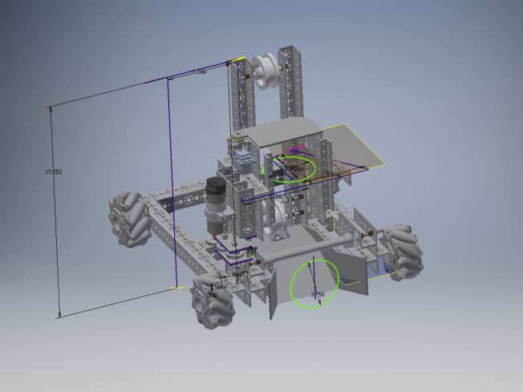

Extruded ramp, added wheels, ball stopper, gearing, and numerous improvements

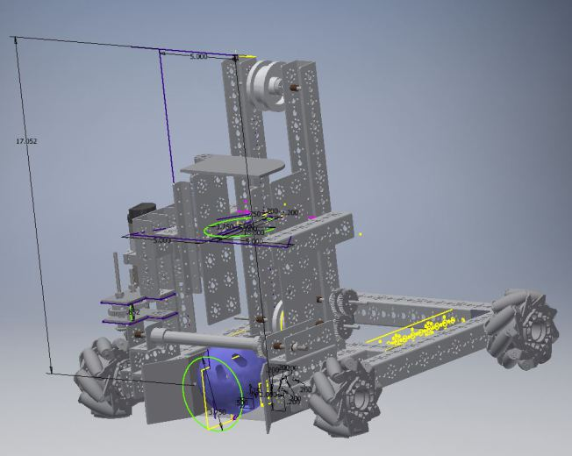 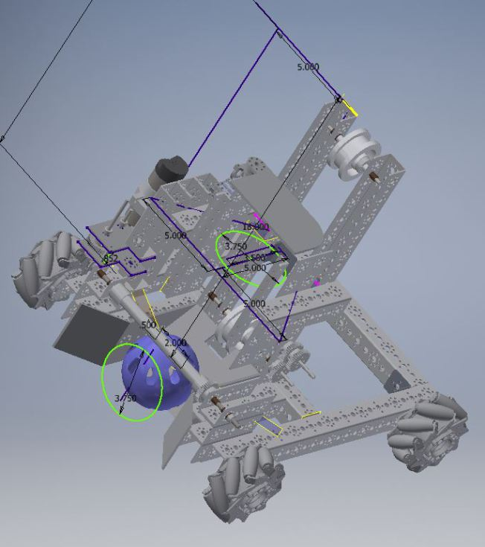

Decided to completely redo the funnel as previous funnel began to grow too complex, simplified design, the funnel can now be 3D printed or made of metal. Funnel can now be attached through screws and nuts only.

#### Particle Transfer – Fabrication V.1

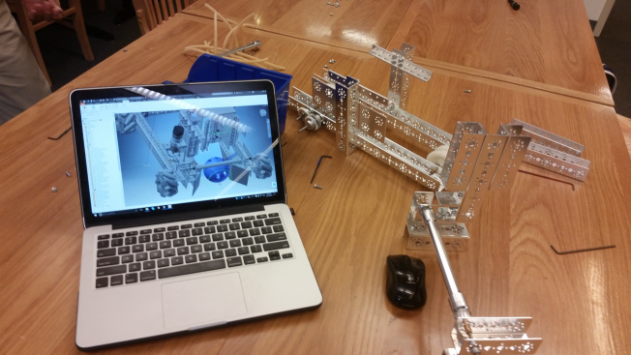

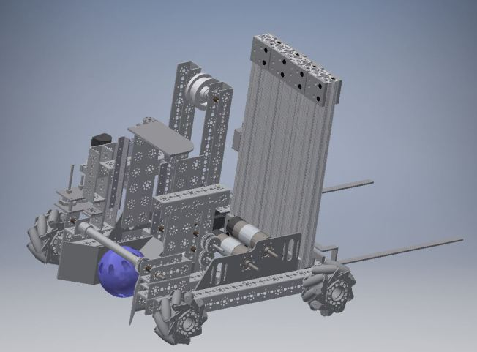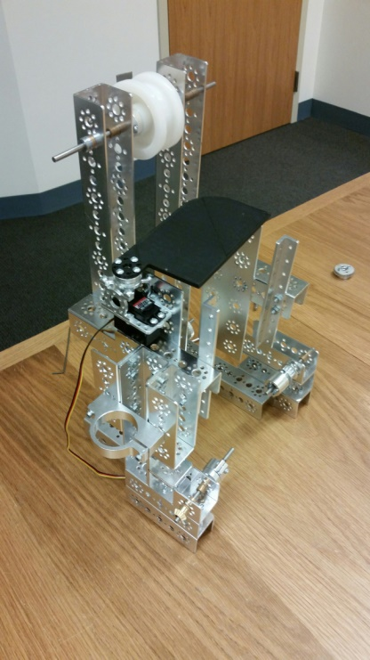

## Particle Transfer Version 2.0

### Date: Week of 12/5 – 12/9/2016

Attendance: Troy, Mike, Arjun, Reed, Maheep, Max, Victor

#### Particle Transfer - Redesign V.2

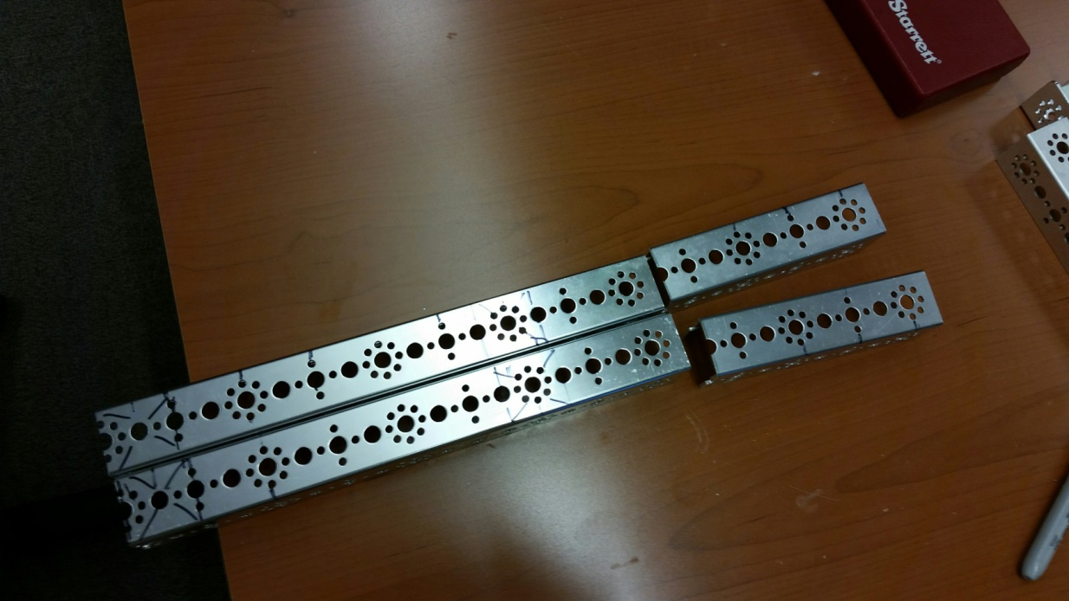

### Date: Week of 12/17 – 12/23/2016

Attendance: Troy, Mike, Arjun, Reed, Maheep, Max, Victor

## C:\Users\rbrodie\Desktop\robotics photos 2016-2017\camera 12_18_2016\IMG_20161217_105814.jpg

*Mike and Reed Brainstorm ideas for new V.2 Particle Transfer*

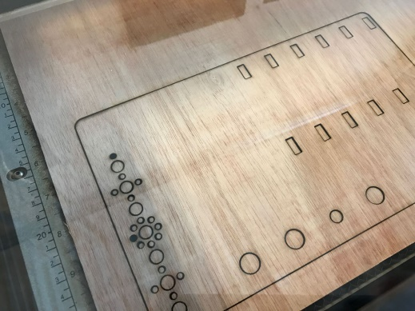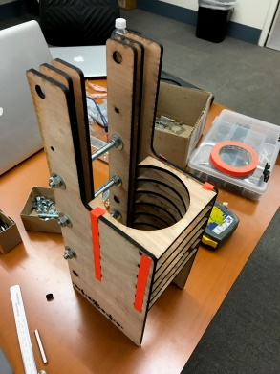

*Laser cut wood mockup of V.2 particle transfer*

After analyzing our prototype, we decided that completely assembling the tower out of aluminum would be difficult and add more weight than we would want. In order to reduce weight and allow for easy fabrication, we decided on a hybrid design made of both acrylic and aluminum. We decided to use the acrylic as side walls to guide the particles up the tower, this would be integrated into the rest of the tower frame. We also decided to add an interesting design element, our number raster into the empty acrylic space. The acrylic would also allow us to create right angles and corners, something that could not be achieved with a router bit on the ShopBot. We influenced the current acrylic design from the previous cardboard particle transfer. The acrylic would allow us to create a slot design, mimicking the cardboard prototype we previously made. Below you can see the full acrylic design along with the aluminum side plate.

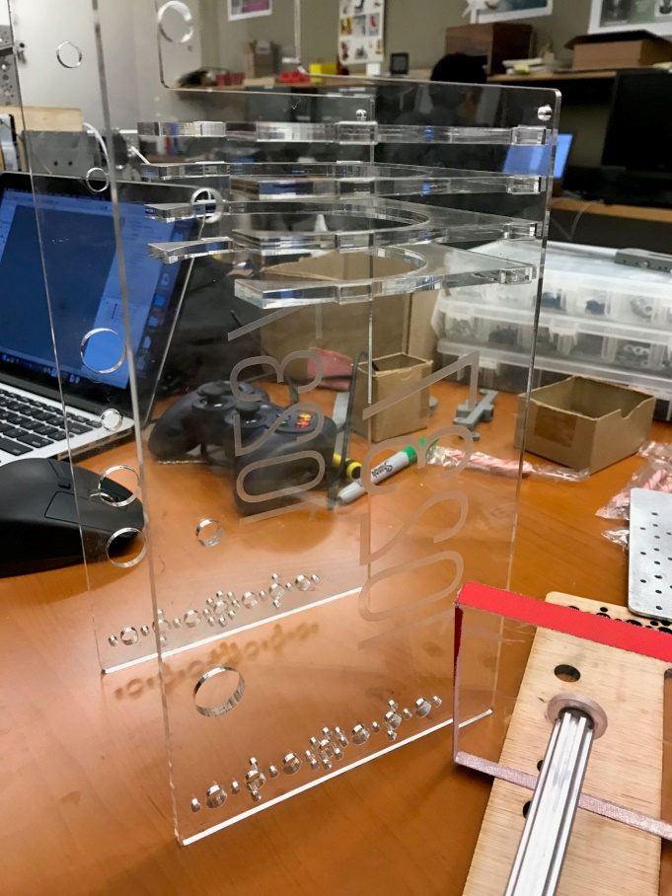 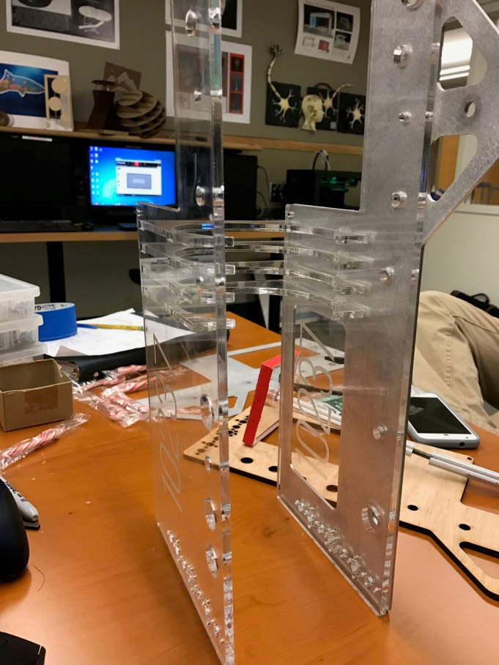

*Full Acrylic Structure with Particle Transfer Slot Design*

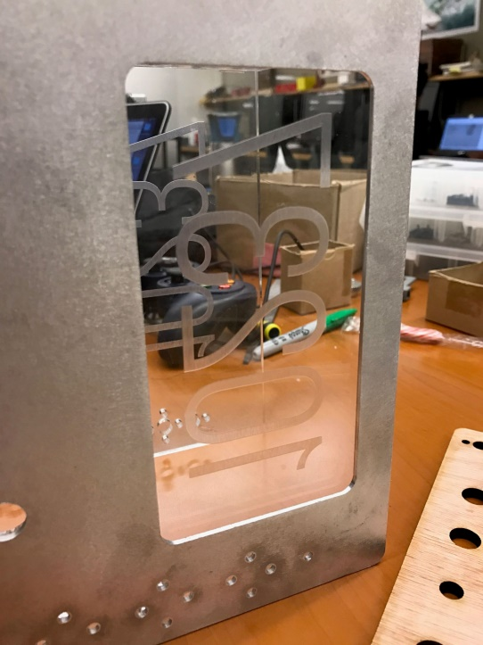 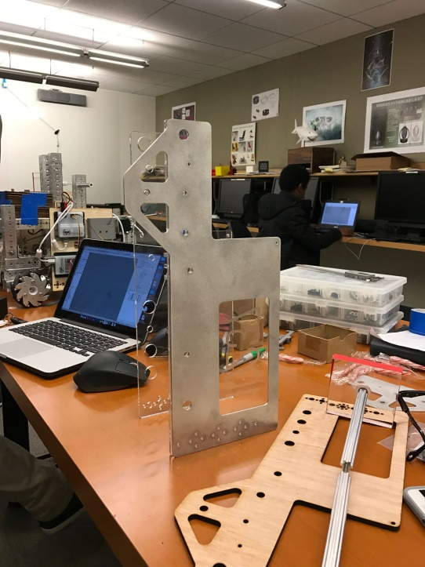

*Team Number Raster into Acrylic Full Outside Aluminum Plate*

As we looked at what we could do with the full tower assembly, we saw the opportunity to integrate multiple components. We took advantage of this and decided to develop the button pusher and integrate its structure into the tower. The Photo above shows the structure that is part of the button pusher assembly. This part will have another symmetrical form allowing for further rigidity.

After the tower was fully assembled and the shooter wheels were attached using the plates we previously made, we decided to test the full unit. Everything looked promising, the power transfer system developed by Troy Young, worked well overcoming the previous problems of gear slippage and loss of power. As we began collecting particles, we noticed that occasionally the particle would become stuck when it applies pressure to the zip ties and center supports. While this did not happen often, when it did happen, it would hurt us in the match preventing us from shooting particles. To solve this solution we decided to remove the center spacer and set the distance by fastening the plates to the outer c-channel. This solved the particle transfer issue. After solving this problem, we began to test again. We then immediately found that there needing to be further guidance of the particle closer to the shooter wheels. We knew this because we saw that the particle would never reach a point where the particle would be griped. To solve this problem we decided to make a "funnel" that would guide the particle at 11 degrees, the same angle of the shooter. Another challenge we had was integrate the shooter into the existing tower design that had already been developed. We thought about drilling through both the aluminum and acrylic, but ultimately decided that we would risk cracking the acrylic. We needed to find a solution that we could integrate into the existing design. We found that the best way to do this was to remove the top acrylic rig and utilize the existing slots.

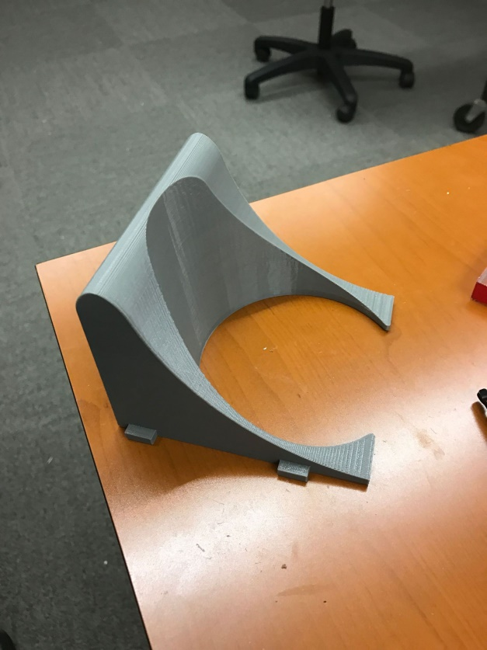

*Particle "Funnel" With Tabs For Tower Integration*

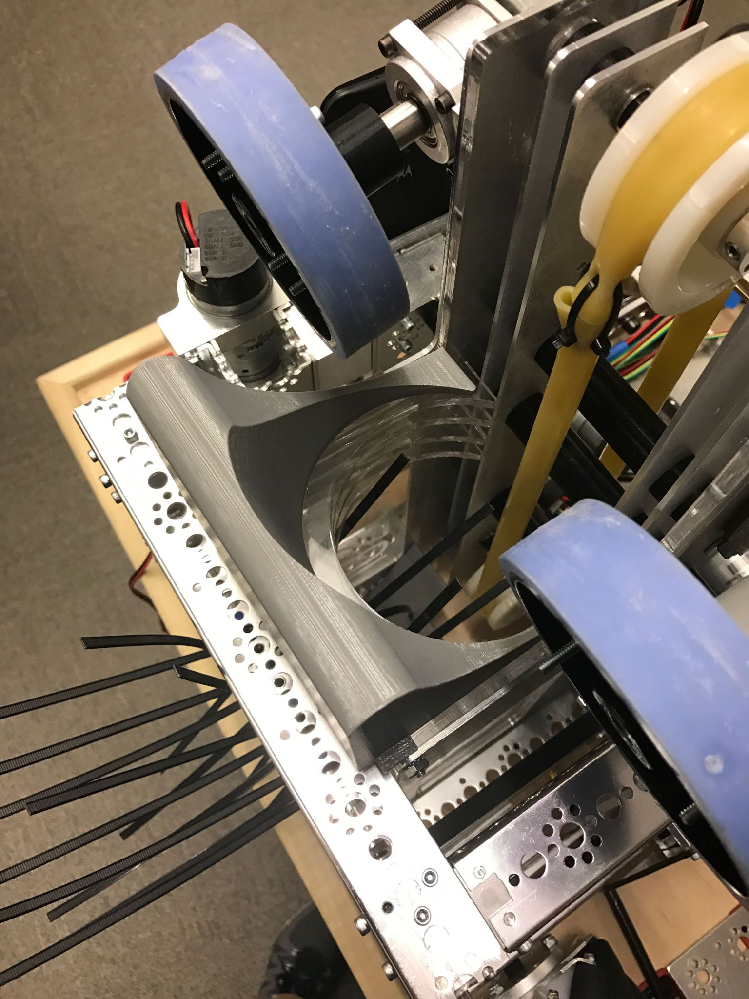

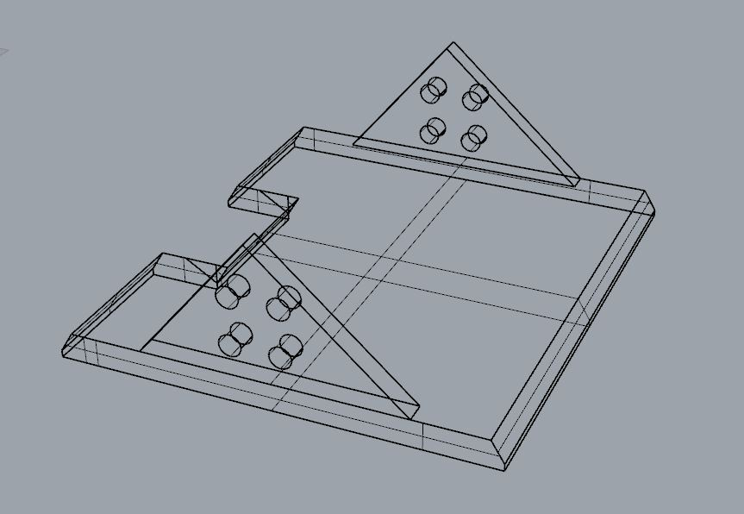

After attaching the ramp, we realized that it was not long enough since we based the design on the ramp for V1. I went back into the file and made the modifications needed. I move the hole for the tubing back and made it wider for the pulley. I made the end of the ramp longer since the positioning sits higher on V2. I also extended the pronged end back to sit against the plates holding the pulley.

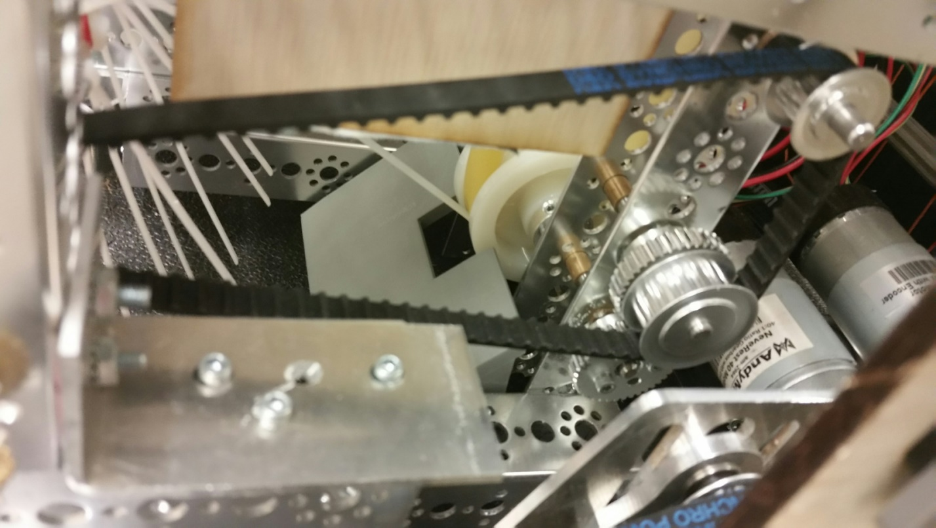

*Redesigned to ramp to be higher up from the ground*

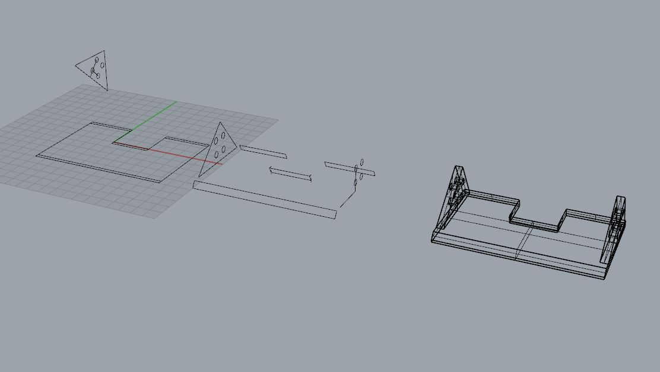

*Using Reeds previous design a model, we redesigned the ramp for the harvester*

## Cap Ball Lift Mechanism

### Date: Week of 9/26 – 9/30/2016

Attendance: Troy, Mike, Arjun, Reed, Maheep, Max, Victor

#### Cap Ball Lift – Design V.1

A big part of Velocity Vortex is the end game, during which the objective is to raise and deposit the “cap ball” into the center vortex. In order to earn the maximum 30 points for completing this task, the ball needs to be raised 50 inches to overcome the stick wall of the center vortex.

In order to complete this task, we needed a lift system that has a large extension range (Over 50 inches), and can be stored inside the 18 x 18 x 18 size of the robot.

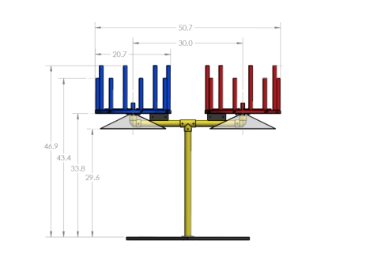

In order to prove the concept, I decided to use some full extension steel drawer slides that we had lying around. After drilling and mounting these slides together, I achieved the goal of the extension distance and compactness. This design was incredibly heavy, and required an unreasonable amount of force to operate. It was also very unstable, which would ultimately tip our robot if  used.

### Date Week of 10/3 – 10/7/2016

Attendance: Troy, Mike, Arjun, Reed, Maheep, Max, Victor

#### Cap Ball Lift - 80/20 Design V.1

We then decided to switch over to the 80 20 series of extruded aluminum. This was much lighter, was smoother, and used much less force to extend. The main con of this design was the hefty price tag, at 300, compared to the 20 dollar price of a drawer slide lift system.

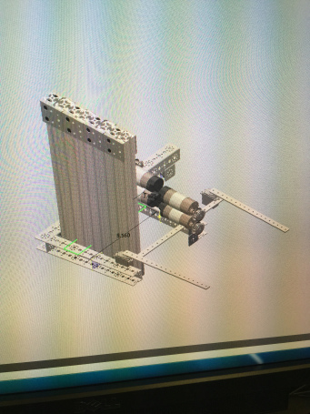

*Retracted view of 80/ 20 lift*

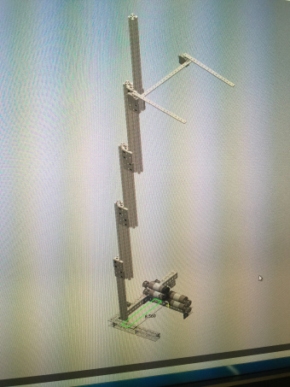

*Extended View*

### Date: Week of 10/10 – 10/14/2016

Attendance: Troy, Mike, Arjun, Reed, Maheep, Max, Victor

#### Cap Ball Lift - Arm Design V.1

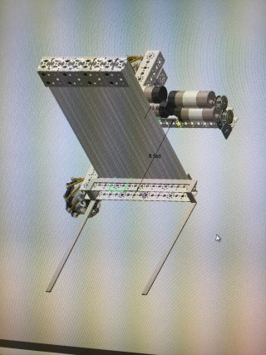 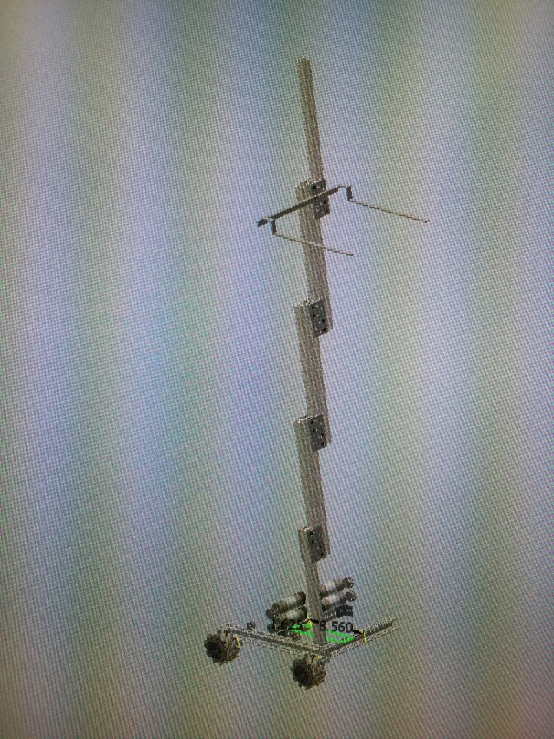

In order to pick up the cap ball, I needed to design a special arm, in order to ensure a simple pickup and efficient operation.

Initially, I decided on two 15 inch long rods, each attached to a servo, in order to fit the sizing constraints. Not only was this idea inefficient, but it also was unstable and would potentially drop the ball if bumped during operation.

I then came up with a design that utilized a fixed “u”, of 18x15x15, with .5 thicknesses for each rod. This idea proved to be viable, as the ball was easily picked up by the lifts arms.

Still, there was the problem of the ball rolling out of the front of the lift arm system, so i bent each arm 30 degrees in order to ensure that the ball stayed put.

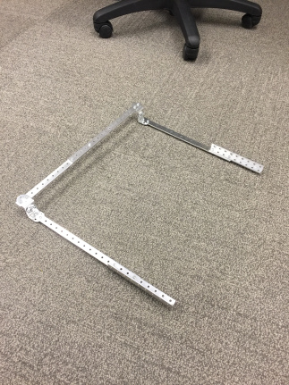 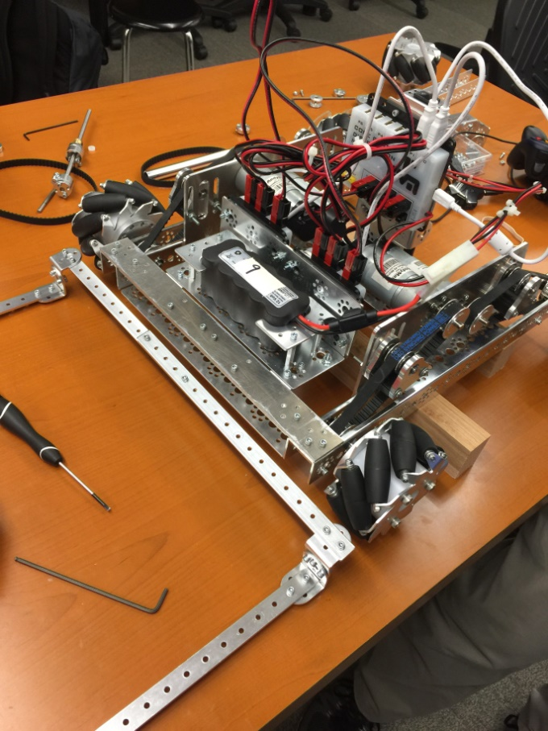

This design connects on a hinge to the lift system, and here’s what it looks like in the engaged position

### Date: Week of 10/17 – 10/21/2016

Attendance: Troy, Mike, Arjun, Reed, Maheep, Max, Victor

#### Cap Ball Lift - Motor Mount V.1

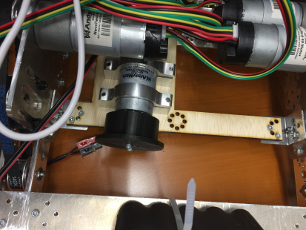

In order to power the lift, I am using a 60:1 gear ratio AndyMark motor with a custom 3d printed pulley for a small profile and footprint. TO support the motor, I designed an aluminum plate to hold the motor and add structural rigidity. I used a laser cut wood piece as a proof of concept prototype.

### Date: Week of 10/24 – 10/28/2016

Attendance: Troy, Mike, Arjun, Reed, Maheep, Max, Victor

#### Cap Ball Lift - Arm Redesign V.1

After many calculations, I decided on using a fixed radius arm to pick up the ball. This works on the principle based on the change in radius of the sphere relative to the height.

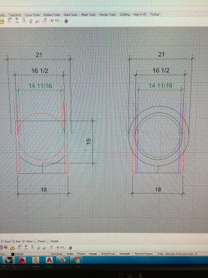

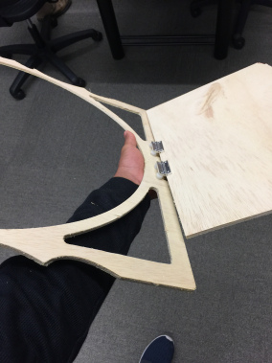 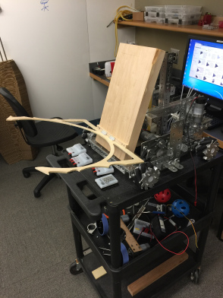

Although this piece will ultimately be made from aluminum, we used wood to mock it up.

### Date: Week of 10/31 – 11/4/201

Attendance: Troy, Mike, Arjun, Reed, Maheep,

#### Cap Ball Lift – Fabrication V.1

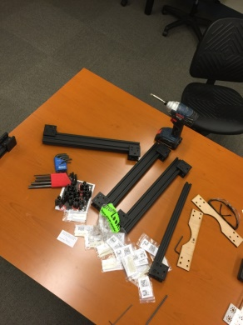

*80/20 Parts ready to be assembled*

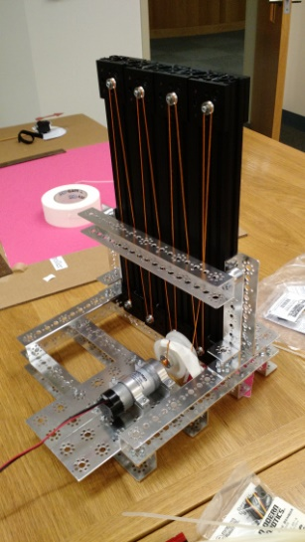

*80/20 Lift mockup*

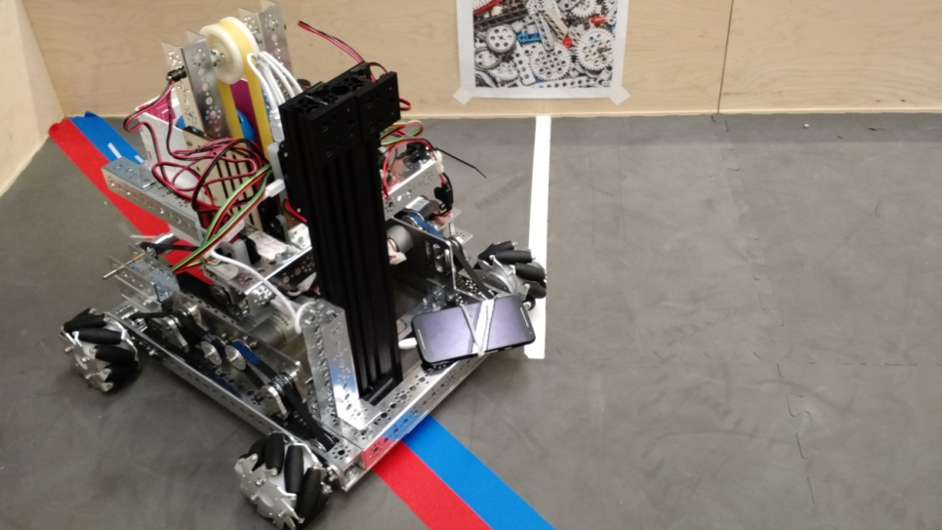

*Lift attached to chassis*

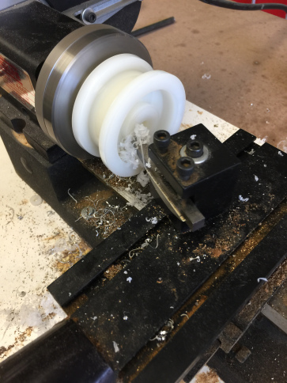

In order to get the winch to fit, we turned down the inner part to make the motor collar flush with the lip, instead of protruding.

### Date: Week of 11/14 – 11/18/2016

Attendance: Troy, Mike, Arjun, Reed, Maheep,

#### Cap Ball Lift – Cable Holder Design and Fabrication V.1

After many tests, the orange prototype string had a tendency to fall off the v bearings. In order to solve this, I designed and 3d printed small pieces to keep the cable on.

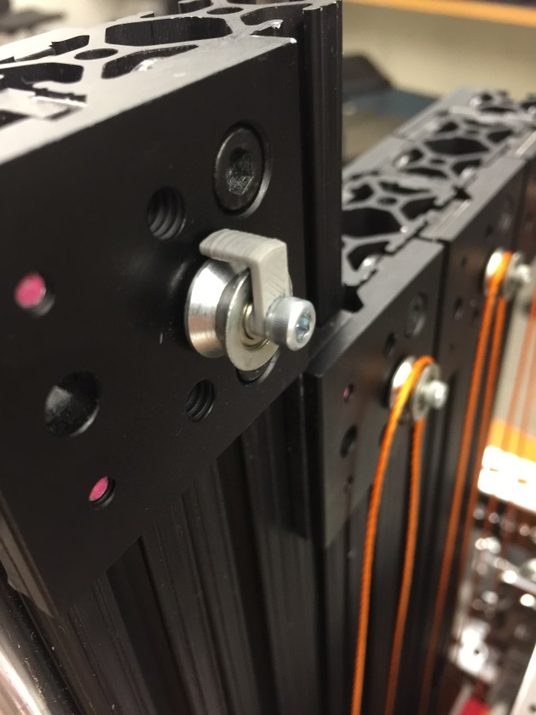 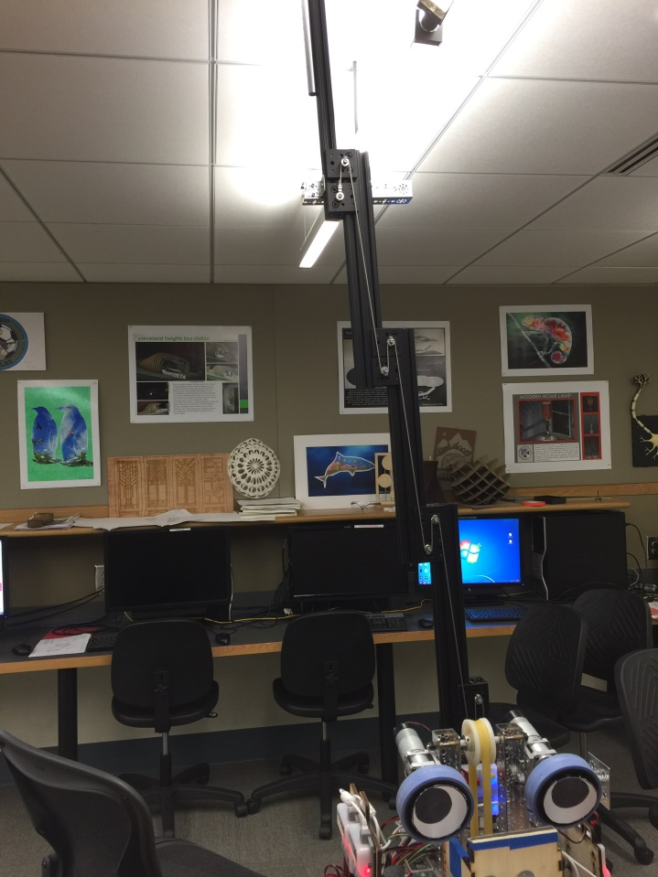

We determined the proper string length and switched from the weak string to strong steel cable. This improved strength and smoothness, and also decreased slippage and mechanical loss. This cable, in conjunction with the guides I printed earlier, made for a strong and reliable mechanical assembly.

Cap Ball Lift – 3rd demension Redesign V.1

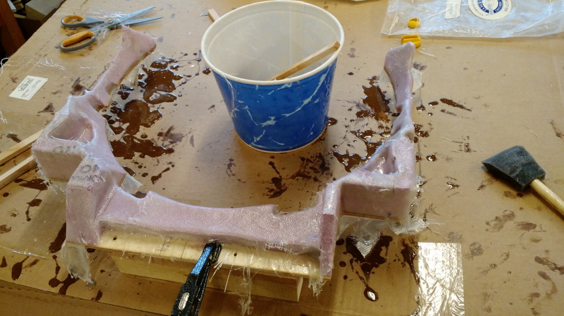

### *After switching to a 3d foam lift arm, we decided that we should wrap the foam in fiberglass*

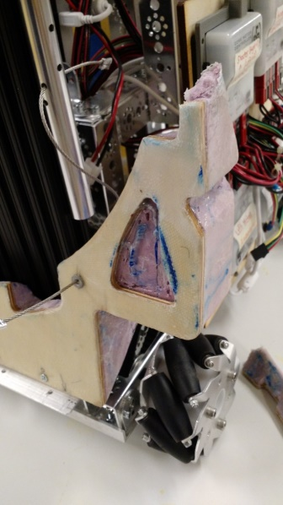 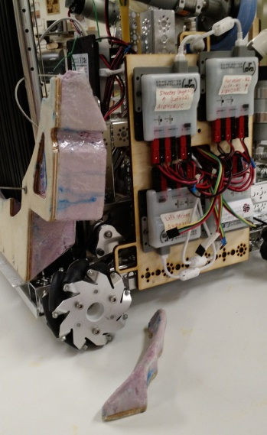

*Unfortunately, our fork arm didn’t fair very well at the Solon scrimmage*.

### Date: Week of 11/21 – 11/25/2016

Attendance: Troy, Mike, Arjun, Reed, Maheep,

Cap Ball – Redesign V.2

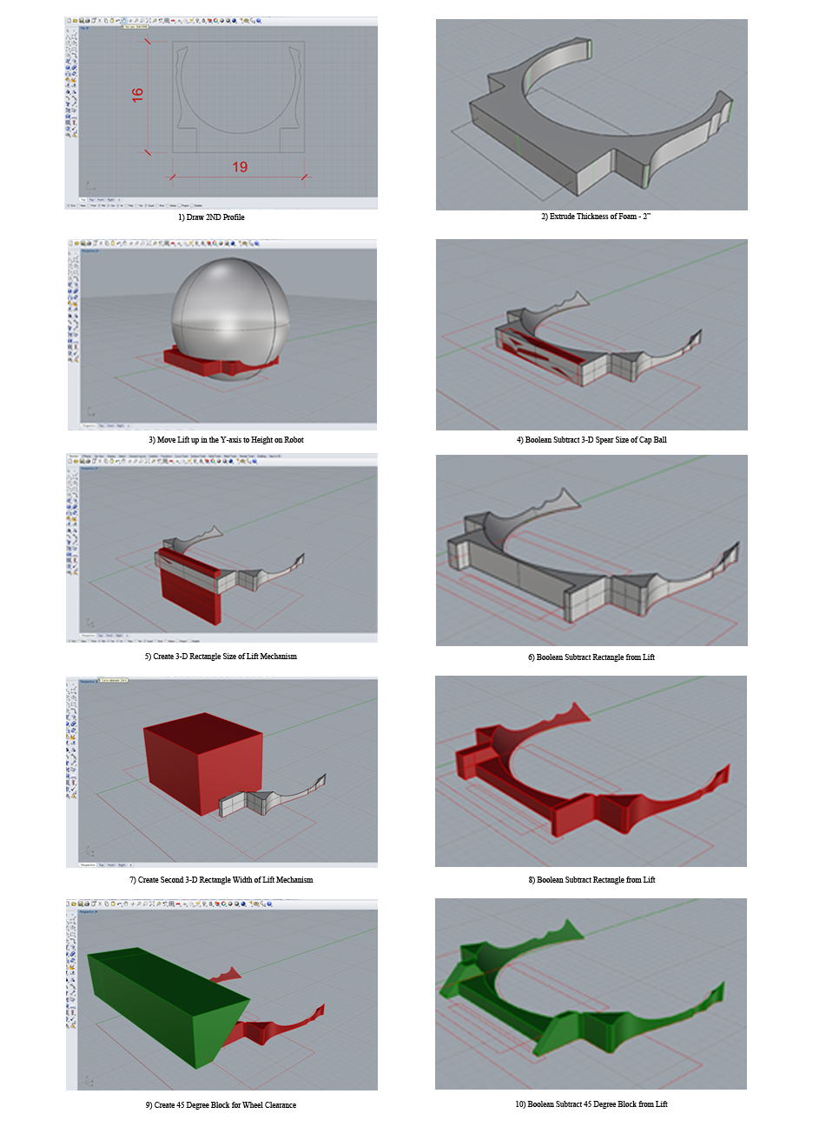

Steps in Rhino 3D for boolean subtraction

### Date: Week of 11/28 – 12/2/2016

Attendance: Troy, Mike, Arjun, Reed, Maheep,

Cap Ball Lift – Fabrication V.2

### new arm 4new arm 3

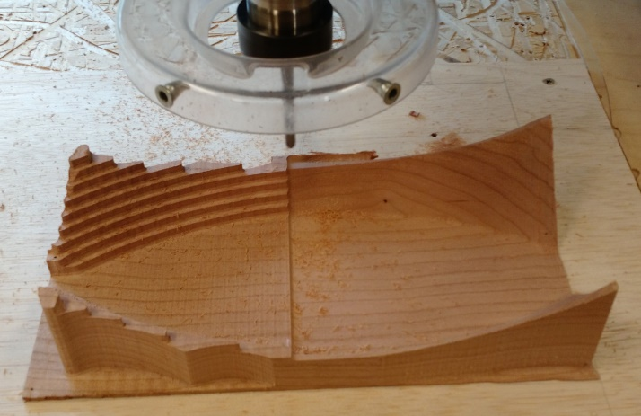 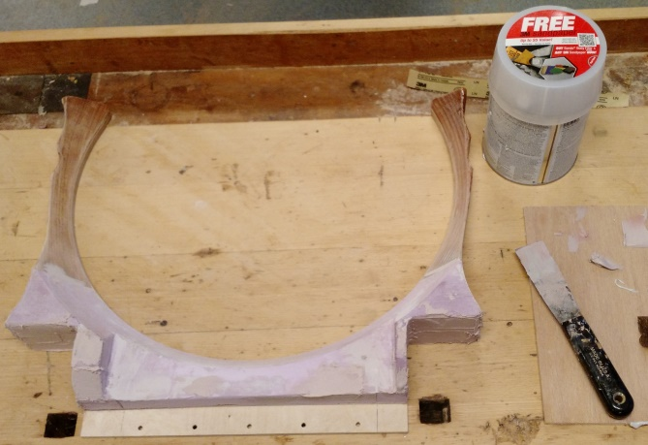

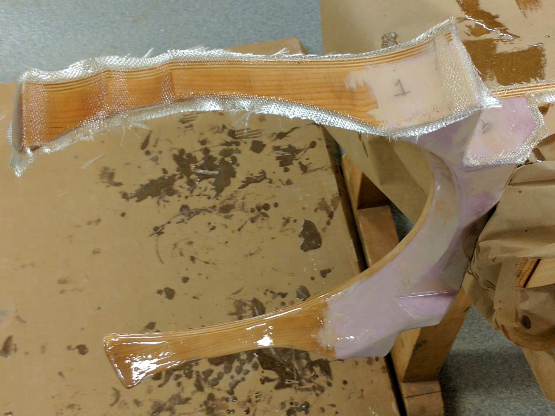

*Fiberglassing V.2 fork*

### Date: Week of 12/5 – 12/9/2016 reviews

Attendance: Troy, Mike, Arjun, Reed, Maheep,

Cap Ball – Installation Modifications V.2

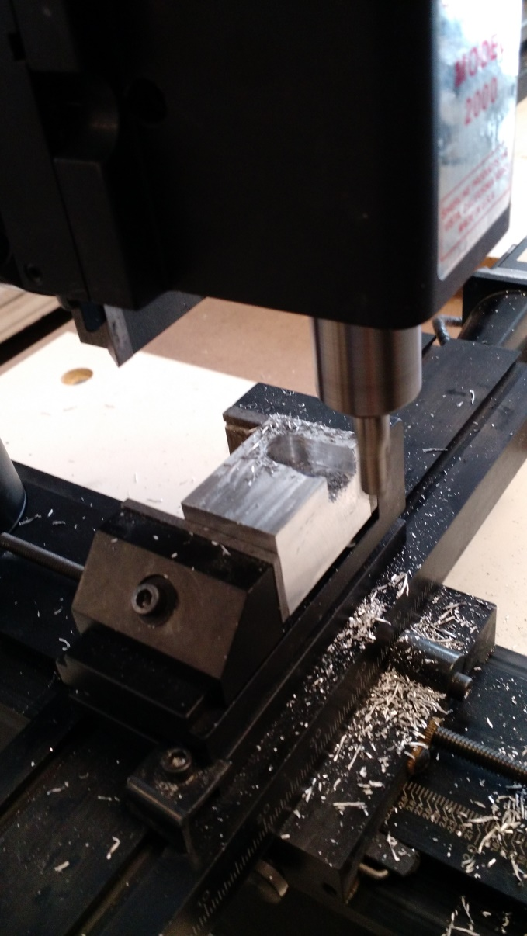

*Making adjustments to lift on the vertical mill*

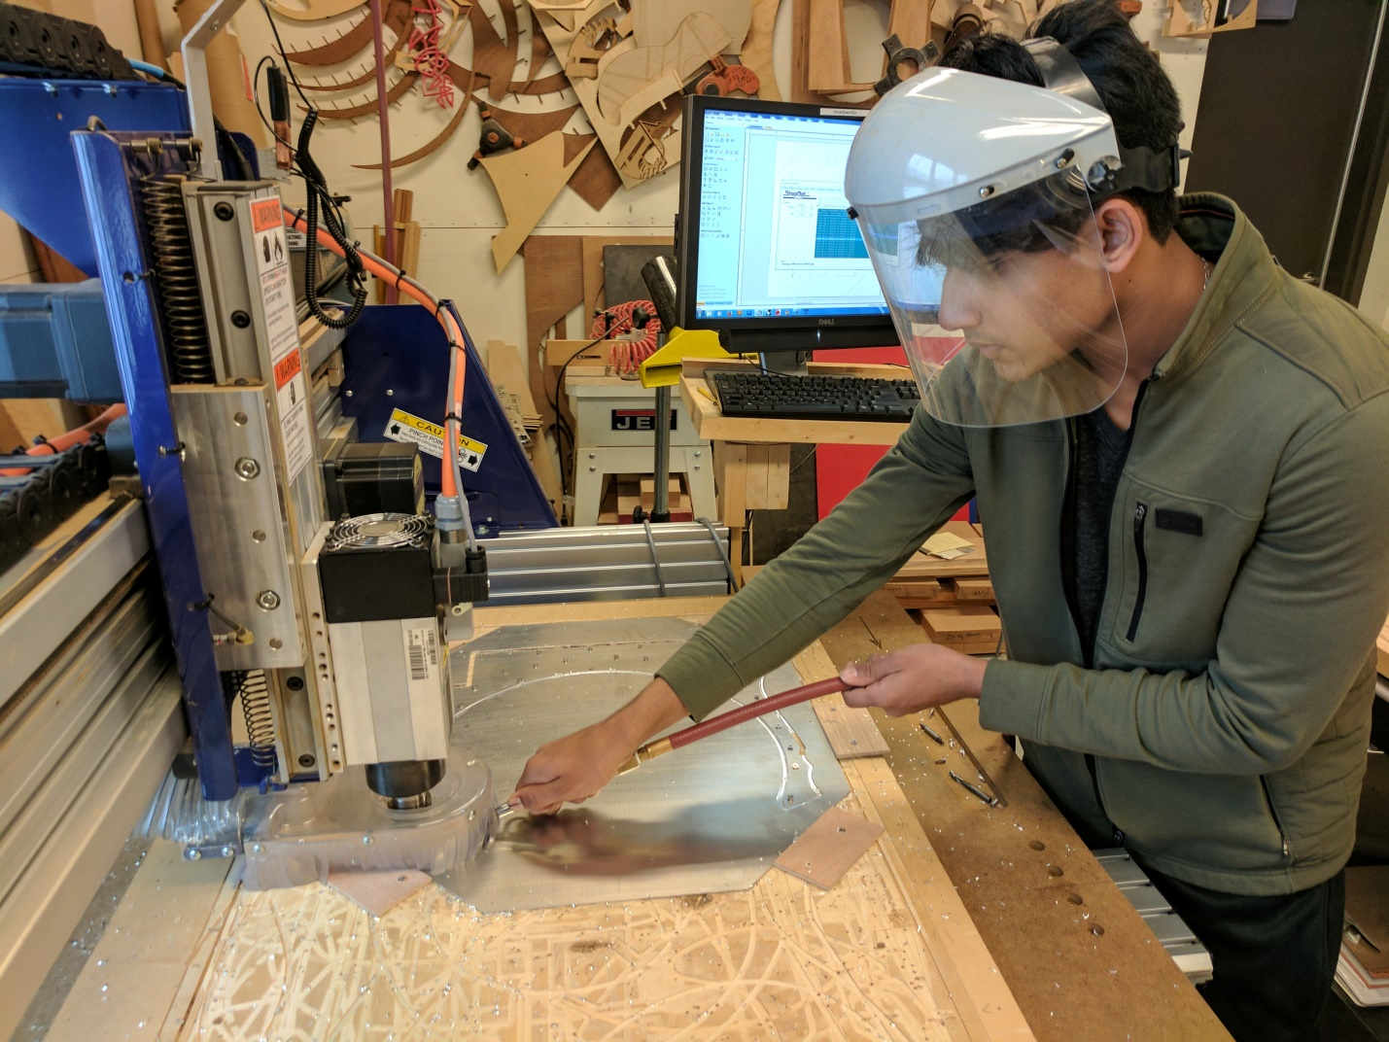

*Arjun using Shopbot CNC to mill aluminum plate for lift.*

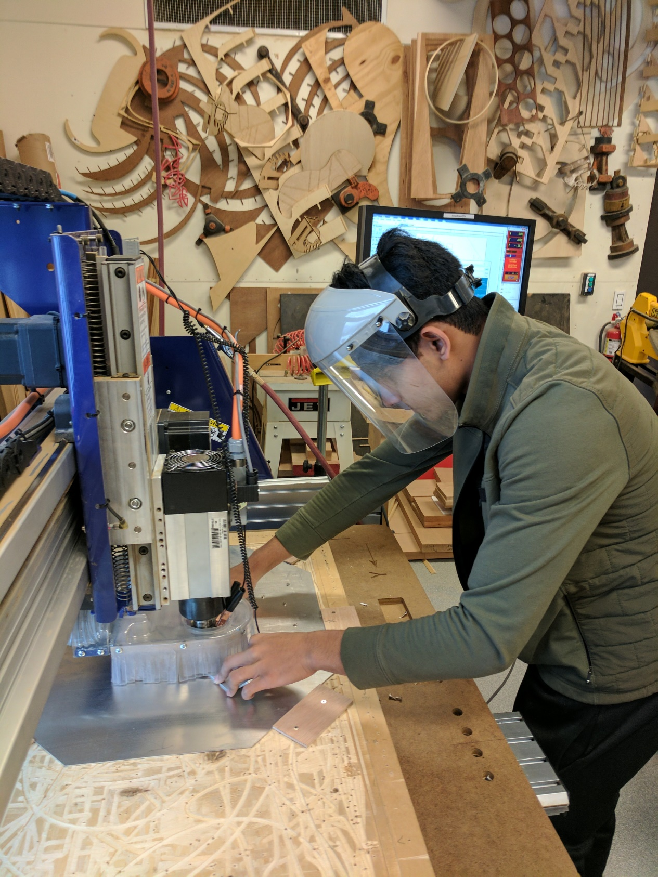

*Arjun using Shopbot CNC to mill aluminum plate for lift.*

## Ball Shooter

### Date: Week of 10/24 – 10/28/2016

#### Shooter Mechanism

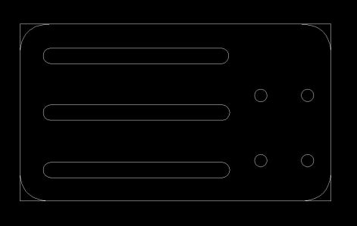

Made in inventor, exported and cleaned up in Autocad. Will be laser cut for testing, then be made out of aluminum.

Unfortunately, the slots are too big and the holes for screws to connect the pieces to the c-channel are also too big. The bottom layer obstructs the adjusting screws that go through the slots. The axel interferes with the motor with this mount.

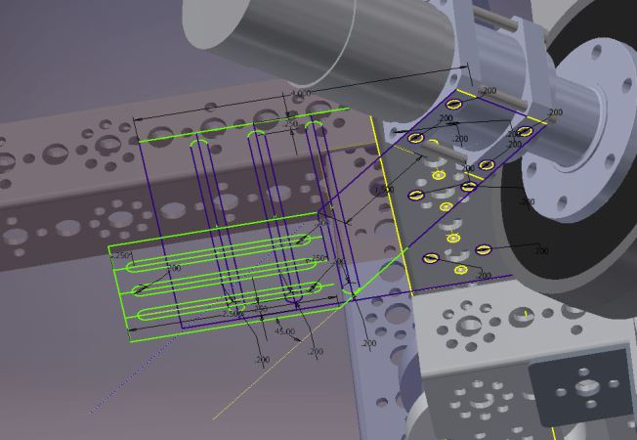 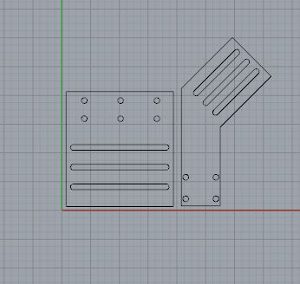 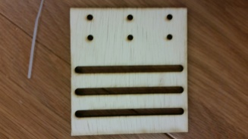

Decreased the diameter of the slots and holes, simplified the design into only 2 pieces, made sure the motor will be able to move around the axel with this mount.

Unfortunately, the holes were designed for larger screws which do not fit into c-channel. Will have to reduce diameter again to accomadate smaller screws.

This will be an easy quick fix Rhino.

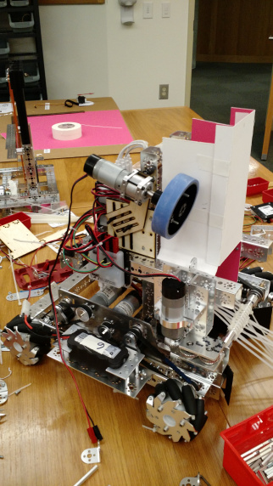 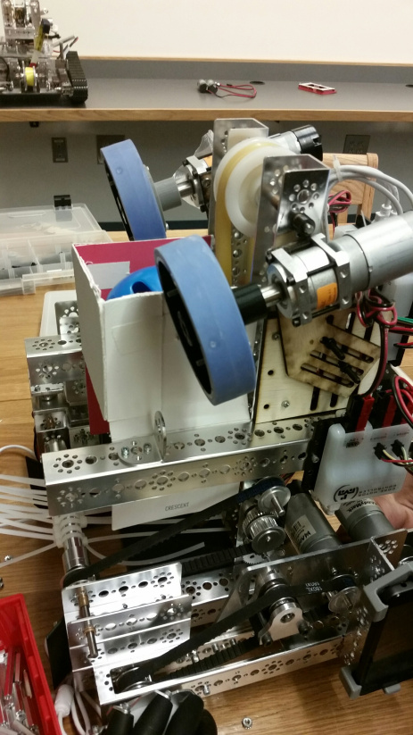

### Date: Week of 10/31 – 11/4/2016

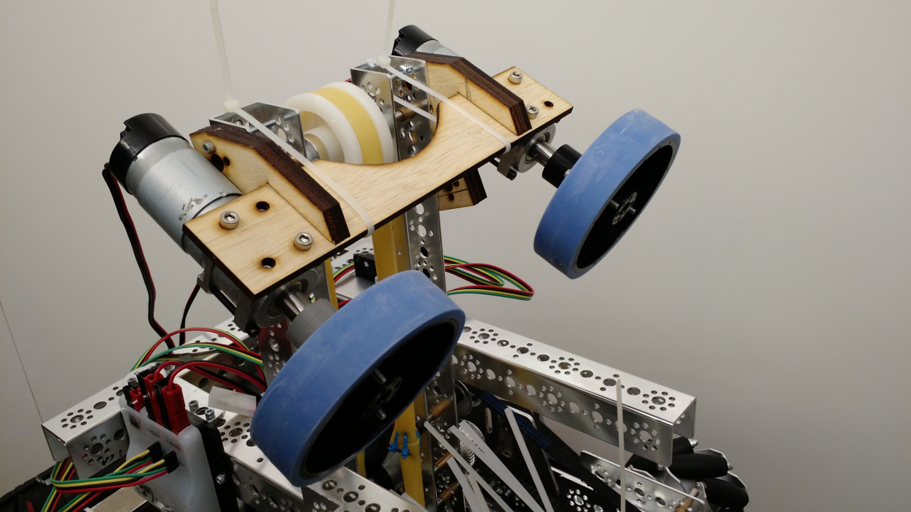

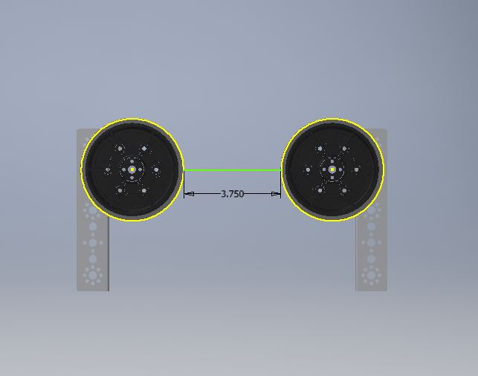

### Date: Week of 11/7 – 11/11/2016

We finished most of the wiring and mounting of hardware with the end goal of having a fully functional robot. We proceeded to debug code running on the phone controlling the robot. Eventually the drive-train, harvester, ball lift and shooter motors were fully functional.

When starting to test the shooter we noticed that it does not perform as previously seen. We realized that the distance between the shooter wheels was further than when we had a successful test. We then preceded to remover the spacers from the motor mount plates. This created a distance between the wheels slightly smaller than the largest diameter of the particle.

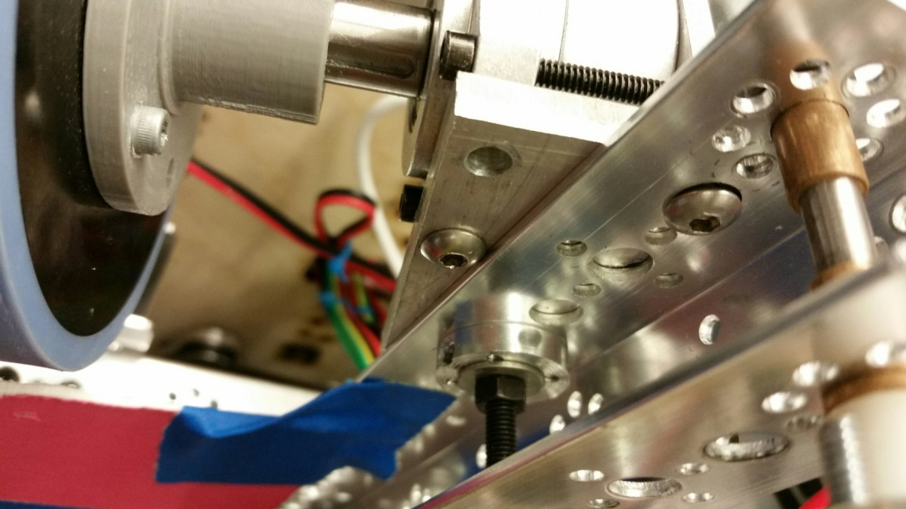 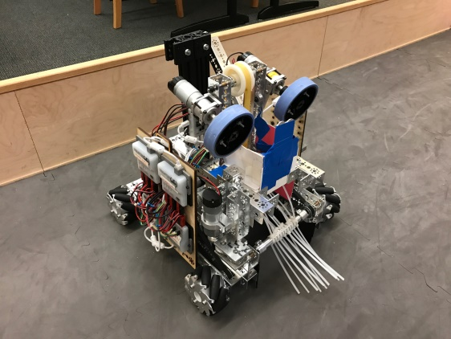  
Shooter Bracket with Spacer Moved

We proceeded to test the shooter and noticed great inaccuracy in distance and direction. We attributed this to the method of feeding the balls into the shooter, a paper and tape "feeder". The only purpose of the paper and tape "feeder" was to do initial tests on the harvester, particle lift and shooter system.

Date: Week of 11/14 – 11/18/2016

In order to address the issue of inaccuracy with the shooter, we decided to create a temporary "feeder" out of laser cut wood. This will hopefully help achieve increased accuracy in the shooter.

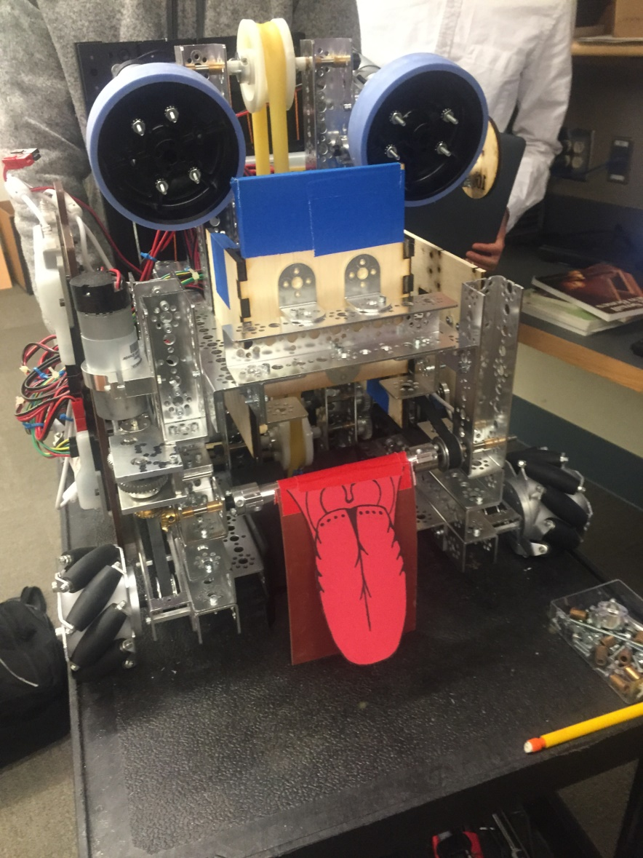

After assembling the "feeder" and attaching it to the robot, we noticed a few problems. One of the most problematic would be the sizing and its control of the ball. The ball has a tendency to move the rubber belt off its pulley. There is also excessive amount of space between the ball and lift. The excessive space creates little pressure against the rubber tubing, preventing the ball from being lifted up.

Date: Week of 11/21 – 11/25/2016

Picking up on designing the particle feeder for the shooter. When reflecting on the previous design, we realized that a feeder contouring the ball would provide increased accuracy when feed into the wheels. We made the initial prototype out of cardboard.

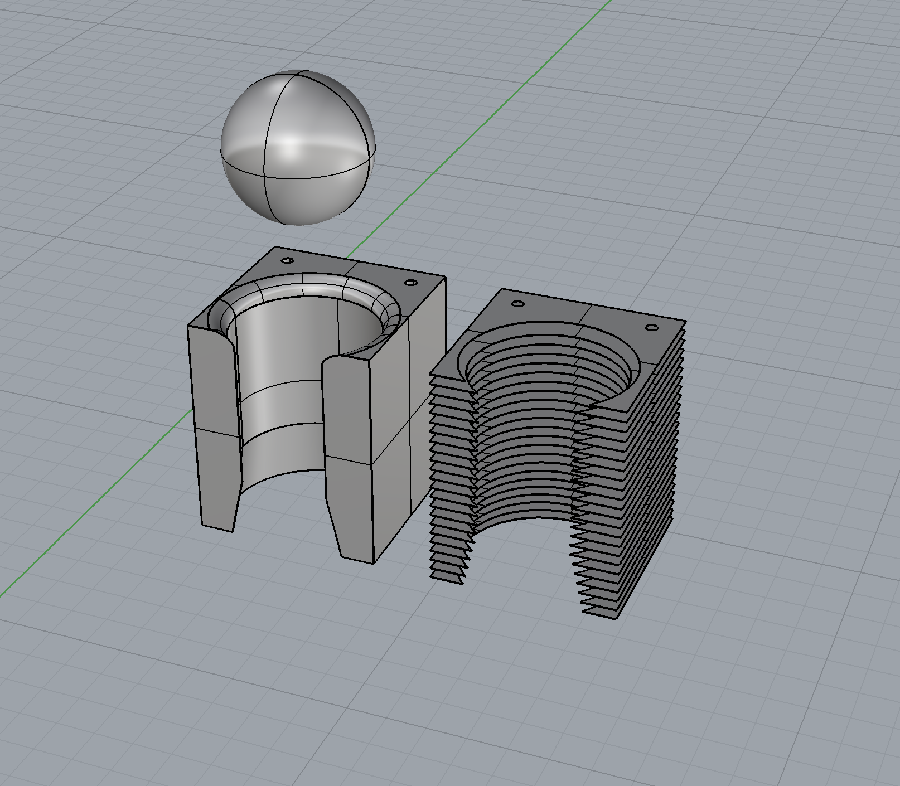

Full 3D Model & Sliced 3D model

After designing the feeder, I used the contour tool to slice the model into 2D surfaces that could be laid out for the laser. Then using the massive unroll script to lay out the individual surfaces with numbers for stacking order.

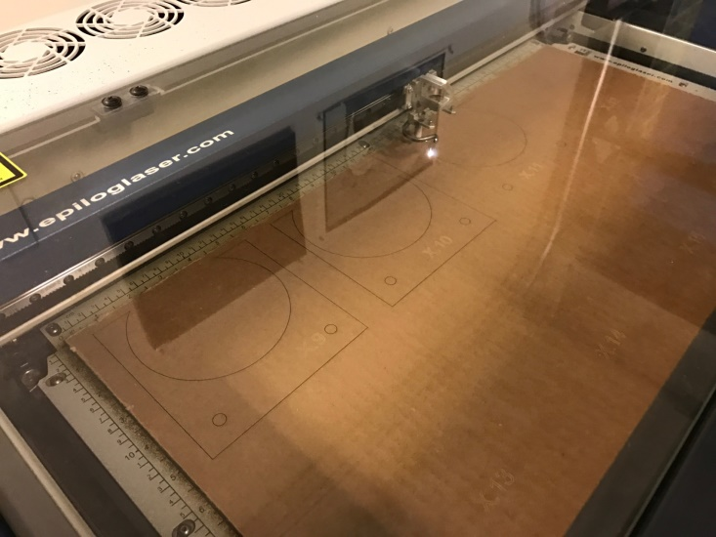

Cutting Cardboard Layers for Funnel Prototype

## Button Pusher and Sparring Bots

### Week of 10/24 – 10/28/2016

#### Beacon Button Pusher

Our original task was to transform circular motion into linear motion in order to have a robot that could lineup with the button. The theory was that the circular would then extend the button pusher out to push the button, and then retract the button pusher back in. This was the inventor file we created for the linear motion button pusher.

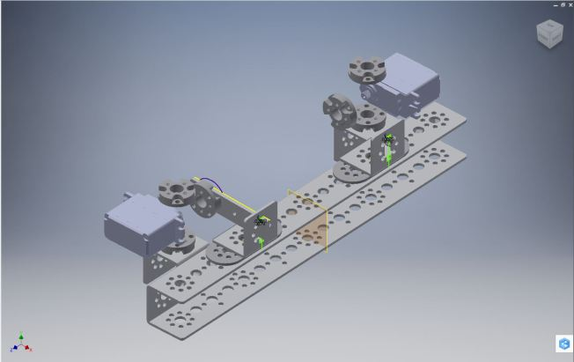

### Week of 10/31 – 11/4/2016

#### Beacon Button Pusher Redesign

Our new design was a simpler one which did not need to incorporate motors or any sort of motion. With omni-directional wheels we simply needed a button  pusher that would extend the width of the robot.

The Completed button pusher will be placed 13 inches from the ground on the robot directly in the center. Button pusher will extend to the edge of the wheels on robot.

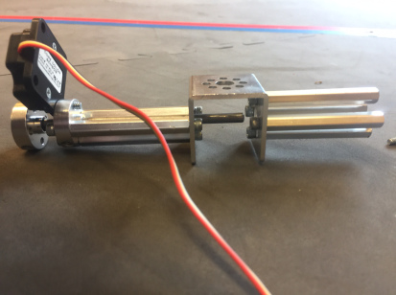 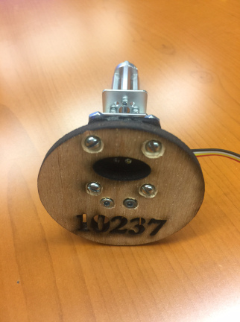

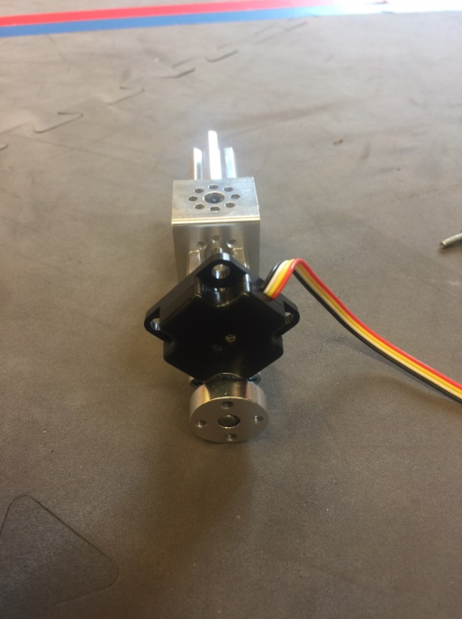 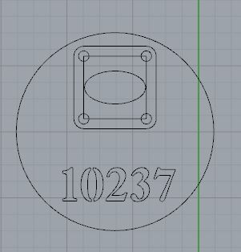

### Week of 11/7 – 11/11/2016

#### Building Sparring Bots

After successfully creating a button pusher, our next challenge was to create two other robots fully equipped with button pushers and functioning electronic boards. The purpose of these robots will be to provide extra robots for practicing maneuvering around the feild of play during the autonomous button pusher round. “Sparring Robots”

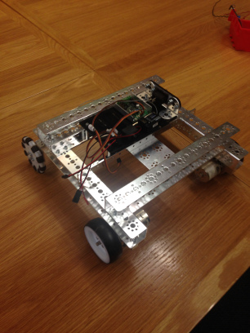 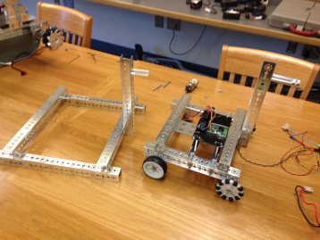

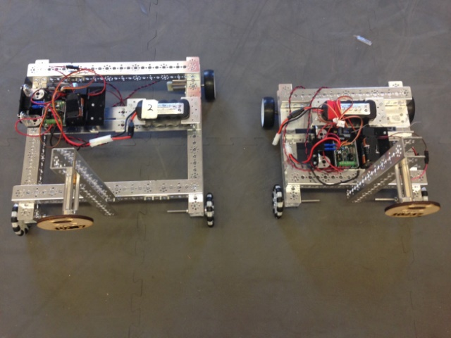 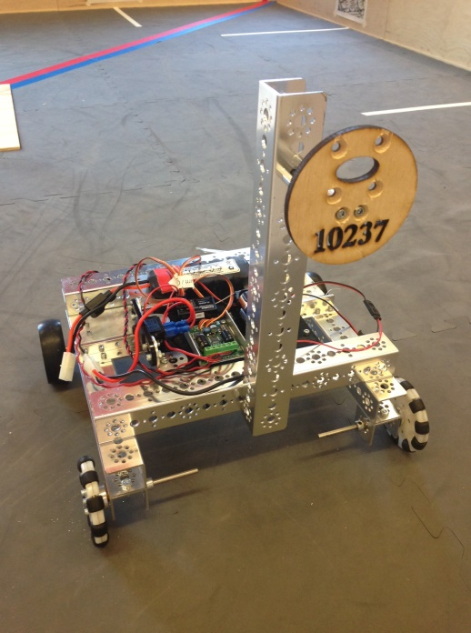

# PROGRAMMING

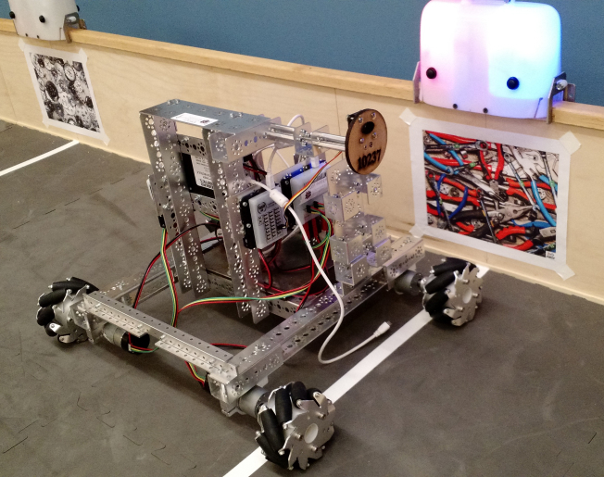

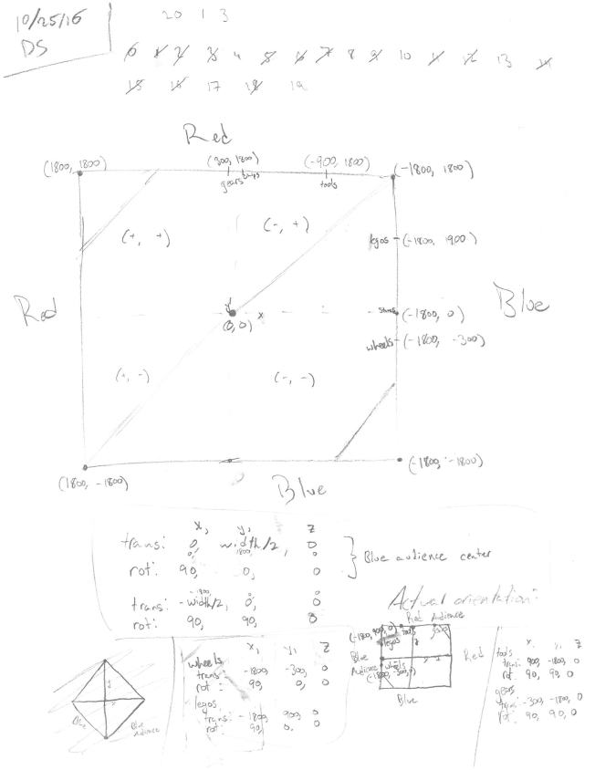

Official GitHub page: <https://github.com/MaxBorsch/ftc_app>

Github Commit History: <https://github.com/MaxBorsch/ftc_app/commits/master>

## September 21

We updated to the new code base. Max implemented a Bluetooth-based telemetry system allowing the robot's position, rotation, and telemetry data to be tracked on a computer in real time. He also started working on a generic task-based state machine for autonomous mode. The system works as follows:

**Robot Tasking**

* A **task** is an abstract job performed by the robot, such as a motor movement towards a goal.
* There is a queue of tasks.
* At any time a task can be added to or removed from the queue.
* Tasks are generally executed in FIFO order.
* A "Task Set" task can be used to contain and execute multiple tasks simultaneously.
* This system allows for synchronized execution of tasks while retaining an update loop for more control over the robot.

**Robot Tracking**

* A **tracker** object represents a method of tracking done by the robot. Trackers can be made for any tracking method, including Dead Reckoning, Time-Based, and Vuforia.
* Trackers can be added or removed from the system at any time.
* Trackers are assigned arbitrary **reliability / accuracy** and **precision** ratings.
* During a tracking update, the robot will cycle through all of its trackers from most to least reliable, receiving that tracker's hypothesis for the current robot position / orientation on the field.
* The robot will use the **most precise** hypothesis that is within a margin of error from the **most reliable** hypothesis as it's presumed position / orientation.
* This system allows the robot to use the **most-reliable, precise**position data available.

## October 21

At this point we had a programming robot built, so we made a quick tele-op mode for it and started to figure out how to control the Mechanum wheels. We just used a simple state-based op-mode for this (no tasks).

## October 22

We added a Vuforia tracker. Vuforia is an augmented reality library included in the FTC code. We got it working so that it tracked 2 of the pictures on the field, however, in the following days we spent a long time trying to figure out the coordinate system that Vuforia used.

## October 26

We finally got the whole task system working. The main thing we worked on in the past few days was getting concurrent task sets to work so multiple motors can run at once.

## November 1



Speed (y) vs. Percent to Target (x) Shown for varying **Ramping** and **Damping**values.

We figured out the math behind ramping the motor speeds up and down to allow the robot to smoothly change its speed and decelerate as it approached its target. First we focused on ramping down. The "amount" of ramping is described as a value 0.0 - 1.0 representing the percent along the way to begin ramping. The robot would have to avoid going below 30% power. Given this information we created a piece-wise function for the robot to use in determining its speed. We also fixed some inches-to-encoder-ticks bugs.

## November 2

Finished testing of ramping and made a quick tele-op for our competition robot.

## November 3

Continued to measure out inches to encoder tick and degree to encoder tick methods to get them accurate. As well, we switched over to Goals instead of integers so that tasks are reusable (Goals are basically resettable integers). Finally we started adding tasks that would navigate the robot to the beacon.

## November 4

Quoting the commit:

"fixed degreesToEncoderTicks, other than that it was a Friday so... "

## November 7

There were some troubles with the autonomous code so we updated the tele-op for our competition bot. We decided on using a control scheme analogous to a drone. Last year we used a control scheme similar to GTA 5. However, since most of our team members fly drones and this year we used Mechanum wheels, everyone really liked the idea of controls like a drone.

## November 8

Fixed the bug with the autonomous code from yesterday.

## November 9

We had had a bug where a task would be very close to complete, but one motor may have been an encoder tick or two off. This caused the motors to buzz and run at a very low speed. We had previously just been giving the robot a little kick to move that last motor the last few encoder ticks. We thought we this bug by added a "margin of error" of ~3 encoder ticks. We also cleaned up the last bugs with the task-based system. Finally:

"Other than that, we actually hit the button (although it was blue side

and we hit the red button). This is probably only going to be looked at

within days of the competetion, so I've just got to say it was pretty

clutch. The whole team was gathered around, I shut them up, I ran it, and

it actually worked. Moral of this story. Dylan Siegler is a god."

And:

"Also Max helped a little bit too"

## November 10

We actually fixed the buzzing/kicking issue by increasing the margin of error. At this point the robot drives right up to the beacon and reads the color. Also, another great quote from the commit:

"Because the builders probably aren't keeping an engineering journal,

today they replaced the ziiiiip ties with danco gangle ruber. As well, they

invented a cloning machine to clone my [Dylan's] tongue and put in on the

robot"

## November 12

Today was the day of the scrimmage. The first thing we did was add functionality so that a touch sensor could be installed to stop the lift mechanism from brining a ball too far up before the shooter has been spooled up. However, after practicing at the scrimmage it is unlikely that we will need this. The second thing we did was try to merge the GitHub repos. We decided to do it in a really sketchy manner and ended up deleting the original repo, but we had it backed up so we still have the commits. The third thing we did was make the robot respond to the color on the beacon, press the correct button, go to the second beacon, and do the same thing there. It isn't completely tuned. However we found that when run on the real robot, it drifts a lot on turns and stops (because of the increased weight combined with the Mechanums), so we hope that with time with the robot we can tune the numbers for the actual numbers (for the Solon scrimmage). We will likely have to spend more time ramping up and down to try and combat the drifting. Finally, we added back the regular tele-op to the competition robot and fixed a longstanding bug that you couldn't reverse the harvester.

# AKRON SCRIMMAGE 11/12/2016

Attendance: Mike Letterio, Arjun Ramachandran, Maheep Brar, Troy Young, Reed Chen, Dylan Siegler, Andrew Heater, Max Borsch, Seamus Kanlkner, Tiree Walker, Daniel Pichkar

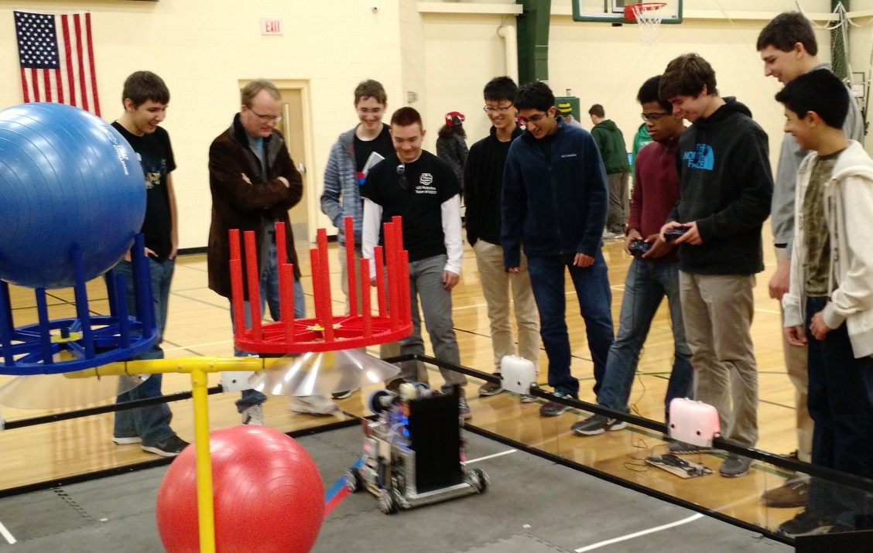

*Mr. Sweeney and Team watching first run of the day*

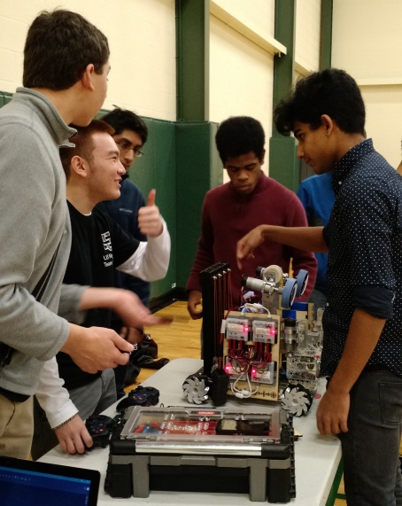 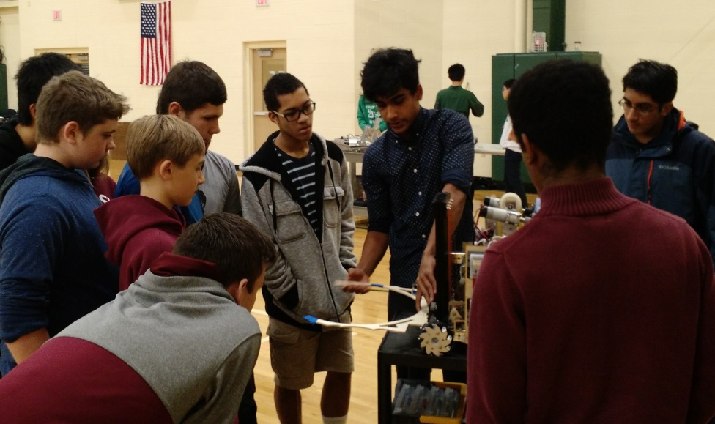

*Troy Thumbs –up Arjun explains how his lift mechanism will work*

# SOLON SCRIMMAGE 11/19/2016



# CLEVELAND QUALIFYING TOURNAMENT



Cuyahoga Community College

Eastern Campus

4250 Richmond Road

Highland Hills, OH 44122

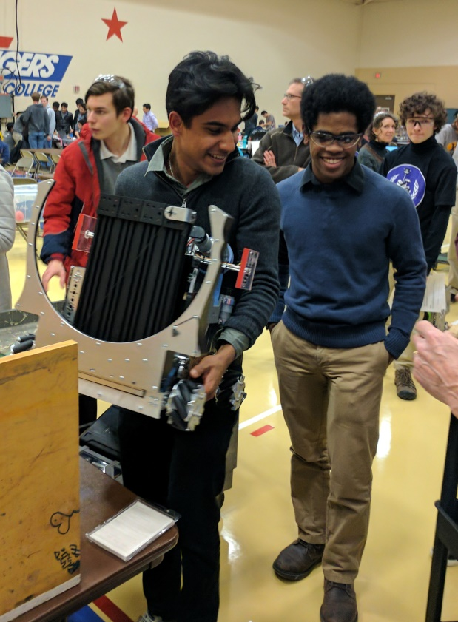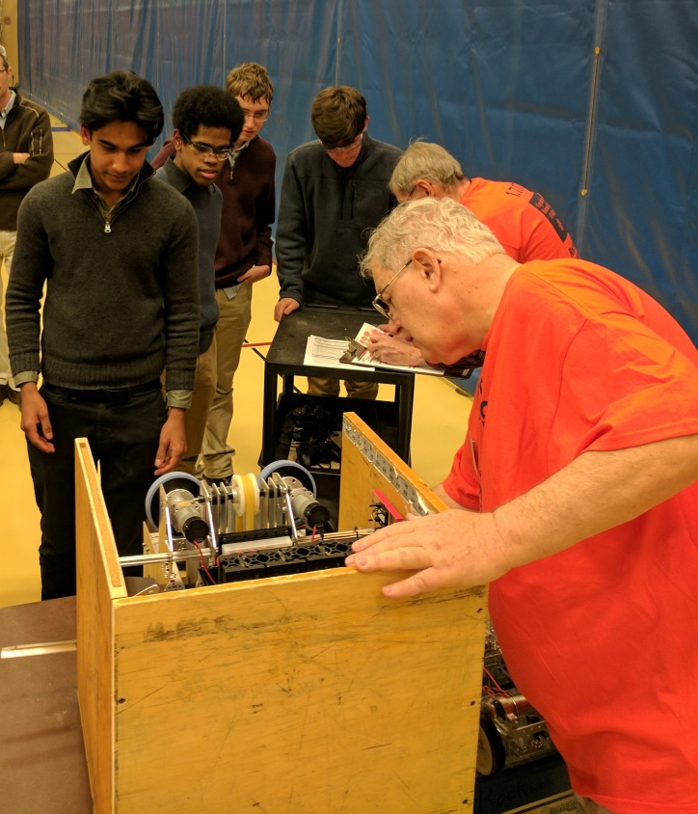

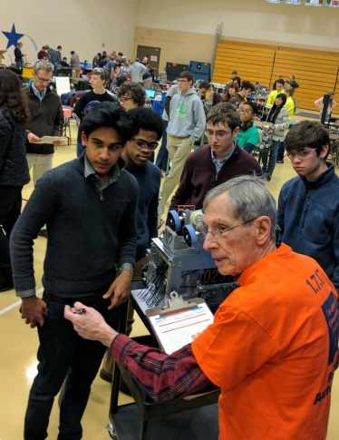 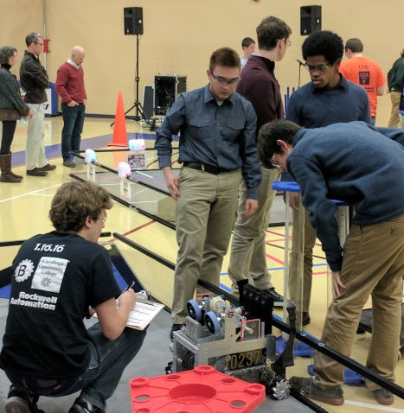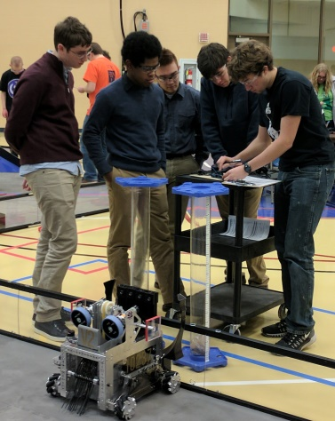

*Robot passes inspection*

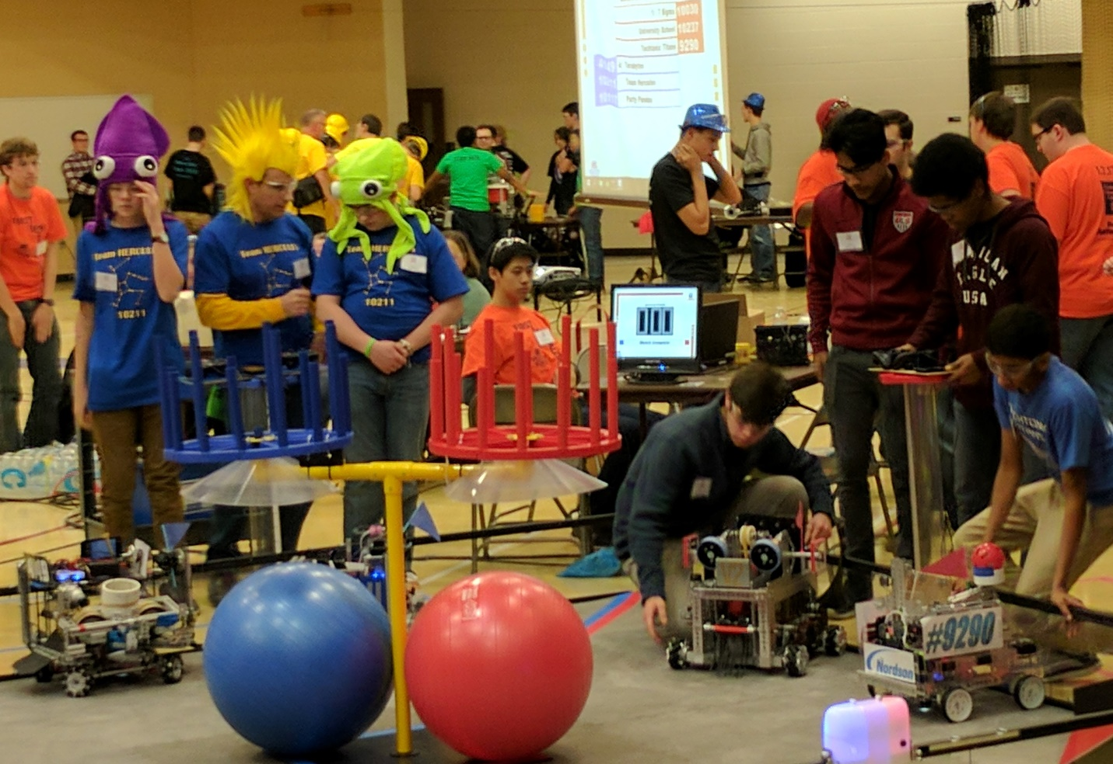

*Mike, Arjun, and Tiree prepare for match*

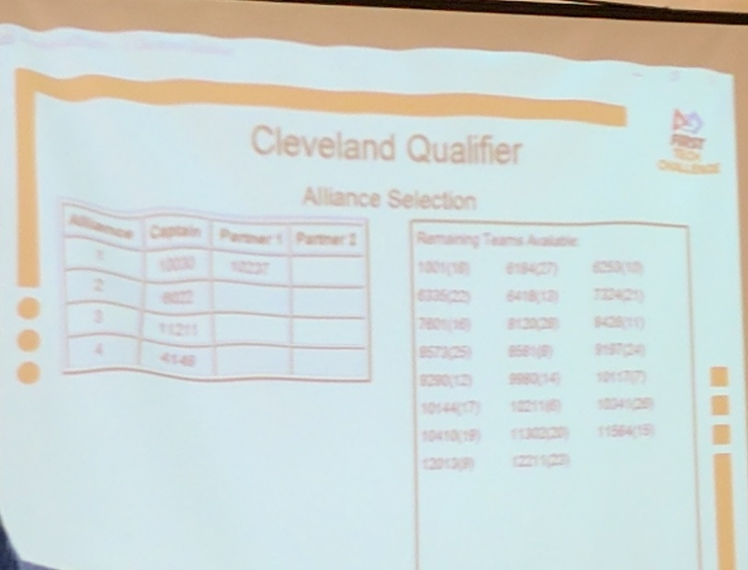

*Won 4 out of 5 matches coming in fifth place overall … but first in alliance selection*

*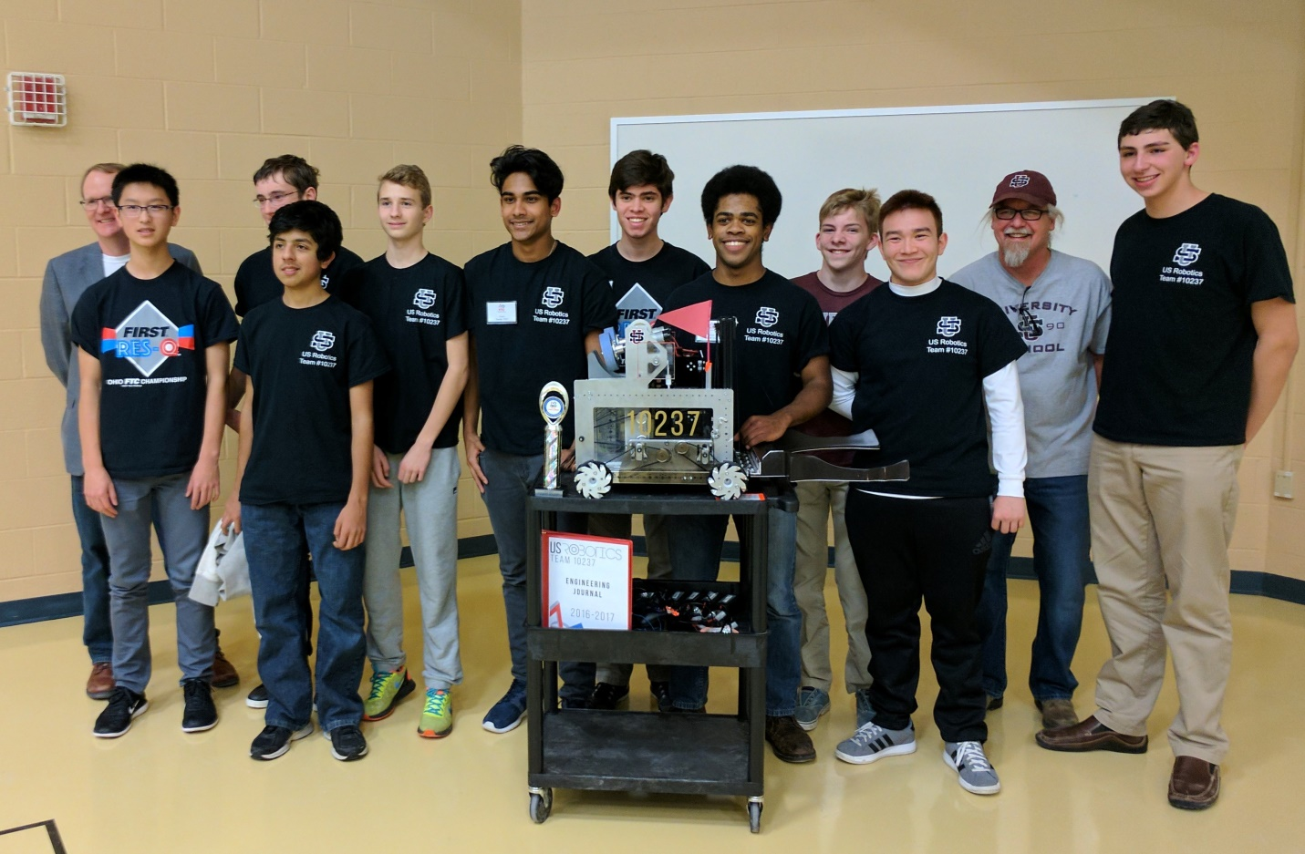*

*On to States!!*